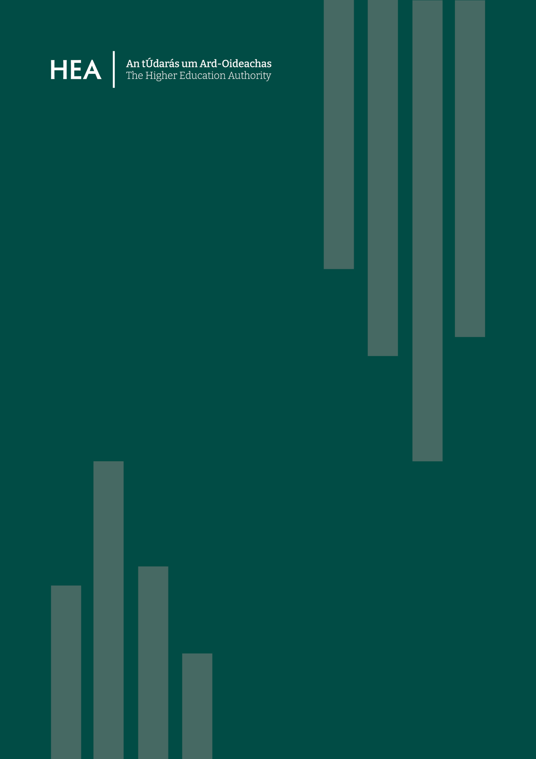
User Guide for Applications

DCIIP Call for Proposals 2026

Digital Creative Industries Innovation Programme

Indicative Timeline
Activity | Date
Call Publication | 16th October 2026
Application Form Launches | 12.00pm Friday, 6th November 2026
FAQ Process Ends | 27th November 2026
Deadline for Applications | 12.00pm Tuesday, 15th December 2026
HEA Application Eligibility Checks | 16th December 2026
Application Assessment | January 2027
Projects Recommended for funding to Minister | February 2027
Call Outcome Notification | Mid-End Feb 2027
Projects Commence | March 2027

Submission of Supporting Documents
The following supporting documents should be completed and sent in a single email to skills@hea.ie before the application deadline, 12.00pm on Tuesday, 15th December 2026.
- Project Consortium & Team Composition (HEA template in Excel format)
- Design, Methodology & Implementation (HEA template in PDF format)
- Gantt Chart (Applicant’s own template, Excel or PDF format)
- Data Management Plan (HEA template in PDF format)
- Budget (HEA template in Excel format)
- Application Endorsement (HEA template, signed accordingly, in PDF format)
We recommend all supporting documents emailed in a single Zipped folder.

Glossary of Terms
Additional Information: This section will outline any other additional relevant information as relevant to the funding scheme/ programme.
Allocation Principles: This section will outline the allocation principles, including but not limited to assessment criteria and assessment process for competitive funding schemes and programmes, and allocation criteria/ models for non-competitive funding schemes and programmes.
Digital Creative Industries: Economic activities combining creativity, culture and technology to generate products, services and experiences.
Eligibility for Funding: This section will reference categories/ types of funded bodies as per the act, indicating which categories are eligible for funding under the given scheme/ programme, and/or conditions that must be met by bodies seeking funding to be eligible for funding under the given funding scheme/ programme.
Eligible Expenditure: This section will indicate which expenditure categories are allowed: current/ capital; pay/ non-pay/ indirect costs, etc.
External Partner: A non-higher education organisation participating in project delivery.
Funding Period: This section will set out the period for which the funding is provided.
Innovation Hub: A collaborative structure bringing together education, industry and stakeholders to support innovation and knowledge exchange.
Lead Administrative/ Governance Institution: The Irish institution responsible for governance, contractual management and reporting.
Other Conditions of Funding: This section will outline other conditions of funding applicable to the given funding scheme/ programme, including but not limited to reporting requirements.
Partnership of Scale: A large-scale strategic collaboration involving multiple institutions and sectoral partners.
Shared Island Collaboration: Activities that strengthen cooperation, innovation and skills development across Ireland and Northern Ireland.

Purpose
The purpose of this document is to guide potential applicants through the application process of submitting their proposal(s) to the Digital Creative Industries Innovation Programme Call, which will deliver funding for projects across Pillar I: Innovation Hubs and Collaborative Networks and Pillar II: Partnerships of Scale. The DCIIP is a collaborative scheme supported by Government of Ireland funding through the Department of Further and Higher Education, Research, Innovation and Science and the Shared Island initiative.
Please ensure to read the 2026 Call Document and Frequently Asked Questions closely while preparing an application submission. Supporting template documents for the submission of an application to the DCIIP can be found on the HEA website: https://hea.ie/skills-engagement/shared-island-digital-creative-industries-innovation-programme/
Should queries arise, they will be addressed through the Frequently Asked Questions process only. FAQs may be submitted to skills@hea.ie no later than Friday, 27th November 2026.

Call Eligibility Requirements

Eligible Institutions
The programme is open to all higher education and research institutions and organisations as listed in Appendix 1 – Eligible Institutions of the Call Document 2026. All institutions and Lead Investigators, as well as Consortium Co-Leads, must meet the eligibility requirements set out in the Call Document 2026.

Consortium Requirements
While there is no limit on the number of Partner Institutions, there must be at least one lead HEI from Ireland and one lead HEI from Northern Ireland in a project consortium. The lead HEI in Ireland will be regarded as the Lead Administrative/ Governance Institution for HEA communication, governance and award management purposes.
Industry partners from outside higher education and research institutions are required in each project application including SMEs, multinational companies, and industry representative organisations.
While projects will be led by HEIs with industry partners, external partners from further education, civic society, cultural organisations, creative enterprise, and innovation from Ireland and Northern Ireland may also be included. NGOs and charities must be officially registered. Research Performing Organisations and other government agencies may be also included as external partners.
Other additional partners from outside of Ireland and Northern Ireland may be included in a project application, provided their inclusion can be demonstrated by the proposers as bringing added value and further support to the project in meeting the aims and objectives of the DCIIP. Such additional partners must not be included in place of partners in Ireland or Northern Ireland.

Eligible Lead Investigators & Consortium Co-Leads
Project applications will be open to eligible researchers, innovators, and interdisciplinary teams from creative industries relevant disciplines, including technology, engineering, arts, humanities, media, and design. Applications will be open to all eligible researchers, at early, mid, or advanced stages of their careers. HEIs are expected to support project applications led by researchers across all career stages.
The Lead Investigators and any Co-Lead Investigators in Ireland and Northern Ireland must have a proven track record and expertise relevant to the creative sector. Interdisciplinary project applications are encouraged.

Applying in Irish
Applications completed in Irish must upload an English language translation of their application to the online portal under Section 10, Question 74. Assessors involved with the call assessment process will provided with both the Irish language application and the English language translation.

Submission Requirements
Pillar | Duration | Maximum Award
Pillar I – Innovation Hubs and Collaborative Networks | 3 Years | €1,100,000
Pillar II – Partnerships of Scale | 3 Years | €3,000,000
Note: Subject to available budget, one or more projects across both Pillars will be funded.

- Projects must be 36 months in duration.
- Projects must begin in 2027. Further clarification will be provided at the award acceptance stage.
- Please ensure to use unencrypted, non-password protected uploads to the application form.
- The number of words in uploads must not exceed the specifications for any given section. Applications that do not comply with these requirements will be deemed ineligible and will be returned without review.
- Appendices or other unsolicited documentation are not permitted. Applications that include such unsolicited documentation will be returned without review and may render an application ineligible.
- Applicants must complete all required fields before submitting an application. The portal will not allow you to submit an application if required fields/uploads are not completed.
- All documents necessary to support a proposal must be uploaded before an application is submitted. Where an official template document has been provided, this must be used.

Supporting Documentation

1. Project Consortium & Team Composition Template
To be submitted in Excel format and uploaded to the Application Form under Section 1, Question 15.
The Project Consortium Template should provide the details of all HEI Partners in Ireland and Northern Ireland, and all Industry Partners in Ireland and/or Northern Ireland. This template also includes sections for details on External Partners (i.e. further education, civic society, cultural organisations, creative enterprise, and innovation) and Additional Partners (i.e. institutions and organisations outside Ireland and Northern Ireland), if any.
The Team Composition Template should provide details for Project Team Members at HEI Partners in Ireland and Northern Ireland must be added. As far as possible research teams should be gender balanced. You will be required to report on the gender balance of the team on an ongoing basis. Details should also be included of Project Team Members from Industry Partner(s). If External Partner(s) and/or Additional Partner(s) are involved in the consortium, details for those Team Members should be included on this template.

2. Design, Methodology and Implementation Template
To be submitted in PDF format and uploaded to the Application Form under Section 4, Question 57.
Define and provide details of the project design and the proposal’s implementation plan and governance structure, demonstrating that it will address the key principles of the DCIIP and the specific programme criteria as set out in the Call Document. Expected project outcomes and impact should be included.

3. Gantt Chart
To be submitted in Excel or PDF format and uploaded to the Application Form under Section 4, Question 58.
A Gantt Chart setting out a representation of the proposal’s expected outputs and deliverables must be submitted.
Please note that the HEA does not provide a Gantt Chart Template. Applicants may use one of their own choosing.

4. Data Management Plan Template
To be submitted in PDF format and uploaded to the Application Form under Section 6, Question 63.
Applicants are asked to provide a high-level description of the data management plan for the proposed project, outlining how research data will be handled, organised, protected, and shared throughout the entire lifecycle of the project.

5. Budget Template
To be submitted in Excel format and uploaded to the Application Form under Section 7, Question 65.
Applicants are asked to provide a clear breakdown of the total funding being requested under the relevant Pillar for the proposed project, using the Budget Template provided by the HEA. Clear justification for the budget must be provided.
One consolidated project budget in euro will be accepted per application. InforEuro website to be used for FX rate calculation.

Pillar I: Innovation Hubs and Collaborative Networks
Maximum Award: €1,100,000
- Up to 30% of overall funding may go to Northern Ireland HEI Partner(s)
- Up to 10% of overall funding may go to eligible Industry Partner(s)
- Up to 5% of overall funding may go to eligible External Partner(s)
- Additional Partner(s) outside Ireland and Northern Ireland cannot be allocated funding
- Up to 25% of pay costs may be sought in institutional overheads, research student stipends and equipment should not be included as pay for the purpose of overhead calculation.
- Up to 10% of overall funding must be included as contingency costs, which are to be justified and budgeted to cover risk-related costs, should they occur

Pillar II: Partnerships of Scale
Maximum Award: €3,000,000
- Up to 30% of overall funding may go to Northern Ireland HEI Partner(s)
- Up to 10% of overall funding may go to eligible Industry Partner(s)
- Up to 5% of overall funding may go to eligible External Partner(s)
- Additional Partner(s) outside Ireland and Northern Ireland cannot be allocated funding
- Up to 25% of pay costs may be sought in institutional overheads, research student stipends and equipment should not be included as pay for the purpose of overhead calculation.
- Up to 10% of overall funding must be included as contingency costs, which are to be justified and budgeted to cover risk-related costs, should they occur

Notes:
- Funding cannot be used for estates, room rental (excluding room conference, meeting room rental, focus group meetings), or office space.
- Funding cannot be used as seed funding for other projects.

6. Application Endorsement Template
To be submitted in PDF format and uploaded to the Application Form under Section 11, Question 75.
All proposals submitted through the online application form must be endorsed with the signature of the President (or Provost)/ Vice-President/ Director of Research or the appropriate office holder in this regard within the Lead Administrative/ Governance Institution in Ireland and the Lead Institution in Northern Ireland. Both Lead Investigators within the Lead Administrative/ Governance Institution in Ireland and the Lead Partner Institution in Northern Ireland must also endorse the form.
Prior to the completion of the Application Endorsement by the Lead Administrative/ Governance Institution in Ireland and Lead Institution in Northern Ireland, each Consortium Co-Lead identified on the application (if any) must provide the Lead Administrative/ Governance Institution with confirmation that their host institution agrees to the submission of the project proposal and to the collaborative management of the project, if successful.
Confirmation in writing from Industry Partners (and External/ Additional Partners, if any) must also be obtained by the Lead Administrative/ Governance Institution in Ireland prior to submission.
Lead Institutions must ensure each application meets all eligibility requirements before endorsing an application.
Where a Vice-President for Research is involved in a proposal, the application must be endorsed by the institution’s President/ Provost.

