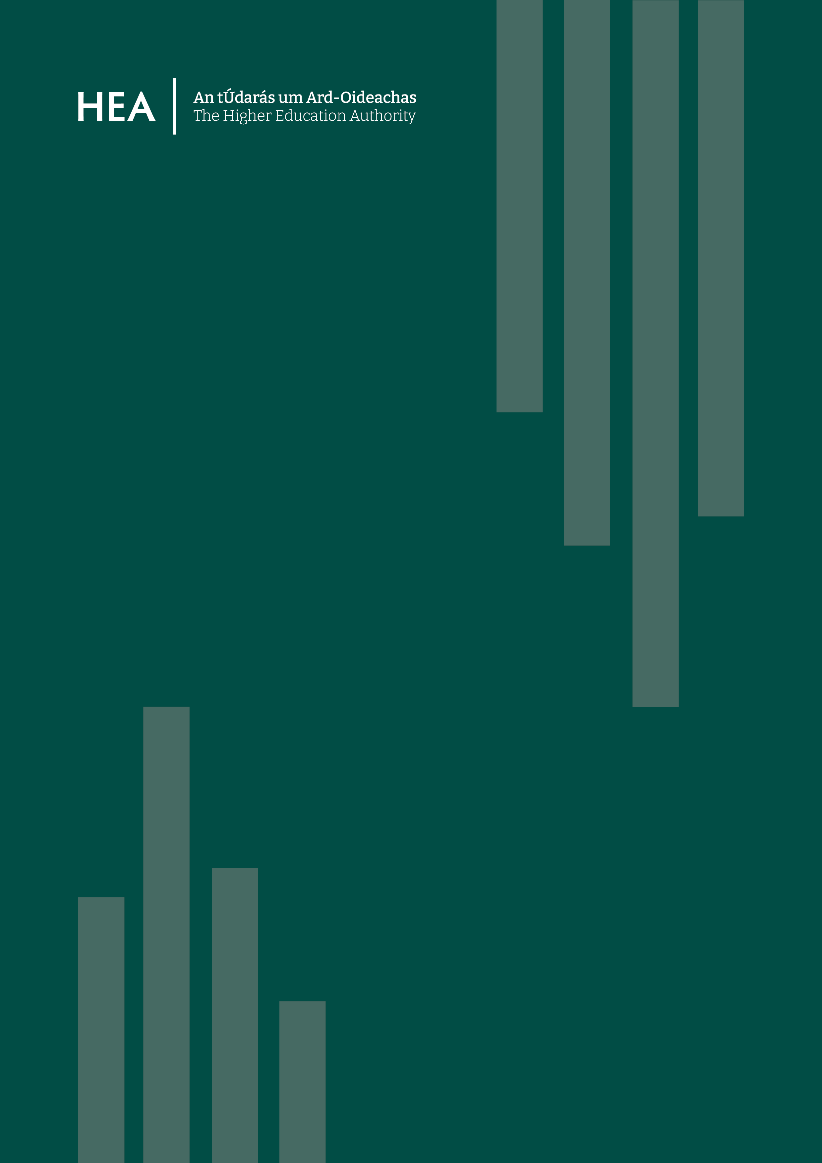
Secondment Opportunity –
Project Officer (HEO/SEO Grade)
GENDERACTIONplus2027

Secondment Opportunity – Project Officer (HEO/SEO Grade)
GENDERACTIONplus2027

Expressions of interest are invited from eligible public sector employees in the Education Sector for the position of Project Officer (Senior/Higher Executive Officer) in the Higher Education Authority.
The secondment will be for a period of 21 months. The arrangement will be reviewed at 3 months and at 6 months to ensure it is meeting the expectations of both parties.
Expressions of interest are sought from staff currently serving at levels that correspond to the indicative competency levels and salary bands associated with the post of Senior/Higher Executive Officer. The secondee will remain on the payroll of the parent organisation and all agreed costs associated with the secondment will be the responsibility of the HEA.
Expressions of interest to be submitted to secondment@hea.ie by 5pm on the 24th of July 2026. All EOIs should include a current CV and statement outlining how the candidate meets the essential criteria set out in the role profile. Candidates must ensure they have the support of their employer before submitting an expression of interest and should include appropriate contact details for their HR Department in their EOI.

Note for Human Resources Officers:
Please note that parent organisations will continue to pay participants for the duration of the period of the secondment, and payroll costs will be invoiced quarterly to the HEA. All other agreed costs associated with the secondment will be the responsibility of the HEA.
All applicants are obliged to seek permission in principle to apply from their respective organisations in advance of submitting any application.
If successful in this competition, it is expected that the candidate will be released to take up the position within 4 weeks from notification.

Background:
The post of GENDERACTIONplus2027 Project Officer is a temporary specialist role located in the HEA, as part of the GENDERACTIONplus2027 project which is funded by Horizon Europe.
GENDERACTIONplus2027 brings together national authorities, research funders, researchers, and European Research Area stakeholders to help strengthen coordination on inclusive gender equality across Europe. Building on the Horizon Europe project GENDERACTIONplus, the project focuses on supporting inclusive gender equality across different national and institutional contexts.
At the centre of the project is a Community of Practice bringing together national authorities and research and innovation funding organisations. Together with other ERA stakeholders, including the ERA Forum Sub-group on Inclusive Gender Equality, the project will develop practical intersectionality guidelines, a flexible monitoring and evaluation approach on inclusive gender equality plans, an ERA monitoring dashboard, and an open toolkit to support policymakers and research funders across Europe.

Role Profile:
Postholder will report to a Senior Manager (or equivalent) in the Centre of Excellence for Equality, Diversity, and Inclusion and will be responsible for a wide range of activities including:
- Coordinating and managing the HEA’s work package tasks and deliverables for GENDERACTIONplus2027, with active support from the Work Package Leader.
- Leading on research and report writing to contribute to the work package deliverables.
- Coordinating and leading the analysis and writing of reports on relevant developments and HEI progress in gender equality policy at national and international level.
- Attending events and meetings relevant to the GENDERACTIONplus2027 project, as identified by the HEA.
- Ensuring that work package milestones and deliverables are met in accordance with project timelines.
- Liaising and communicating effectively with stakeholders, including the project coordinators, project partners, HEA stakeholders and higher education institutions.
- Supporting meetings of relevant project partners and stakeholders.
- Ensuring funding agency requirements are adhered to on all deliverables etc.
- Overseeing the financial management of the project budgets and contributing to financial reporting.
- Ensuring appropriate documentation is in place to satisfy funding agency audit requirements.
- Any other duties assigned by the Senior Manager, Head of International, Communications and EDI, and CEO.

Eligibility:
Candidates must, on 24th July 2026:
- Be already serving in the public service in a post that approximately corresponds to the competency level and within the indicative range of the salary band associated with the grade of SEO/HEO.
- Have satisfactorily completed probation in their current role or have obtained a satisfactory rating in their organisation’s performance management system for the year 2025 and be suitable from the point of view or health, with particular reference to sick leave Circular 05/2018 and satisfactory attendance.
- Possess the necessary experience, skills and competencies required to perform the role and be remunerated approximately within the range of the salary band associated with the post being applied for.
- Have pre-approval for the application by their organisation’s HR Division.
- Offers will be dependent on satisfactory references from the releasing line manager confirming satisfactory conduct and levels of absence/sick leave.

Essential Skills and Competencies:
Essential
- NQF Level 8 qualification or higher in a relevant discipline area.
- Minimum of 18 months relevant management experience with excellent analytical and problem-solving skills, capable of providing strategic input to programme planning and implementation.
- Knowledge of equality, diversity and inclusion policy and practice in the Higher Education sector, particularly in the area of gender equality policy, gender equality plans, monitoring and evaluation (or the ability to upskill quickly in this area)
- Excellent written and verbal communication skills including strong report writing and presentation skills, particularly to international audiences.
- Experience of working collaboratively and cross functionally with multiple internal and external stakeholders.
- Relevant management experience with excellent analytical and problem-solving skills, capable of providing strategic input to programme planning and implementation.
- Excellent interpersonal and facilitation skills with a track record of building collaborative relationships.
- Experience in the Microsoft Office suite of programmes, including competency in Microsoft Word, Outlook, Excel, PowerPoint and video conferencing software, etc.

Desirable
- A postgraduate degree (NFQ Level 9 or above) or equivalent in a directly relevant discipline, or experience of research activity in the area of gender equality.
- Experience and knowledge of monitoring and analysing equality, diversity and inclusion policy, in particular gender equality.
- Experience of participating in EU funded grants or coordinating multicentre projects.
- Experience of working with the European Commission or European programmes.
- Experience of representing the organisation externally.

Conditions of Assignment:
- The secondment will be for a period of 21 months.
- This arrangement will be reviewed after three and six months to ensure that it is meeting the expectations of both parties.
- In the event of the level of performance not being satisfactory, the secondment arrangement will cease and the secondee will return to their parent organisation.
- While on secondment, the secondee will continue to have access to promotional opportunities in their parent organisation
- Flexi time applies where applicants have this in their current position.
- At the end of the period of secondment, staff will return to their parent organisation. In the event that there is no suitable position in their parent organisation, staff will return to work in accordance with the secondment policy provisions in place within their organisations at that time.

Application Process:
Applications, which must be pre-approved in principle by your organisation’s HR Department, should be made by 5pm on the 24th of July 2026 to secondment@hea.ie.
Applications should include a CV, contact details for the parent association HR Department and a personal statement addressing the essential and desirable requirements set out in the role profile.
Applications received after the closing date will not be considered.

Selection Process:
If the numbers applying are such that it would not be practical to interview all applicants, it may be necessary to shortlist only those that appear most suitable for the role based on the information contained in their application.
The interview may include a presentation by the candidate. Where this is required, candidates will be provided with additional information in advance.
It is intended that interviews will be in person. Details will be provided to shortlisted candidates in advance.
Interviews will be held on week commencing 27th of July and the onus is on candidates to make themselves available to attend interview during this period of time.
The HEA is an equal opportunities employer. We are committed to championing an inclusive and diverse workforce that reflects modern Ireland and the people we serve. We strive to create a culture where all staff have equal access to opportunity and feel comfortable and confident to be themselves at work. Reasonable Accommodations will be provided to candidates, if required, during this recruitment process. To discuss and request reasonable accommodations in confidence please contact the HEA’s Disability Liaison Officer, dlo@hea.ie.
FAQ
Q. Will my pay change?
A. No. You will continue to be remunerated by your Organisation on your current pay rate. Increments due will be paid to you on your due date.
Q. Will there be a change to my Terms and Conditions of Employment?
A. No, you will continue to be an employee of your Organisation under your existing Terms and Conditions for the duration of the secondment.
Q. I have more holidays than is usual for a public servant. How many will I be allowed to have in this post?
A. Successful candidates can carry over their current leave allowance to their post. This is subject to an upper limit of 29 days per annum. Candidates who usually have more annual or special leave than this (e.g. a teacher) will be expected to voluntarily align themselves with the upper limit of 30 days for the duration of the secondment.
Q. Can I continue to apply for promotional opportunities in my current organisation, should they arise?
A. Yes.
Q. Can I apply for promotional opportunities in the Higher Education Authority should they arise?
A. You are eligible to apply for external competitions within the HEA but not for confined competitions or internal mobility.
Q. My salary is slightly higher/lower than the indicative salary band for the post I am interested in. Can I still apply to that post?
A. Yes, however when shortlisting the shortlisting panel will take this matter into consideration in addition to other factors (e.g. level of competency, experience, qualifications, etc.)
Q. I want to apply for this role but my HR Department will not allow to me to apply. What should I do?
A. All applications must be pre-authorised by your organisation’s HR Department prior to submission.
Q. Can I avail of flexi-time?
A. If you have flexi time at the moment, it may continue in line with the policy that is currently in place in the Civil Service.
Q. Can I avail of blended working?
A. Candidates should note the HEA’s Blended Working Policy is that employees are required to work a minimum of 2 days per week in the office. All applications for blended working are subject to approval. If approved employees will be required to attend on specific days each week agreed with the manager and on days as and when required by the manager, for example for collaboration, meetings, training and key events.

