HEA Healthy Campus Case Study

NOTES FOR COMPLETION
- Case studies should relate to your institution's healthy campus initiative.
- Where possible send a photograph or illustration, links, or resources to accompany your case study.
- It is recognised that not all sections will be relevant to all case studies – the proforma is designed to offer consistency across a range of case studies.
- Case studies will be used as part of HEA communications including email, website, and social media.
- Case studies should be written in the third person and anonymous when it comes to participants’ names.
- Please be as concise and clear as possible and consider the use of bullet points to summarise information.
- Please submit your case study to healthycampus@hea.ie.

HEALTHY CAMPUS CASE STUDY
Name of Institution/ Organisation | Trinity College Dublin
Who lead the initiative? | TCD Faculty of Health Sciences and faculty of STEM. Healthy Trinity initiative.
Date and timeframe of the initiative | The academic years 2022 – 2025 and ongoing.
What was the reach of the initiative? | Target audience included women experiencing menopause or a friend/family member of someone experiencing menopause.  The initial Menopause Café series in 2022 engaged Trinity staff, students, and healthcare workers. Subsequent events targeted women in addiction recovery and the general public.  Cumulative reach is estimated at 250+ attendees over multiple events,
Initiative Title | Let’s talk about menopause – café series
Aims/ Objectives | - To raise awareness around women's health issues in the context of menopause  - To provide free, expert-led events on topics such as mental health, menopause, nutrition, exercise, and general health.  - To reduce stigma and create an inclusive, supportive space for women in menopause.  - To raise awareness, empower attendees, and inform policy through engagement.
The rationale for the action, including any identified health needs | We identified a gap in health support and education for women in menopause. Feedback from menopause café events highlighted unmet needs in health services, especially mental and physical wellness. We seek to discuss and addressed stigma and barriers to access services and raise awareness.  We have developed themed menopause café events with one for Trinity staff; one for the general public; one for people with disabilities going through menopause; one focusing on research into menopause and one for women with addiction issues. For instance, Menopause and addiction recovery are seldom addressed together in healthcare or education. Initial feedback from a Menopause and addiction café event we ran identified unmet needs for information on menopause, mental health, nutrition, exercise, and dental care. Additionally, stigma, homelessness, illiteracy, and social exclusion disproportionately affect this group, creating barriers to accessing care.  Our initiative directly responds to Ireland’s evolving health strategy, which now includes menopause in public health discourse (e.g., Women’s Health Taskforce, CSO Well-being Strategy).
Identify all frameworks, policies, or strategies this initiative aligns to  (internal, local or national) | - Healthy Trinity and Healthy Ireland Framework  - Women’s Health Action Plan (Dept. of Health)  - 2022 CSO Well-being Strategy on Menopause  - 2021 Global Consensus Statement on Menopause in the Workplace  - WHO Mental Health and Wellbeing Strategy  - Irish Women’s Health Action Plan
Summary | Please provide a summary of your case study.  Since 2022, as part of Healthy Trinity, we have taken innovative steps to promote open dialogue on menopause and expand outreach to underserved groups. It began with a Menopause Café on World Menopause Day in 2022, featuring expert talks from endocrinologists, GPs, pharmacists, and exercise coaches. Our menopause café series is designed to be conversational and welcoming and demystify menopause. Due to the nature of talk, we found that a group of 40-60 allows for attendees to feel comfortable asking questions about menopause.  We expanded this model to include women in addiction recovery—a doubly marginalised group. In partnership with community stakeholders, we hosted the first “Menopause and addiction Recovery” cafe event. The event marked the first of its kind in Trinity and the wider Irish university system. Attendees voiced needs around mental health, nutrition, dental care, exercise, and gynecological health.  Attendees of the Menopause and addiction Recovery Cafe event included women from shelters, hostels, and the Traveller community. All events are free, inclusive, and tailored to those with lower literacy or healthcare access.  The initiative is more than awareness-raising—it’s a civic engagement model and a support network for vulnerable women in and beyond Trinity College.  We intend to continue running this menopause café series as long as we can resource/fund it and as long as there continues to be a demand for it. In our experience, from the number of attendees at our events we can see the clear need for this.  Each event is designed to provide safe, stigma-free access to expert knowledge, empower attendees with actionable information, and create a network of support. Events are free and tailored in language and format to ensure accessibility for all.  This initiative is a civic engagement model connecting academic resources to community needs and will contribute to awareness, and improved health outcomes for a vulnerable, often overlooked population.
Did you collaborate with internal and/or external stakeholders to deliver? | Include stakeholders here.  - Health Trinity  - TCD Faculty of STEM  - TCD Faculty of Health Science  - TCD HR Dept  - TCD St James Hospital  - TCD Unit 18 and the Unit 18 Advisory Group  - Recovery Academy Ireland (RAI)  - Ringsend Drugs Forum  - South Inner City Drugs and Alcohol Taskforce  - Health Trinity Sexual and Reproductive Health Group
How was the initiative organised? | Please include elements such as action planning, piloting, approval for the initiative, committee meetings, timeframes etc.  How was the initiative organised?  - We started with Stakeholder engagement and planning meetings  - A schedule of themed menopause café was developed  - Speakers and venues were confirmed  - The menopause café were marketed as free events which were catered and all our menopause café have been sold out.  - Initial Menopause Café was run in Oct 2022. A series of menopause cafes have been run across Trinity Campus and in St James Hospital and Unit 18 by us since October 2022 to present. Our most recent menopause café was pilot menopause + addiction event which focused on women recovering from addiction and going through menopause.  - Feedback-driven development of multi-topic series with each event having a specific focus such as Menopause and disability; Menopause and exercise; Menopause and nutrition; menopause and addiction.  - Collaboration with stakeholders to refine topics, identify speakers, and confirm venues  - Events scheduled in multiple locations  - We regularly seek funding through grant applications and requests to fund this menopause series.
What resources did you need? | Including financial, staffing and others.  - Funding from Healthy Trinity, Faculty of STEM, and Faculty of Health Sciences, TCD HR dept and Health Trinity Sexual and Reproductive Health Group  - Volunteer and professional speaker time  - Securing Venues: Unit 18, The Pav (TCD), St. James’s Hospital, and spaces across Trinity College Campus  - Catering, event logistics, promotional materials  - Yoga instructors, moderators, tech support for presentations
Has it been evaluated? How successful has it been? | Include details of any results/ outcomes here.  Quantitative: attendance numbers, repeat engagement  Qualitative: feedback forms, verbal testimonials, future topic requests  Media coverage: internal communication and internal news pieces  Research: planned journal submissions and conference presentations  Success indicators: increased awareness, stakeholder partnerships
Any future plans, including the sustainability of the initiative? | - Regular themed health events to continue through 2025  - Development of menopause workplace policy within Trinity  - Toolkit for other institutions and workplaces  - Secure additional funding from State bodies  - Expand to support other underserved demographics
Key Learning Points | Menopause is a public health and workplace issue requiring multifaceted responses. Open discussion reduces stigma and fosters inclusion by creating a supportive forum and services.

Healthy Campus Framework Categories (please tick all that apply)
Healthy Campus Process | Whole Campus Approach | Topic | Population Group
Commit ☐ | Leadership, Strategy & Governance ☐ | Alcohol ☐ | Students ☐
Coordinate ☒ | Campus Environment (Facilities & Services) ☐ | Substance Misuse ☐ | Staff ☒
Consult ☒ | Campus Culture & Communications ☒ | Healthy Eating / Food  ☐ | Wider community ☒
Create ☐ | Personal & Professional Development  ☐ | Mental Health & Wellbeing  ☒ | Other ☐
Celebrate & Continue ☐ |  | Sexual Health & Wellbeing  ☒
Tobacco Free Campus
☐

Physical Activity / Active Transport
☐

Wellbeing on the Curriculum (can also fall under ‘Personal & Professional Development)
☐

Health & Sustainability
☐

Other
☐

Contact Details
Contact Name/s | Dr Katie O’Connor and Ms Fiona Brown
Date | 25/4/2025
Email Address | Oconnk33@tcd.ie
Links | Please add links to any relevant pages/ documents. Please attach any items not in a link format with your submission.  Below are two photos:  Photo of our first Menopause café in 2022  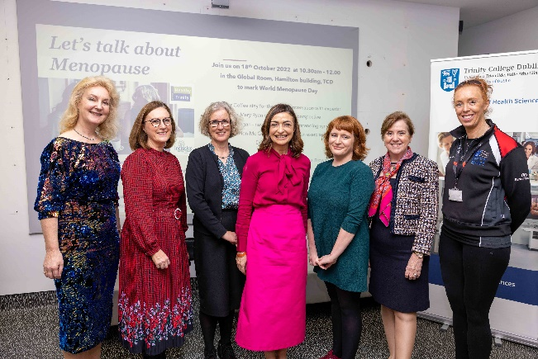  Panel of speakers and Event organisers  (Left to right: Dr Mary Ryan; Ms Fiona Ryan, Dr Susan Smith; Mrs. Oonagh O’Hagan; Dr Katie O’Connor; Prof Orla Sheils; Mrs. Deirdre Mullen-Mc Guinness)  Photo of recent Menopause and addiction café in 2024  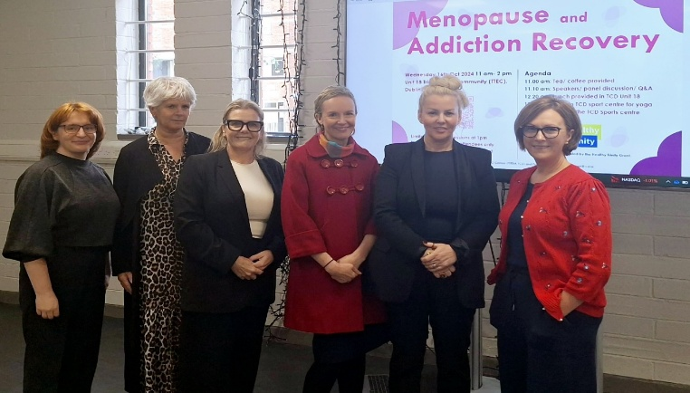  Left to right: Dr Katie O’Connor (FSTEM, TCD); Dr Maria Wilson (GP); Claire Naughton (RAI); Dr Anne O’Connell (GP); Dr Jo-Hanna Ivers (TCD); Fiona Brown (FHS, TCD)

