HEA Healthy Campus Case Study

NOTES FOR COMPLETION
- Case studies should relate to your institution's healthy campus initiative.
- Where possible send a photograph or illustration, links, or resources to accompany your case study.
- It is recognised that not all sections will be relevant to all case studies – the proforma is designed to offer consistency across a range of case studies.
- The HEA will invite selected institutions to present their case studies at the HEA Wellbeing Conference, in Dublin, on April 20th, 2023. All case studies will be printed and displayed at the conference.
- Case studies will be used as part of HEA communications including email, website, and social media.
- Case studies should be written in the third person and anonymous when it comes to participants’ names.
- Please be as concise and clear as possible and consider the use of bullet points to summarise information.
- Please submit your case study to healthycampus@hea.ie.

HEALTHY CAMPUS CASE STUDY
Name of Institution/ Organisation | Student Volunteer Ireland
Who lead the initiative? | Host University: University of Limerick  Partner Universities: University of Galway, University College Cork, University College Dublin, Technological University of Dublin.
Date and timeframe of the initiative | From 2016 at the IUA no ongoing from UL.
What was the reach of the initiative? | Currently we have over 29,649 student applications to volunteering projects across Ireland since 2016.
Initiative Title | StudentVolunteer.ie
Aims/ Objectives | Student Volunteer Ireland (StudentVolunteer.ie) is national collaborative social enterprise born out of higher education staff ingenuity to unite universities in fostering student engagement in community service on a grand scale.  StudentVolunteer.ie is a technical solution designed with staff and students to connect universities with local, national, and international volunteering opportunities with non-profits and charities for societal impact.  This initiative enhances students' personal and professional development while significantly benefiting local communities. Overall our vision is that every student in Ireland has the opportunity to volunteer and be supported and recognised in their volunteering.  Within the “StudentVolunteer.ie National Strategy” we have ambitiously set out a series of high-level Objectives underpinned by fifteen Actions that include increase recognition of student volunteering and aligning to the Sustainable Development Goals for major impact.  Our Strategy: “The Value and Impact of Higher Education Student Volunteering” https://www.studentvolunteer.ie/reports/The_Value_and_Impact_of_Higher_Education_Student_Volunteering_in_Ireland.pdf
The rationale for the action, including any identified health needs | Student volunteering plays a crucial role in enhancing both health and well-being:  - Mental Health Benefits: Volunteering helps reduce stress and anxiety by providing a sense of purpose and accomplishment. It can also combat feelings of loneliness and depression by fostering social connections.  - Personal Growth: Engaging in volunteer activities allows students to step out of their academic comfort zones, fostering resilience, adaptability, and a sense of responsibility.  - Social Skills: Volunteering enhances social and communication skills. Working with diverse groups helps students develop teamwork, effective communication, and conflict resolution skills.  - Physical Health: Some studies have shown that volunteering can lead to better physical health outcomes, such as lower cardiovascular risk factors.  - Academic Enrichment: Volunteering provides practical applications for theoretical knowledge, reinforcing and deepening students' understanding of classroom concepts.  - Civic Responsibility: It instils a sense of civic duty and empathy, encouraging students to contribute positively to their communities.  Student Volunteer Ireland tracks the impact of student volunteering not only on the student but also the wider community and university community:  - Enhanced Community Engagement: Student volunteers help bridge the gap between the university and the local community. By participating in community service, students foster stronger connections and collaborations with local organizations and residents.  - Positive University Image: Active student involvement in volunteering projects enhances the university's reputation. It showcases the institution's commitment to social responsibility and community support.  - Resource Support: Volunteers provide valuable support for university events and initiatives, such as open days, fundraisers, and community outreach programmes. This helps the university run these events more smoothly and effectively.  - Leadership Development: Volunteering opportunities help students develop leadership skills, which can be beneficial for student organizations and university governance. This, in turn, creates a more dynamic and engaged student body.  - Stronger Alumni Network: Students who volunteer often remain connected to the university after graduation. This can lead to a stronger alumni network, which can provide support and resources for future students and university projects.  - Diverse Perspectives: Student volunteers bring fresh ideas and perspectives to the university community. Their diverse backgrounds and experiences can lead to innovative solutions and improvements within the university.
Identify all frameworks, policies, or strategies this initiative aligns to  (internal, local or national) | National  - Second National Strategy on Education for Sustainable Development - ESD to 2030 : Section 4 – youth volunteering  - The Department of Rural and Community Development National Volunteer Strategy 2025: Names StudentVolunteer.ie as a key partner in delivering on youth volunteering  - National Strategy for Higher Education to 2030 names community-based learning as a priority.  - HEA Systems Performance Framework 2023-2028  - Ireland’s National Skills Strategy  Internal University Strategies name campus specific student volunteering initiatives and the value of experiential education.
Summary | According to StudentSurvey.ie 46.5% of undergraduates “do not plan to volunteer” and “have not decided to volunteer” (Irish Survey of Student Engagement Results 2023). Non-participation in volunteering is a problem that we have sought to understand through research and critical reflection. It is a significant challenge for Irish Higher Education to mobilise and engage students. We have carried out structured literature reviews of published research, focus groups and interviews with students and Volunteer Involving Organisations (VIOs) while also positioning ourselves on the ground daily engaging with students to gather informal data.  StudentVolunteer.ie is the only platform in Ireland that provides bespoke volunteering opportunities specifically for third-level students that can be undertaken alongside their studies and responsibilities. It directly links in with the student data through HEAnet, each volunteering structure in the programme partnership HEIs, and ensures that they are provided with access to training, institutional awards, and support. The innovative aspect of the platform is the cost-effective support it offers to university volunteering programmes and staff. Through our programme, StudentVolunteer.ie technology, the HEI staff can scale-up volunteer programmes and manage logistics beyond cumbersome excel and google forms.  Nonprofits and voluntary groups from across Ireland create online profiles with learning experiences through volunteer roles for students. With one click a charity can actively recruit and recognise students for their contribution. Currently no other higher education body provides this technical solution.  Through StudentVolunteer.ie universities are able to highlight and recruit students to campus volunteering programmes and there is a significant growth in student led health initiatives. Programmes such as Active Consent, Bystander Training, Niteline, are all driven through student volunteering hours! Students actively participate in these programmes and can log their volunteering at StudentVolutneer.ie for a campus recognition award. This increases the visibility of the impact of the voluntary programmes.
Did you collaborate with internal and/or external stakeholders to deliver? | Most significantly we have achieved success at StudentVolunteer.ie collectively. Rather than each university having a standalone technical interface to support student-community volunteering, we cost effectively utilise a shared platform. Sharing technology provides a community of practice for staff to connect, learn and grow our volunteering programmes. We are five HEIs collaborating: UL, UCC, UCD, TU Dublin, University of Galway. There is significant investment in personnel and budgets within each member HEI to StudentVolunteer.ie.  Instead of working in competition, as so many universities are unfortunately positioned for funding, we have and will continue to achieve collaboration and a movement together through combined resourcing. A coherent nationwide approach to student volunteering will enable the future of the sector and enhance the diverse communities of Ireland.  We are deeply connected and rooted into the national and international fabric for enabling volunteering through several partnerships and collaborations:  - We are actively involved on several committees of the National Volunteering Strategy for Ireland.  - With Volunteer Ireland we are collaborating to design and deliver a transition plan that directs students as they graduate into young adulthood to the i-Vol database and platform of further volunteering projects and roles.  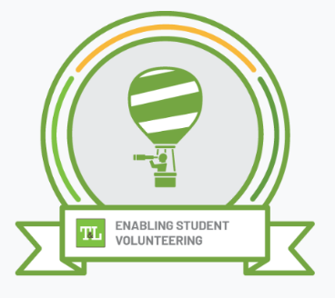  - We are in partnership with Comhlamh to provide international volunteering opportunities to students that adhere to the national Comhlamh standards and guidance.  - In June 2024 we delivered the micro credential Digital Badge – Enabling Student Volunteering - in partnership with the National Forum for the Enhancement of Teaching and Learning in Higher Education to over forty students and staff in ten different Higher education institutions.  - We have held four online Community of Practice workshops in collaboration to build our skills.  Image: Our Digital Badge, Ireland’s National Strategy that names our programme to lead on student volunteering.  Collaboration is at the heart of our programme. From primary, secondary to a diverse range of third level options there will be a shared language and framework to support youth volunteering. There is energy and strategic vision on how to build on and maximise the potential socio-economic impact of student volunteering.
How was the initiative organised? | In January 2024 the programme team held its inaugural meeting at the IUA offices. Student voice is central to our decision-making and students are trained and supported to participate in the project governance. The programme team have extensive experience in student engagement with extra-curricular and co-curricular programmes as well as university-community civic engagement strategies.  * Management Group - Six HEI practitioners, utilising the technical platform SV.ie daily, acting through weekly SV.ie working groups and demonstrating extensive commitment to student-community action for student wellbeing.  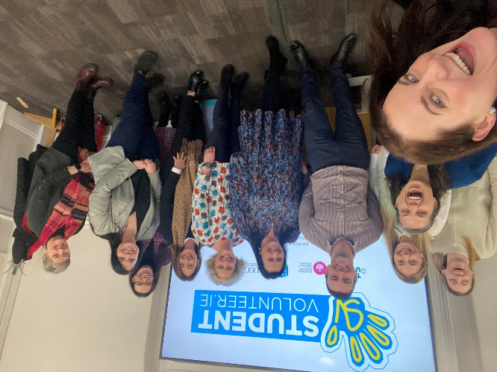  - Management Group Membership: UCD - Theresa O’Leary and Niamh Byrne, UCD in the Community; UL - Linda Fitzgerald, Nichola Keegan, Student Volunteering Office; TU Dublin - Claire Flannery, Student Volunteer Coordinator; UCC - David Jones, Graduate Attributes Programme Officer; University of Galway – Ann O’Brien, Community Engagement Manager.  * Executive Group - Six HEI senior staff representatives are a hands-on highly engaged student experience professionals  - Executive Group Membership: UCD Dean of Students, Jason Last; UL Associate Vice President Student Engagement Ronni Greenwood; UL Director of Student Affairs Division, Rhona McCormack; UCC Head of Civic & Community Engagement Martin Galvin; TU Dublin Senior Manager Student Life, Christy O’Shea; University of Galway Dean of Students, Ciara Meehan  * Advisory Group - student volunteers and community representatives from Volunteer Involving Organisations (VIOs) to ensure inclusion and as leading youth engagement and volunteering experts.  - Student & Community Advisory Group Membership: Eileen Costello Rawat, Young Social Innovators; Karol Quinn, Gaisce; Nina Arwitz, Volunteer Ireland; Caitriona Rogerson, STAND; Ciarán Ó hIarnáin, Student Sport Ireland Representative; Mikayla Morton, NiteLine Coordinator; Riona Hughes, Chair Board of Irish College Societies (BICS)  Current students and recent alumni are trained to be members of the Advisory Group and then take up roles within the Executive and Management Groups in order to ensure that student voice is central to decision-making. Student voice in StudentVolunteer.ie is guided by a research report commissioned in 2022 and national training standards at NSTEP. The students undertake NSTEP governance training to support their active voice in our programme meetings and have presented at two Conferences on the impact of student volunteering. The programme team draws on a wide range of skills from career development, student mental health and wellbeing, and technical abilities. 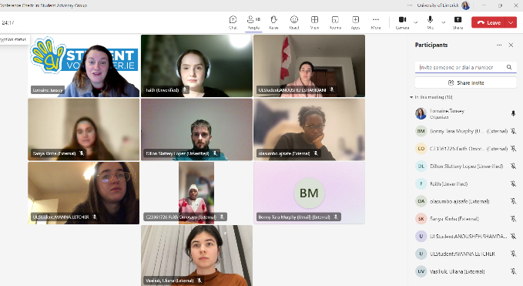  - Student Volunteer Ireland Programme Manager: Dr Lorraine Tansey
What resources did you need? | 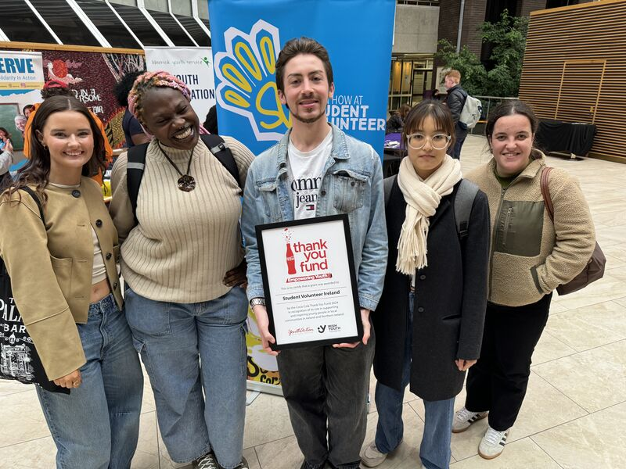  A significant challenge we faced was ensuring that we brought student voice to our decision-making and truly engaged students in our growth and development of student volunteering practice and policies.  - We applied for funding to the Irish Youth Foundation and were successful! This funding enabled us to run training workshops for student volunteers in 2024 and 2025 to take on the leadership role in our governance. This training is aimed at students that represent minority backgrounds.  Our core funding to provide StudentVolunteer.ie is an annual subscription membership from HEIs.
Has it been evaluated? How successful has it been? | Some Stats! Since inception StudentVolunteer.ie has been immediately successful in providing a dynamic space for students and voluntary groups:  - 1,515 Volunteer Involving Organisations have created accounts with us at StudentVolunteer.ie.  - 25,020 Students have created accounts with us at StudentVolunteer.ie to find volunteering opportunities, reflect on their experience and build their time bank for campus recognition.  - Over 2,000 volunteer projects have been shared at StudentVolunteer.ie as most Volunteer Involving Organisations repeatedly visit the platform and post more than one volunteer opportunity.  - Most students participate in more than one volunteer opportunity and visit the platform regularly to add to their volunteering portfolio and we have 29,025 student volunteering signups.  - 40,8799 hours of volunteering have been logged by students to their univeristy and wider communities.
Any future plans, including the sustainability of the initiative? | Our national Student Volunteer Ireland Conference is on the horizon bringing together students, community and higher education to grow and sustain our work.  Integrate Volunteering and Community engagement into the Curriculum: Embedding volunteering topics prepares society to address future challenges.  Community Engagement: Building partnerships with local communities and organizations can enhance the impact of student volunteering efforts and voice from the community.  Research and Innovation: Encouraging research that focuses on student volunteering challenges and solutions can drive innovation and contribute to our growth.  Financial Sustainability: Developing diverse funding sources, including grants, partnerships, and alumni contributions, ensures the long-term financial health of the programme.  Policy and Governance: Establishing clear policies and governance structures that prioritize student volunteering can guide decision-making and ensure recognition of invisible labour.  Student Involvement: Empowering students to lead volunteering projects and initiatives fosters a culture of sustainability and ensures that the next generation is actively engaged in these efforts.  Continuous Improvement: Regularly assessing and updating student volunteering practices ensures that the programme remains relevant and effective in addressing new challenges.
Key Learning Points | Student’s have and can continue to lead on campus Health initiatives on a voluntary basis. This is best supported and enabled through recognition, training and structure through the national frameworks at Student Volunteer Ireland. Growth and development of further voluntary health initiatives requires policy support and visibility.  StudentVolunteer.ie innovatively connects students with diverse volunteer opportunities, making a profound societal impact. This approach allows learners to engage directly with real-world challenges, applying theoretical knowledge in meaningful contexts. Collaborating with charities and non-profits not only enhances students' understanding of societal issues but also cultivates empathy and a sense of community. By working on projects that address actual needs, students develop problem-solving abilities, teamwork, and leadership skills, preparing them for future careers and civic engagement. This experiential learning model bridges the gap between classroom education and real-life application, making education more relevant and impactful.  We believe that the benefits of civic and community engagement are vital to our students, and we will work to ensure that those students that experience barriers to volunteering will share this transformative learning experience. This requires us to work together for national standards, for creative solutions to engagement through technology and research and collaboration. We have already made significant strides in our national strategy with the resourcing of our new governance, establishing the Advisory Group and a Programme Manager position - a powerful boost on our journey to mobilise 100,000 students to volunteer by 2026!

Healthy Campus Framework Categories (please tick all that apply)
Healthy Campus Process | Whole Campus Approach | Topic | Population Group
Commit ☐ | Leadership, Strategy & Governance ☒ | Alcohol ☐ | Students ☒
Coordinate ☒ | Campus Environment (Facilities & Services) ☐ | Substance Misuse ☐ | Staff ☒
Consult ☐ | Campus Culture & Communications ☐ | Healthy Eating / Food  ☐ | Wider community ☒
Create ☐ | Personal & Professional Development  ☐ | Mental Health & Wellbeing  ☒ | Other ☐
Celebrate & Continue ☒ |  | Sexual Health & Wellbeing  ☐
Tobacco Free Campus
☐

Physical Activity / Active Transport
☐

Wellbeing on the Curriculum (can also fall under ‘Personal & Professional Development)
☐

Health & Sustainability
☒

Other
☐

Contact Details
Contact Name/s | Dr Lorraine Tansey
Date | 12th February 2025
Email Address | Lorraine.tansey@ul.ie
Links | www.studentvolunteer.ie

