HEA Healthy Campus Case Study

HEALTHY CAMPUS CASE STUDY
Name of institution/ organisation | The Royal College of Surgeons in Ireland
Who led the initiative? | StEP project research team.
Date and timeframe of the initiative | January – March 2024 with plans to continue initiative and evaluation.
What was the reach of the initiative? | 15 medicine students of mixed stages, ages, genders, and ethnicities.
Initiative title | Exploring the Impact: Empowering Individuals in a Medical Education Institution with Mental Health First Aid Training
Aims / objectives | The aim of this initiative is to assess the feasibility of integrating Mental Health First Aid (MHFA) into the medicine curriculum at the Royal College of Surgeons in Ireland (RCSI). Since MHFA is currently part of the Year 3 undergraduate pharmacy curriculum, this initiative is exploring the potential of MHFA being incorporated into the medicine curriculum which could support medicine students in learning skills to support each other and future patients.  What are the considerations that impact the delivery of a Mental Health First Aid course to the medicine course at RCSI?  - What are the barriers as perceived by students in undertaking mental health first aid during their medical education?  - Delivering MHFA training during which year of the programme at RCSI provides the biggest improvement in helping behaviour, stigmatising attitudes, and confidence in addressing mental health crises?  - What is the long-term impact of MHFA in a medical cohort, and how does this impact differ by year?  - What suggestions do medical students have for tailoring MHFA to suit those with a medical background?  - What is the best time to incorporate MHFA training into the medical programme at RCSI?
The rationale for the action, including any identified health needs | Statistically, it is evident that individuals in the medical field, including both professionals and students, face a heightened risk of experiencing mental health issues. However, they are often less inclined to seek support and treatment, influenced by various factors. Despite the emphasis placed on Basic Life Support (BLS) training as a mandatory component of medical education, mental health training is either not prioritised or overlooked entirely.  Mental Health First Aid (MHFA) training equips practitioners with the skills to identify and address mental health emergencies and facilitate access to specialised support for those in need. The importance of these skills is equivalent to those acquired in Basic Life Support training, as they empower medical students to enhance their own mental well-being and provide support to both colleagues and patients.  This initiative was led and designed by two medicine students who identified a need for more mental health education within the medicine curriculum which focused on skill development to support each other and future patients with mental health challenges.
Identify all frameworks, policies, or strategies this initiative aligns to  (internal, local or national) | Healthy Campus Charter Ireland  Connecting for Life  Sharing the Vision: A Mental Health Policy for Everyone  Making Every Contact Count
Summary | This initiative was run as part of a student engagement project at RCSI between January – March 2024 which involved two medicine students as collaborators and leaders in the project design and goals. It also involved a collaboration between RCSI student welfare service, St John of God’s (SJOG) Hospital and Mental Health First Aid Ireland (MHFAI), along with a PhD researcher and senior academic who has experience of integrating this training into the MPharm programme as a mandatory component.  Ethics was applied for to be able to evaluate the training. The training was held at SJOG hospital in March with 15 medicine students of mixed ages, genders, and ethnicities. The instructors on the training were the PhD researcher who has experience delivering MHFA to MPharm students and an external MHFAI instructor.  The training was successful and positive outcomes were identified. All students felt they gained essential mental health communication skills from the training and that these were not skills they had previously learned on their medical training.  Students identified the need for the training to incorporate more information on cultural competencies within mental health, particularly due to the cultural diversity present at our institution.  We are in the process of identifying more opportunities to deliver MHFA training to the medicine student population, which has involved training more instructors in our institution to facilitate this. We will continue to evaluate the outcomes and consider the adaptations that may be necessary for this student population.
Did you collaborate with internal and/or external stakeholders to deliver? | This involved a collaboration between medicine students, student welfare service, SJOG, and PhD student and senior academic in the School of Pharmacy and Biomolecular Sciences.
How was the initiative organised? | The initiative was led by two final year medicine students who identified a need for more focused mental health skill development and education within the medicine curriculum. These students applied for a student engagement programme with this initiative which usually involves students and staff coming to together to conduct a research project together.  Staff members in student welfare, and PhD researcher and senior academic in School of Pharmacy and Biomolecular Sciences were identified to support the students in the facilitation of this project. The PhD researcher is also a trained MHFAI instructor and delivers this training on an annual basis to MPharm students. All members of the team met together to discuss aims and objectives of the project, agree on timelines and plan the deliverables of the project.  Contact was then made to MHFAI about the project, and the PhD researcher held a meeting with the manager of MHFAI to discuss the project and make plans for the training dates and coordination.  Contact was also made with the Chief Pharmacist in SJOG who is responsible for setting up MHFA in Ireland. They arranged the training location and supported in identifying a second instructor to facilitate the training.  The training was delivered on 26th and 27th March at SJOG hospital and included 15 students. Focus groups were then facilitated by the medical students, and this was presented to the student engagement ceremony in April.
What resources did you need? | Additional instructor, catering, provision of MHFA manuals, room booking.
Has it been evaluated? How successful has it been? | Evaluation is still on-going; however, the outcomes were positive and because approximately 70 students signaled their interest in this training, we are identifying more opportunities with medicine students to hold more MHFAI trainings and focus groups.  The training was successful and positive outcomes were identified. All students felt they gained essential mental health communication skills that would enable them to support their fellow students, and future patients through mental health challenges. The students identified that these were not skills they had previously learned on their medical training.  Students identified the need for the training to incorporate more information on cultural competencies within mental health, particularly due to the cultural diversity present at our institution.  We are identifying more opportunities to deliver MHFAI training to the medicine student population, which has involved training more instructors in our institution to facilitate this. We will continue to evaluate the outcomes and consider the adaptations that may be necessary for this student population.
Any future plans, including the sustainability of the initiative? | There are plans to hold more MHFA for medicine students in 2024 and 2025 and to evaluate the impact and identify opportunities for adaptation and integration of this training.
Key Learning Points | - Medical students are keen to engage with early intervention training on mental health.  - Medical students identify a gap in their medical curriculum relating to mental health skills, confidence, and knowledge.  - There is a need to expand on cultural competencies within mental health education.

Healthy Campus Framework Categories (please tick all that apply)
Healthy Campus Process | Whole Campus Approach | Topic | Population Group
Commit ☐ | Leadership, Strategy & Governance ☐ | Alcohol ☐ | Students ☒
Coordinate ☐ | Campus Environment (Facilities & Services) ☐ | Substance Misuse ☐ | Staff ☐
Consult ☒ | Campus Culture & Communications ☐ | Healthy Eating / Food  ☐ | Wider community ☐
Create ☒ | Personal & Professional Development ☒ | Mental Health & Wellbeing  ☒ | Other ☐
Celebrate & Continue ☐ |  | Sexual Health & Wellbeing  ☐
Tobacco Free Campus
☐
Physical Activity / Active Transport
☐
Wellbeing on the Curriculum (can also fall under ‘Personal & Professional Development)
☒
Health & Sustainability
☐
Other
☐

Contact Details
Contact Name/s | Zoe McCormack
Date | 14/05/24
Email Address | Zoemccormack22@rcsi.ie
Links | Please add links to any relevant pages/ documents. Please attach any items not in a link format with your submission.

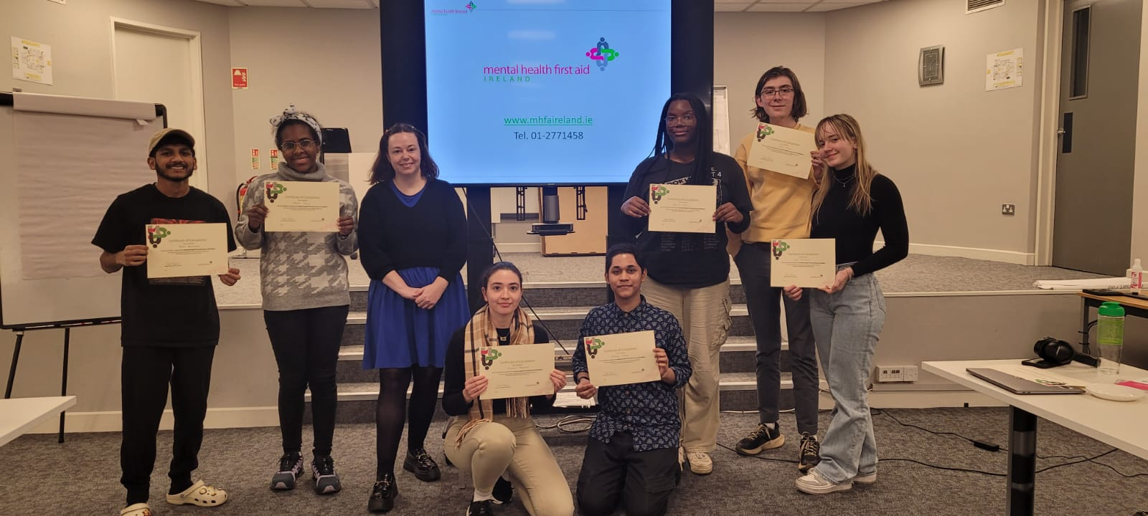
Some of the students who participated in the training on 26/27th March.

