HEA Healthy Campus Case Study Template 2026

NOTES FOR COMPLETION
Context
- Case studies should relate to your institution's progression of the following policies:
  - HEA Healthy Campus Charter and Framework
  - HEA Healthy Campus Self-Evaluation Tool
  - National Student Mental Health and Suicide Prevention Framework
  - The Limerick Framework for Action: Advancing the Health Promoting Campus Agenda
- Case studies can include a wide range of work including those relating to governance and oversight, planning, strategy, policy, research, implementation, as well as others.
- We encourage examples that also showcase the interaction of wellbeing and other areas for example sustainability, belonging, progression, teaching and learning.
Template
- Please be as concise and clear as possible and consider the use of bullet points to summarise information.
- All sections must be completed.
- Case studies should be written in the third person and anonymous when it comes to participants’ names.
- Case studies will be used as part of HEA communications including email, website, and social media.
Submission
- Please submit your case study to healthycampus@hea.ie by COB Friday, April 3rd for display at the 2026 Health and Wellbeing Conference.

HEALTHY CAMPUS CASE STUDY
- Project Title | Sober Sessions
- Institution/ Organisation | University of Limerick
- Who leads/ led the project? | Equally shared by Healthy UL, UL Student Life (Students Union - ULSL) and Irish World Academy of Music and Dance (WAMD)
- Date and timeframe | AY 25/26 and ongoing
- Population Group (tick all that apply) | - Students ☒  - Staff ☒  - Wider community ☐  - Other ☐
- Health Topic (tick all that apply) | - Alcohol ☒  - Substance Misuse ☒  - Healthy Eating / Food ☐  - Mental Health & Wellbeing ☒  - Sexual Health & Wellbeing ☐  - Tobacco/ Vape Free Campus ☐  - Physical Activity / Active Transport ☐  - Wellbeing and the Curriculum ☐  - Health & Sustainability ☐  - Other ☐

- Project Alignment

Use the categories below to highlight the alignment of the project with national policy. Please tick all that apply.

Limerick Framework for Action - 10 Actions  LFfA pg. 12 | Healthy Campus Process  HCCF pg. 4 | Whole Campus Approach  HC Tool pg. 8 | Principles of a Healthy Campus  HC Tool + HCCF | National Student Mental Health and Suicide Prevention Framework NSMHSPF
1.Ethos ☐ | Commit ☐ | Leadership, Strategy & Governance  (Pillar 1) ☐ | Participation ☒ | Lead ☐
2.Act ☐ | Coordinate ☐ | Campus Environment (Facilities & Services) (Pillar 2) ☒ | Partnership ☒ | Collaborate ☒
3.Localise ☐ | Consult ☒ | Campus Culture & Communications (Pillar 3) ☒ | Evidence Based ☐ | Educate ☐
4.Leadership ☐ | Create ☐ | Personal & Professional Development  (Pillar 4) ☐ | Sustainability (Longevity) ☐ | Engage ☐
5.Policies ☐ | Celebrate & continue ☒ | Health Focused Area (Pillar 5) ☒ |  | Identify ☐
6.Culture ☒ |  |  |  | Support ☐
7.Partnership ☒ |  |  |  | Respond ☐
8.Students ☐ |  |  |  | Transition ☐
9.Research ☐ |  |  |  | Improve ☐
10.Celebrate ☒

- Project Rationale | This initiative commenced in September 2025 to celebrate International Recovery Day on September 30th  Three persons at UL are trained in SMART Recovery facilitation. In addition to substance use harm reduction messaging and signposting to internal and external services, we wished to raise awareness about this alternative for people that are ‘sober curious’, wish to reduce their use, are in ‘active’ recovery and needing support, and/or looking for information and support as an affected family member/significant other/concerned peer.
- Aims and Objectives | - Celebrate recovery, regardless of where a person/family member/peer is on the recovery spectrum.  - Provide a pro-social, non-substance use, on-campus social event.  - Raise awareness about harm reduction and substance use services, on and off campus, including SMART recovery.  - Recognising that once-off events have low impact, create a wrap-around and sustained harm reduction and signposting awareness social media campaign throughout the Academic Year, in addition to providing ongoing training opportunities for students and staff.
- Project Overview/ Summary | - Project planning commenced in June 2025, with a three-member task-based working group (WG) (Healthy UL, ULSL, WAMD) setting out aims and objectives for the Academic Year. The WG met on ten occasions during June ’25 – March ’26.  - We are now planning for AY 26/27 and will explore forming a SMART Recovery group on campus. Three members of the UL campus community are trained as SMART recovery facilitators.  - The project comprised two events during the Academic Year, one at lunchtime (September 30th, 2025) in celebration of International Recovery Day, one at evening time (March 26th,2026).  - The events were held in the foyer of the new ULSL Student Centre.  - Free lunch (September) & mocktails (March) for participants.  - Social media campaigns preceding, during and following the events.  - Informal awareness raising - harm reduction information and signposting to campus-based and regional services including SMART recovery.  - Rolling PowerPoint presentation on big screen.  - Healthy UL, ULSL, MWRDAF & SMART recovery pull-ups with QR codes for sign posting.  - ULSL, Healthy UL and MWRDAF staff mingled informally to chat with students throughout the event.  - Live music provided by the UL student community.  - In total, 220 students actively engaged with us during the event - 60 in September and 160 in March.
- Collaboration | In addition to the joint collaboration with ULSL and the WAMD, he Midwest Regional Drug and Alcohol Forum (Task Force) collaborated on the two events to support awareness raising about services.  UL student volunteers and the UL Music Society supported the events.
- Resource Requirements | - Healthy UL provided funding for food for 40 people for event one, and Healthy UL and UL student life shared funding to provide mocktails for 120 people for event two.  - WAMD and UL Music Society volunteered their contribution to entertainment.  - MWRDAF provided attendance for free.  - UL Volunteers supported the event and received PVA hours.
- What are the next steps for the project? | The WG will continue to meet and plan similar events for AY 26/27.  UL is exploring the feasibility of facilitating a SMART Recovery group on campus.
- Key Learning Points | - Collaboration and partnership are key to successful Healthy Campus initiatives. In this initiative, the partners included Healthy UL, UL Student Life, and the WAMD, with support from the MWRDAF.  - The evening event attracted better engagement from students.  - Incentives work for engagement.  - Informal engagement (walking the room) works better than passive tables with information.  - Combine fun with low key exposure to substance use harm reduction and signposting awareness in a pro-social environment.  - Wrap-around social media messaging around an event.  - Plan initiatives based on local/regional/national policies & frameworks and on best practice evidence in the substance use intervention field.
- Images and Links | 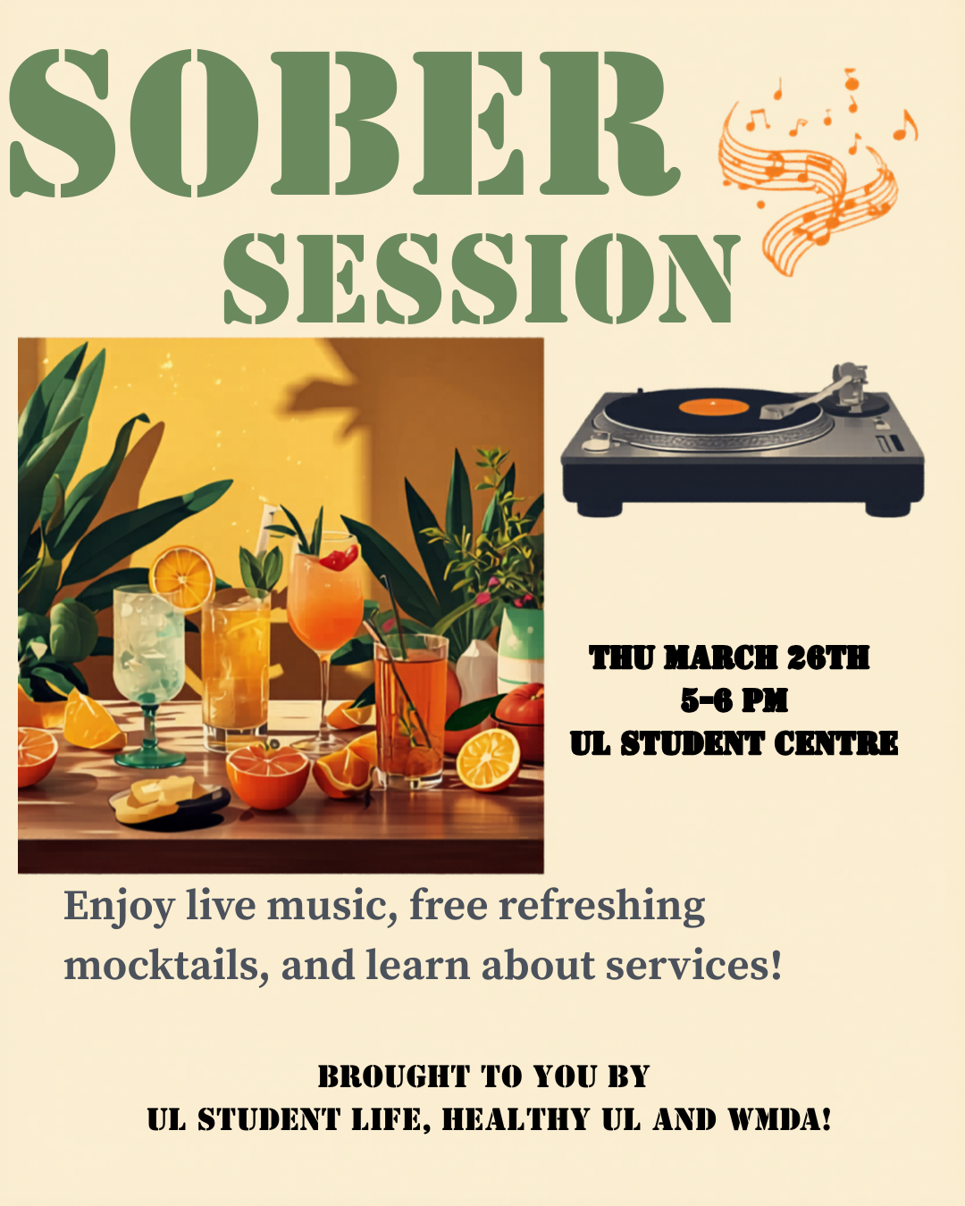  QR code for a link to a reel about the event  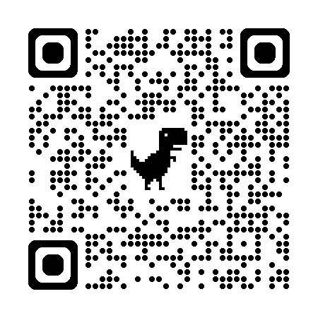

- Evaluation
How was the project evaluated?
Please check the box(es) that apply regarding the type of evaluation and data collection method
Type of Evaluation
Formative Evaluation: ☐  Conducted during development or early implementation to make improvements to the program design. | Process Evaluation: ☒  Assesses how the program is being implemented, including participation rates, quality of delivery, and whether it is reaching its target audience. | Outcome Evaluation: ☐  Focuses on the results—the changes in behaviors, attitudes, or conditions—at the end of a project. | Summative Evaluation: ☐  Assesses the overall effectiveness of a program after its completion to determine if it achieved its intended goals.
Data Collection Method
Survey/Questionnaire ☐  Document Review ☐ (project reports, financial data, attendance logs, etc.)  Direct Observations ☒ | Focus Groups ☐  Interviews ☐  Case Studies ☐  Other social media analytics__________
High-Level Outcome and Impact
Please include high-level outcomes and impact if not already covered in the summary above.

- Contact Details
Contact Name/s | Dr. Eva Devaney
Date | April 3rd, 2026
Email Address | eva.devaney@ul.ie

