HEA Healthy Campus Case Study Template 2026

NOTES FOR COMPLETION
Context
- Case studies should relate to your institution's progression of the following policies:
  - HEA Healthy Campus Charter and Framework
  - HEA Healthy Campus Self-Evaluation Tool
  - National Student Mental Health and Suicide Prevention Framework
  - The Limerick Framework for Action: Advancing the Health Promoting Campus Agenda
- Case studies can include a wide range of work including those relating to governance and oversight, planning, strategy, policy, research, implementation, as well as others.
- We encourage examples that also showcase the interaction of wellbeing and other areas for example sustainability, belonging, progression, teaching and learning.
Template
- Please be as concise and clear as possible and consider the use of bullet points to summarise information.
- All sections must be completed.
- Case studies should be written in the third person and anonymous when it comes to participants’ names.
- Case studies will be used as part of HEA communications including email, website, and social media.
Submission
- Please submit your case study to healthycampus@hea.ie by COB Friday, April 3rd for display at the 2026 Health and Wellbeing Conference.

HEALTHY CAMPUS CASE STUDY
- Project Title | Using experiential learning to design a sensory trail in the UCD Woodland – a collaboration with UCD Landscape Architecture
- Institution/ Organisation | University College Dublin
- Who leads/ led the project? | A collaboration between Healthy UCD and UCD Landscape Architecture
- Date and timeframe | Academic year 2024 (ongoing)
- Population Group (tick all that apply) | - Students ☒  - Staff ☒  - Wider community ☒  - Other ☐
- Health Topic (tick all that apply) | - Alcohol ☐  - Substance Misuse ☐  - Healthy Eating / Food ☐  - Mental Health & Wellbeing ☒  - Sexual Health & Wellbeing ☐  - Tobacco/ Vape Free Campus ☐  - Physical Activity / Active Transport ☒  - Wellbeing and the Curriculum ☐  - Health & Sustainability ☒  - Other ☐

- Project Alignment

Use the categories below to highlight the alignment of the project with national policy. Please tick all that apply.

Limerick Framework for Action - 10 Actions  LFfA pg. 12 | Healthy Campus Process  HCCF pg. 4 | Whole Campus Approach  HC Tool pg. 8 | Principles of a Healthy Campus  HC Tool + HCCF | National Student Mental Health and Suicide Prevention Framework NSMHSPF
1.Ethos ☒ | Commit ☐ | Leadership, Strategy & Governance  (Pillar 1) ☐ | Participation ☐ | Lead ☐
2.Act ☒ | Coordinate ☐ | Campus Environment (Facilities & Services) (Pillar 2) ☒ | Partnership ☒ | Collaborate ☐
3.Localise ☒ | Consult ☐ | Campus Culture & Communications (Pillar 3) ☐ | Evidence Based ☒ | Educate ☐
4.Leadership ☒ | Create ☒ | Personal & Professional Development  (Pillar 4) ☐ | Sustainability (Longevity) ☒ | Engage ☐
5.Policies ☒ | Celebrate & continue ☒ | Health Focused Area (Pillar 5) ☒ |  | Identify ☐
6.Culture ☒ |  |  |  | Support ☐
7.Partnership ☒ |  |  |  | Respond ☐
8.Students ☒ |  |  |  | Transition ☐
9.Research ☐ |  |  |  | Improve ☐
10.Celebrate ☐

- Project Rationale | The UCD EDI Neurodiversity Working Group was established in 2021 to better understand the campus climate in relation to neurodiversity, and to make recommendations that help make UCD a neurodiversity friendly environment for all in which to study and work.  The “Making UCD a Neurodiversity Friendly Campus” Research Report was launched in April 2024. This report provided a list of 31 recommendations, one of which was to “Identify opportunities to develop more inclusive sensory physical environments including indoor and outdoor quiet spaces and sensory spaces in collaboration with key stakeholders.”  Fostering inclusion is also one of the 3 key attributes of the UCD Breaking Boundaries Strategy to 2030.  A campus can often feel overwhelming, leading some individuals to engage in sensory avoidance—seeking escape from overstimulation. Sensory spaces offer a gentle, engaging alternative by creating spaces designed to stimulate one or more of the senses. These spaces invite visitors to interact—by observing plants up close, reaching out to touch textures, inhaling fragrances, listening to natural and crafted sounds, and fully immersing themselves in a multi-sensory experience.  With dedicated indoor space difficult to secure for sensory spaces, Healthy UCD wanted to explore how the existing 40 acres of woodland in UCD could be utilised to provide a clearly identifiable sensory trail that staff, students and the wider community could enjoy and benefit from.
- Aims and Objectives | The aim of the project was to collaborate with UCD Landscape Architecture to explore the potential of the UCD woodlands to develop a sensory trail. UCD Access and Lifelong Learning had already developed several small sensory spaces on campus and had set a precedent for this type of development.  The objective of the project was to develop an overall design concept that could be used to secure funding for project implementation through the UCD Foundation, an independent registered charity that works to advance the strategic goals and objectives of UCD.
- Project Overview/ Summary | - Healthy UCD collaborated with students from UCD Landscape Architecture (Socio-Environmental Studies module) from September-December 2024 to explore how the UCD woodland might be developed to include additional sensory spaces.  - Healthy UCD facilitated sessions with the students each week of term, with presentations from the various stakeholders helping to inform their work.  - The students presented an overview of their designs to the key stakeholders in Spring 2025.  - Healthy UCD and UCD Landscape Architecture collated the designs and presented them to the UCD Foundation in Summer 2025, to discuss the potential for funding. The project concept was well received by the UCD Foundation, who advised the team to (a) secure a potential site for the sensory trail on campus and (b) to develop the students designs into one overarching design concept.  - Healthy UCD and the incoming group of students from the UCD Landscape Architecture Socio-Environmental Studies module 2025/2026 met with UCD Estates Services in Spring 2026 to identify suitable areas for the sensory trail within the UCD Woodlands.  - The students are currently developing the work of the previous group to design an overall concept, including costs, for the sensory trail, based on the site identified within the UCD woodland.
- Collaboration | Key stakeholders for the project include Healthy UCD, UCD Landscape Architecture (Socio-environmental Studies elective module), UCD estates, UCD EDI Neurodiversity Group, UCD Sustainability, UCD Access and Lifelong Learning, the UCD Foundation and Neurodiversity Ireland.
- Resource Requirements | Significant funding will be required to deliver this project
- What are the next steps for the project? | Following the completion of the design for the sensory trail, funding will be sought through the UCD Foundation. If successful, the project will then go through the standard procurement process to acquire the relevant services, whilst ensuring the co-design with the students continues through to project delivery.
- Key Learning Points | - Collaborating with faculty on campus provides an opportunity for experiential learning within the curriculum, where students can apply what they are learning in a practical way and feel like they can make an impact  - Taking time to identify and engage with all of the relevant stakeholders, both internally and externally, is key to project success  - Patience is required as it can take time to develop concepts, engage with stakeholders and secure the relevant approval and required funding  Some of the reflections from the students:  “This project was a fascinating challenge and an opportunity to explore how inclusive design can intertwine with environmental sustainability.”  “The project flexibility encouraged us to think critically and creatively, tailoring our approaches to address the unique challenges and potential solutions we identified.”  “Too often, we rush through life without pausing to simply sit and be still. Our designs aimed to provide moments of respite: a hammock or basket swing for gazing at the sky, wind chimes crafted from repurposed items gently ringing above, or symbols encouraging interaction with the mature woodland trees around the campus.”
- Images and Links | https://www.ucd.ie/equality/support/neurodiversity/report/  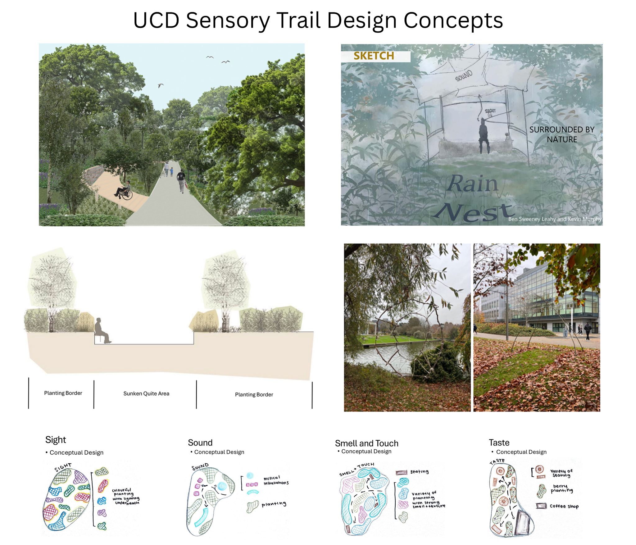

- Evaluation
How was the project evaluated?
Please check the box(es) that apply regarding the type of evaluation and data collection method
Type of Evaluation
Formative Evaluation: ☒  Conducted during development or early implementation to make improvements to the program design. | Process Evaluation: ☐  Assesses how the program is being implemented, including participation rates, quality of delivery, and whether it is reaching its target audience. | Outcome Evaluation: ☐  Focuses on the results—the changes in behaviors, attitudes, or conditions—at the end of a project. | Summative Evaluation: ☒  Assesses the overall effectiveness of a program after its completion to determine if it achieved its intended goals.
Data Collection Method
Survey/Questionnaire ☐  Document Review ☒ (project reports, financial data, attendance logs, etc.)  Direct Observations ☐ | Focus Groups ☐  Interviews ☐  Case Studies ☐  Other____________
High-Level Outcome and Impact
Utilising the outdoor space on the UCD campus to provide a place where students, staff and the entire community can benefit from the grounding effects of nature and take a break from the hustle and bustle of a busy campus environment.

- Contact Details
Contact Name/s | Mags Carey
Date | 1/4/2026
Email Address | mags.carey@ucd.ie

