HEA Healthy Campus Case Study Template 2026

NOTES FOR COMPLETION
Context
- Case studies should relate to your institution's progression of the following policies:
  - HEA Healthy Campus Charter and Framework
  - HEA Healthy Campus Self-Evaluation Tool
  - National Student Mental Health and Suicide Prevention Framework
  - The Limerick Framework for Action: Advancing the Health Promoting Campus Agenda
- Case studies can include a wide range of work including those relating to governance and oversight, planning, strategy, policy, research, implementation, as well as others.
- We encourage examples that also showcase the interaction of wellbeing and other areas for example sustainability, belonging, progression, teaching and learning.
Template
- Please be as concise and clear as possible and consider the use of bullet points to summarise information.
- All sections must be completed.
- Case studies should be written in the third person and anonymous when it comes to participants’ names.
- Case studies will be used as part of HEA communications including email, website, and social media.
Submission
- Please submit your case study to healthycampus@hea.ie by COB Friday, April 3rd for display at the 2026 Health and Wellbeing Conference.

HEALTHY CAMPUS CASE STUDY
- Project Title | Jumpstart Your Success: Everyday Matters [Wellbeing and the Curriculum Project]
- Institution/ Organisation | University College Cork
- Who leads/ led the project? | Dr. Eithne Hunt, Department of Occupational Science and Occupational Therapy
- Date and timeframe | 2025 - 2028
- Population Group (tick all that apply) | - Students ☒  - Staff ☐  - Wider community ☐  - Other ☐
- Health Topic (tick all that apply) | - Alcohol ☐  - Substance Misuse ☐  - Healthy Eating / Food ☐  - Mental Health & Wellbeing ☒  - Sexual Health & Wellbeing ☐  - Tobacco/ Vape Free Campus ☐  - Physical Activity / Active Transport ☐  - Wellbeing and the Curriculum ☒  - Health & Sustainability ☐  - Other ☐

- Project Alignment

Use the categories below to highlight the alignment of the project with national policy. Please tick all that apply.

Limerick Framework for Action - 10 Actions  LFfA pg. 12 | Healthy Campus Process  HCCF pg. 4 | Whole Campus Approach  HC Tool pg. 8 | Principles of a Healthy Campus  HC Tool + HCCF | National Student Mental Health and Suicide Prevention Framework NSMHSPF
1.Ethos ☐ | Commit ☐ | Leadership, Strategy & Governance  (Pillar 1) ☐ | Participation ☒ | Lead ☒
2.Act ☒ | Coordinate ☐ | Campus Environment (Facilities & Services) (Pillar 2) ☐ | Partnership ☒ | Collaborate ☒
3.Localise ☒ | Consult ☐ | Campus Culture & Communications (Pillar 3) ☐ | Evidence Based ☒ | Educate ☐
4.Leadership ☐ | Create ☐ | Personal & Professional Development  (Pillar 4) ☒ | Sustainability (Longevity) ☒ | Engage ☒
5.Policies ☐ | Celebrate & continue ☐ | Health Focused Area (Pillar 5) ☒ |  | Identify ☒
6.Culture ☒ |  |  |  | Support ☒
7.Partnership ☐ |  |  |  | Respond ☐
8.Students ☒ |  |  |  | Transition ☒
9.Research ☒ |  |  |  | Improve ☒
10.Celebrate ☒

- Project Rationale | “The curriculum is important to mental health and wellbeing because it is one of the few guaranteed points of contact between students and the university. The curriculum is central to the student experience, providing focus, structure, engagement, connection and purpose. If universities are to take mental health and wellbeing seriously, the role of the curriculum must be core to their response.”  UK Education for Mental Health Toolkit (2022) funded by the UK Office for Students  The curriculum is specifically named within the pillars deemed essential for implementing the Healthy Campus Charter and Framework. Curricular approaches to wellbeing are a vital part of a continuum of supports across universal (‘good for all’), targeted (‘necessary for some’) and intensive tiers (‘essential for a few’).
- Aims and Objectives | - A three-year Wellbeing and the Curriculum project is underway in UCC supported by Higher Education Authority Mental Health funding and sponsored by the Deputy President & Registrar and the Director of Student Experience.  - The overall aim of the Wellbeing and the Curriculum project is to reduce and/or prevent mental distress and promote wellbeing and academic success amongst UCC students by delivering and evaluating a novel curricular/co-curricular approach to wellbeing for UCC students - Everyday Matters: Healthy Habits for University Life®.  - In one strand of this project, in 2025-2026, first-year students in selected UCC modules had the opportunity to 'learn to be well' so they could 'be well to learn' by completing Jumpstart Your Success: Everyday Matters.
- Project Overview/ Summary | - Jumpstart Your Success: Everyday Matters is a bespoke, self-paced online unit [approximately one lecture period] available to nominated programmes/modules on students’ Canvas dashboards and signposted by academic staff within these identified modules.  - The idea is that this material is presented to students as core curricular content rather than supplementary content so that students perceive it as part of their programme of study and not an ‘add-on’.  - Almost 2,400 first-year students were enrolled on the unit in this first year of delivery.  - Twenty-two percent (n= 531) logged on to the unit, of whom 300 (56%) completed the unit in full.  - Module-level completions ranged from 0% to 81% (average 13%), with significant variation in engagement across disciplines.  - Logins (female n = 396/75%; male n = 128/25%) and completions (female n = 226/77%; male n = 68/23%) varied significantly by gender.  - One hundred and eighteen students recorded feedback at the end of the unit. Fifty-four percent (n=63) agreed and 39% (n=46) strongly agreed that they would recommend Jumpstart Your Success: Everyday Matters to other students.
- Collaboration | A multi-stakeholder expert advisory panel was established to maximise staff and student engagement in the project, facilitate alignment of the project's activities with other internal university strategic commitments and external sector developments, offer strategic advice on the implementation of the project, and  to support the translation of project outputs into meaningful and sustainable change across the institution. Membership includes Students’ Union officers; Healthy Campus officer; academic staff from each of the 4 Colleges, professional services colleagues including from Teaching & Learning, Peer Support, Library, Careers, Access; policy advisor from Department of Health; national Healthy Campus coordinator; National Tertiary Programme and an external academic.
- Resource Requirements | - The project lead designed the one-unit course and worked with IT colleagues to host it on the university's virtual learning environment Canvas.  - Programme leaders are invited to identify one lecture period early in semester I in year I for students to engage in the unit.  - Academic staff then embedded/signposted to the unit in their regular curriculum.  - The project lead is evaluating and refining the unit.
- What are the next steps for the project? | - Following student consultation, the unit’s name will change to Finding Your Feet at UCC for 2026/2027.  - In 2026/2027 the target is for 50% of all academic programmes across UCC to embed the unit within a module (and 100% programmes in 2027/2028).  - The content will be further refined to simplify some points on resilience and to amplify the message that “savvy students use supports”.  - The unit is being made more interactive and visually appealing using Articulate Rise software.  - Tips from 100 students will be incorporated throughout to amplify the student voice and enhance engagement.  - Signposting resources will be available to programme leaders/professional services colleagues on a SharePoint site.  - Agreements are now in place for signposting to each programme class cohort by assigned UCC Peer Support Leaders and UCC Students’ Union class representatives.  - The unit will be promoted in the new student app Goin’ and in materials sent to students upon acceptance of their college place, alongside promotion via the expert advisory panel members’ respective units.
- Key Learning Points | - The feedback provided by students who completed the unit is overwhelmingly positive.  - Personal recommendations from lecturers and protected in-class time to engage in the content were influential in increasing engagement.  - Academic buy-in is critical. The influence of programme/module leaders is key to increasing student logins, while the unit's design is key to maintaining student engagement through completion.  - Academic colleagues expressed an interest in more information/training on the content.  - Staff noted that there is a lot of pressure to communicate core information to students at the start of the academic year. Further thought needs to be given to the sequence and timing of key academic and personal support and wellbeing at different time points along the students’ college journey.  - Significant gender differences across male and female students’ logins and completions were observed.  - Students sought more interactive elements in the unit and less video content.  - There is a tension between creating frictionless pathways for students to progress through the content and capturing user completion and experience data. Canvas's data analytics functionality is limited. Full ethical approval and informed consent are required for a robust evaluation. However, this introduces the need for necessary but potentially distracting consent processes.  - Some academic colleagues felt that this content should be a mandatory element of modules. This requires careful consideration.
- Images and Links | 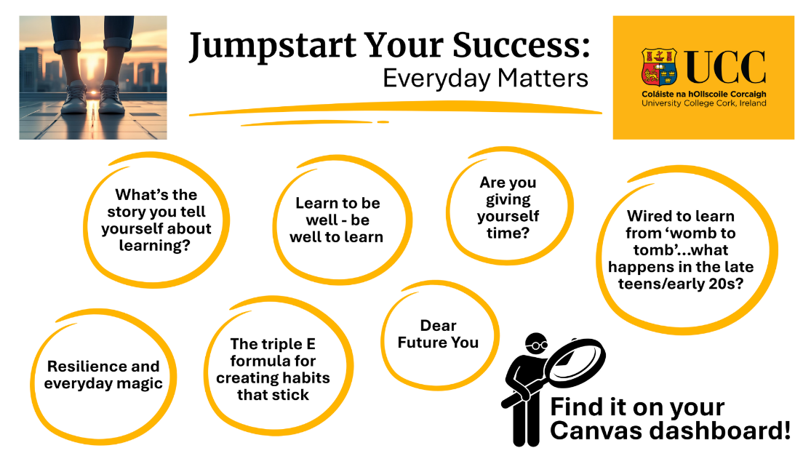  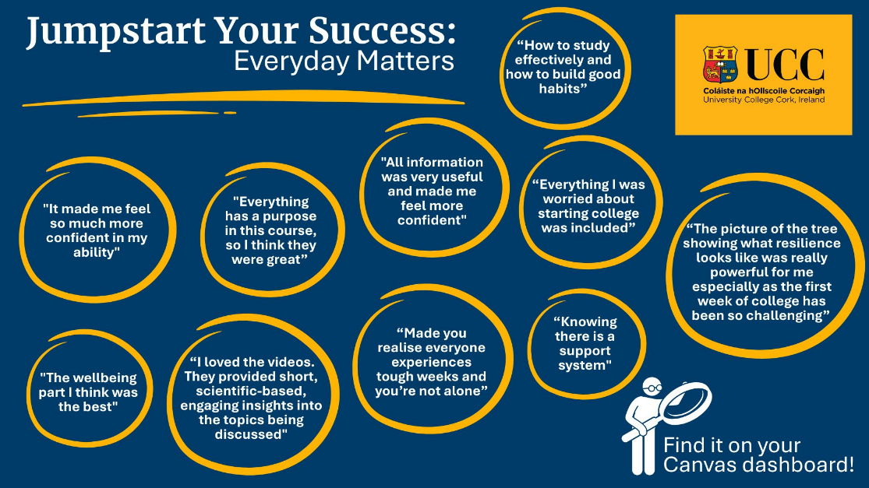

- Evaluation
How was the project evaluated?
Please check the box(es) that apply regarding the type of evaluation and data collection method
Type of Evaluation
Formative Evaluation: ☒  Conducted during development or early implementation to make improvements to the program design. | Process Evaluation: ☒  Assesses how the program is being implemented, including participation rates, quality of delivery, and whether it is reaching its target audience. | Outcome Evaluation: ☒  Focuses on the results—the changes in behaviors, attitudes, or conditions—at the end of a project. | Summative Evaluation: ☐  Assesses the overall effectiveness of a program after its completion to determine if it achieved its intended goals.
Data Collection Method
Survey/Questionnaire ☒  Document Review ☒ (project reports, financial data, attendance logs, etc.)  Direct Observations ☐ | Focus Groups ☐  Interviews ☐  Case Studies ☒  Other: World Café, data analytics, student reflections
High-Level Outcome and Impact
The innovative Jumpstart Your Success: Everyday Matters unit delivers key mental health literacy information to students at the beginning of their university journey, supports a culture of ‘resourced resilience’ among students and staff, and highlights wellbeing as central to learning. This unit and the wider Wellbeing and the Curriculum project advances UCC’s strategic goals on student success and wellbeing, in line with national and international policy and best practice.

- Contact Details
Contact Name/s | Dr. Eithne Hunt
Date | 31.03.26
Email Address | e.hunt@ucc.ie

