E-SHEILD Enabling Students and Higher Education Institutions to Lead the response on Drugs.
University College Cork

HEA Healthy Campus Case Study Template 2026

NOTES FOR COMPLETION
Context
- Case studies should relate to your institution's progression of the following policies:
  - HEA Healthy Campus Charter and Framework
  - HEA Healthy Campus Self-Evaluation Tool
  - National Student Mental Health and Suicide Prevention Framework
  - The Limerick Framework for Action: Advancing the Health Promoting Campus Agenda
- Case studies can include a wide range of work including those relating to governance and oversight, planning, strategy, policy, research, implementation, as well as others.
- We encourage examples that also showcase the interaction of wellbeing and other areas for example sustainability, belonging, progression, teaching and learning.
Template
- Please be as concise and clear as possible and consider the use of bullet points to summarise information.
- All sections must be completed.
- Case studies should be written in the third person and anonymous when it comes to participants’ names.
- Case studies will be used as part of HEA communications including email, website, and social media.
Submission
- Please submit your case study to healthycampus@hea.ie by COB Friday, April 3rd for display at the 2026 Health and Wellbeing Conference.

HEALTHY CAMPUS CASE STUDY
- Project Title | E-SHEILD : Enabling Students and Higher Education Institutions to Lead the response on Drugs.
- Institution/ Organisation | University College Cork
- Who leads/ led the project? | ESHEILD Project Team (School of Applied Psychology, Cork University Business School, School of Public Health, Dept. Student Health).
- Date and timeframe | 2025 - ongoing
- Population Group (tick all that apply) | - Students ☒  - Staff ☒  - Wider community ☐  - Other ☐
- Health Topic (tick all that apply) | - Alcohol ☐  - Substance Misuse ☒  - Healthy Eating / Food ☐  - Mental Health & Wellbeing ☐  - Sexual Health & Wellbeing ☐  - Tobacco/ Vape Free Campus ☐  - Physical Activity / Active Transport ☐  - Wellbeing and the Curriculum ☐  - Health & Sustainability ☐  - Other ☐

- Project Alignment

Use the categories below to highlight the alignment of the project with national policy. Please tick all that apply.

Limerick Framework for Action - 10 Actions  LFfA pg. 12 | Healthy Campus Process  HCCF pg. 4 | Whole Campus Approach  HC Tool pg. 8 | Principles of a Healthy Campus  HC Tool + HCCF | National Student Mental Health and Suicide Prevention Framework NSMHSPF
1.Ethos ☒ | Commit ☐ | Leadership, Strategy & Governance  (Pillar 1) ☐ | Participation ☒ | Lead ☐
2.Act ☒ | Coordinate ☐ | Campus Environment (Facilities & Services) (Pillar 2) ☒ | Partnership ☒ | Collaborate ☐
3.Localise ☒ | Consult ☐ | Campus Culture & Communications (Pillar 3) ☒ | Evidence Based ☒ | Educate ☐
4.Leadership ☒ | Create ☐ | Personal & Professional Development  (Pillar 4) ☒ | Sustainability (Longevity) ☒ | Engage ☐
5.Policies ☒ | Celebrate & continue ☐ | Health Focused Area (Pillar 5) ☒ |  | Identify ☐
6.Culture ☒ |  |  |  | Support ☐
7.Partnership ☒ |  |  |  | Respond ☐
8.Students ☒ |  |  |  | Transition ☐
9.Research ☒ |  |  |  | Improve ☐
10.Celebrate ☒

- Project Rationale | The ESHEILD project was developed to address the prevalence of drug use and associated harms among higher-education students in Ireland. The Drug Use in Higher Education in Ireland (DUHEI) study revealed that many students engage in substance use, often experiencing negative health, academic, and social consequences. Prior institutional responses were inconsistent and fragmented, and did not consistently take a whole campus approach, highlighting the need for a coordinated, evidence-informed approach.  ESHEILD combines behavioural science, digital innovation, and institutional support to reduce harms. The MyUSE platform delivers personalised, interactive guidance to promote safe behaviours and informed decision-making, while the ESHEILD project supports HEIs in implementing the national Framework for Response to Illicit Substances, including policy development, student engagement, and collaboration with community stakeholders. By integrating research, education, and institutional culture change, ESHEILD seeks to create safer, more supportive campus environments, reducing the health, social, and academic impacts of student drug use while promoting harm reduction across Irish higher education.
- Aims and Objectives | Two key aims of the ESHEILD project are to provide the MyUse program, a digitally delivered drug harm reuction programme to 150 000+ students. The second aim is to provide HEIs with guidance to align with the national Framework for Response to the Use of Illicit Substances in Higher Education. This Framework assists institutions in developing actionable policies, implementing educational and preventative strategies, and establishing monitoring mechanisms to evaluate the effectiveness of interventions.  The project’s objectives are :  - Provide a digitally delivered harm reduction intervention to150 000 students. Provide comprehensive support to Irish Higher Education Institutions (HEIs) in adopting tailored drug and alcohol policies and action plans that reflect the specific needs of their student populations.  - Promote evidence-based, digital interventions that improve student awareness, encourage safer behaviours, and provide accessible support for those at risk.  - Strengthen collaboration between HEIs, local stakeholders, and regional Drug and Alcohol Task Forces  - Focuses on monitoring and evaluation, enabling continuous improvement and sustained effectiveness of harm-reduction initiatives across campuses.  Through these aims and objectives, the ESHEILD project represents a comprehensive, research-driven approach to addressing the challenges of student drug use while promoting wellbeing, safety, and informed decision-making in higher education.
- Project Overview/ Summary | ESHEILD is a comprehensive, multi-component initiative that combines digital interventions, institutional support, and community collaboration.  Its planning is grounded in evidence, stakeholder consultation, and national policy alignment. Its implementation embeds both student-focused behavioural interventions and systemic institutional strategies. Its evaluation ensures continuous improvement, sustainability, and the capacity to reduce drug-related harms effectively across 6 campuses, engaging with more than 150 000 students.  Planning Phase  The project was designed to respond to high prevalence of student drug use and associated harms identified by the Drug Use in Higher Education Survey (2022). Prior efforts lacked evidence-based frameworks. The objectives of ESHEILD are to  - Reduce drug-related harms among higher-education students.  - Enhance institutional capacity to implement evidence-informed, student-centred harm-reduction strategies.  - Promote awareness, education, and supportive environments for all students.  The development of ESHEILD was guided by the national Framework for Response to the Use of Illicit Substances in Higher Education, and this was integrated with behavioural science frameworks to inform intervention design.  Implementation Phase  - Six higher education institutions are receiving access to MyUse, a digital harm-reduction Intervention that provides an interactive, personalised, evidence-based tool for students. MyUse provides student support based on their individual experiences, risk levels, and decision-making contexts.  - ESHEILD provides support to HEIs in developing institution-specific drug and alcohol policies and action plans. It provides leadership guidance, staff training, and student engagement strategies to embed harm reduction into campus culture.  - Community Collaboration: Partnerships with local student health and support services, and regional Drug & Alcohol Task Forces.  Monitoring & Assessment:  - Ongoing evaluation of MyUSE platform engagement, usability, and impact on student behaviour.  - Institutional assessment of policy implementation, action plan execution, and alignment with the national Framework and aligned with Health Campus Charter and Framework.
- Collaboration | The ESHEILD Project is collaborating with 6 higher education institutions to developer MyUse and enhance institutional capacity to implement evidence-informed, student-centred harm-reduction strategies. The HEIs who will receive MyUse and ESHEILD support are University College Cork, University of Limerick, University College Dublin, South East Technological University, Atlantic Technological University and Trinity College Dublin. Al HEIs will be able to avail of the supports and guidance from ESHEILD in relation to implementing the national Framework for Response to the Use of Illicit Substances in Higher Education.  The ESHEILD Project includes an Executive Oversight Group, and also a National Implementation Group that will function as a community of practice to foster collaboration and knowledge sharing among HEIs in relation to reducing harms associated with drug use for students.
- Resource Requirements | The project is funded by the Department of Health under its Prevention and Education Funding Programme to reduce drug-related harm among higher education students.
- What are the next steps for the project? | The findings and actions of the ESHEILD project will be used to provide direction, guidance and evidence for HEIs to reduces harms associated with drug use for students in higher education. Based on monitoring and evaluation, the ESHEILD will provide evidence of drug use patterns across HEIs, deliver a drug harm intervention programme to 150000+ students as well as providing HEIs with support to implement actions to address drug harms across HEI campuses.
- Key Learning Points | The ESHEILD project will run until 2027, and is currently in progress.  Observations to date are that successful harm-reduction initiatives require both student-centred interventions and strong institutional commitment. Digital tools like the MyUSE platform can effectively engage students, raise awareness, and promote safer behaviours, but their impact is maximised when HEIs embed harm-reduction principles into campus culture, adopt clear policies, and invest in staff training.  Several aspects have contributed to ESHEILD level of success to date, these include :  - Early engagement with stakeholders including students, student groups, staff, and community partners.  - A combination of individual-focused interventions with systemic approaches, linking digital tools with institutional policies and support services.  - Grounding the project in evidence and behavioural theory to focus on drug harm reduction as relevant to students in higher education.  - Consider actions to embed practices into institutional structures and ensuring resources and monitoring mechanisms are in place.
- Images and Links | Please include 1/2 images related to the project, this can include document cover pages, logos, a picture of a team meeting etc. Please include links to webpages/ documents related to the project.  https://esheild.ie/ 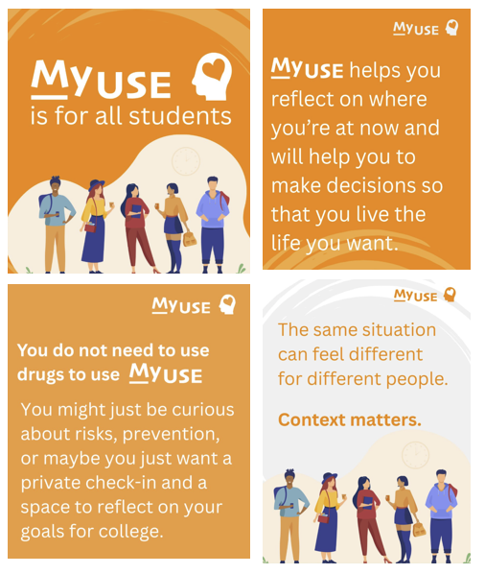  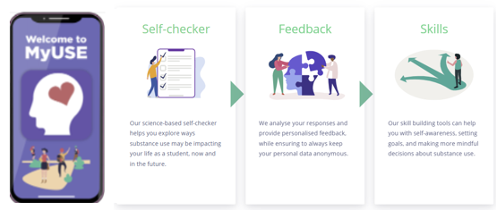

- Evaluation
How was the project evaluated?
Please check the box(es) that apply regarding the type of evaluation and data collection method
Type of Evaluation
Formative Evaluation: ☒  Conducted during development or early implementation to make improvements to the program design. | Process Evaluation: ☒  Assesses how the program is being implemented, including participation rates, quality of delivery, and whether it is reaching its target audience. | Outcome Evaluation: ☒  Focuses on the results—the changes in behaviors, attitudes, or conditions—at the end of a project. | Summative Evaluation: ☒  Assesses the overall effectiveness of a program after its completion to determine if it achieved its intended goals.
Data Collection Method
Survey/Questionnaire ☒  Document Review ☒ (project reports, financial data, attendance logs, etc.)  Direct Observations ☐ | Focus Groups ☐  Interviews ☐  Case Studies ☐  Other____________
High-Level Outcome and Impact
Please include high-level outcomes and impact if not already covered in the summary above.

- Contact Details
Contact Name/s | Prof. Samantha Dockray
Date | 03 April 2026
Email Address | s.dockray@ucc.ie

