HEA Healthy Campus Case Study Template 2026

NOTES FOR COMPLETION
Context
- Case studies should relate to your institution's progression of the following policies:
  - HEA Healthy Campus Charter and Framework
  - HEA Healthy Campus Self-Evaluation Tool
  - National Student Mental Health and Suicide Prevention Framework
  - The Limerick Framework for Action: Advancing the Health Promoting Campus Agenda
- Case studies can include a wide range of work including those relating to governance and oversight, planning, strategy, policy, research, implementation, as well as others.
- We encourage examples that also showcase the interaction of wellbeing and other areas for example sustainability, belonging, progression, teaching and learning.
Template
- Please be as concise and clear as possible and consider the use of bullet points to summarise information.
- All sections must be completed.
- Case studies should be written in the third person and anonymous when it comes to participants’ names.
- Case studies will be used as part of HEA communications including email, website, and social media.
Submission
- Please submit your case study to healthycampus@hea.ie by COB Friday, April 3rd for display at the 2026 Health and Wellbeing Conference.

HEALTHY CAMPUS CASE STUDY
- Project Title | Student Wellbeing Week
- Institution/ Organisation | TU Dublin
- Who leads/ led the project? | Student Health Centres, Engagement, Collaborative Event of Stakeholders in TU Dublin
- Date and timeframe | 23rd – 26th March 2026 across 5 campuses, annual event
- Population Group (tick all that apply) | - Students ☒  - Staff ☐  - Wider community ☐  - Other ☐
- Health Topic (tick all that apply) | - Alcohol ☒  - Substance Misuse ☒  - Healthy Eating / Food ☒  - Mental Health & Wellbeing ☒  - Sexual Health & Wellbeing ☒  - Tobacco/ Vape Free Campus ☒  - Physical Activity / Active Transport ☒  - Wellbeing and the Curriculum ☐  - Health & Sustainability ☒  - Other ☐

- Project Alignment

Use the categories below to highlight the alignment of the project with national policy. Please tick all that apply.

Limerick Framework for Action - 10 Actions  LFfA pg. 12 | Healthy Campus Process  HCCF pg. 4 | Whole Campus Approach  HC Tool pg. 8 | Principles of a Healthy Campus  HC Tool + HCCF | National Student Mental Health and Suicide Prevention Framework NSMHSPF
1.Ethos ☒ | Commit ☒ | Leadership, Strategy & Governance  (Pillar 1) ☒ | Participation ☒ | Lead ☒
2.Act ☒ | Coordinate ☒ | Campus Environment (Facilities & Services) (Pillar 2) ☒ | Partnership ☒ | Collaborate ☒
3.Localise ☒ | Consult ☒ | Campus Culture & Communications (Pillar 3) ☒ | Evidence Based ☒ | Educate ☒
4.Leadership ☒ | Create ☒ | Personal & Professional Development  (Pillar 4) ☒ | Sustainability (Longevity) ☒ | Engage ☒
5.Policies ☒ | Celebrate & continue ☒ | Health Focused Area (Pillar 5) ☒ |  | Identify ☒
6.Culture ☒ |  |  |  | Support ☒
7.Partnership ☒ |  |  |  | Respond ☒
8.Students ☒ |  |  |  | Transition ☒
9.Research ☒ |  |  |  | Improve ☒
10.Celebrate ☒

- Project Rationale | To provide students with opportunities to engage in wellbeing activities and heighten awareness of wellbeing supports available.
- Aims and Objectives | To promote and provide students with a greater understanding of the support services in TU Dublin, that can help to prepare them for exams and minimise exam stress.  To highlight the available resources that can enhance student wellbeing including on campus, locally and online, paying particular attention to low-cost ventures.  To allow students explore new options for self-care and wellbeing facilitated through a display of initiatives and supports available on each campus in addition to participant workshops and stands including Mindfulness, Art Therapy, Sports, Sun Smart, Quit Smoking/Vaping, Alcohol Awareness, Music, Dog Therapy, Financial Aid advice, Exam Support, Counselling, Blood Pressure Checks, Diet & Nutrition, Breakfast Smoothies and Granola/Fruit Bowls, Fun Runs/Walks, Volunteering, Felt Making, Campus Clean Ups, Breathing, Massage, Magician, DJ, Kite Making & Ice Cream Van.
- Project Overview/ Summary | - Planning commenced in December with bi-monthly meetings of the collaborative calendar group composed of Health & Wellbeing providers/stakeholders in the University from across the 5 campuses. Minutes and actions were recorded of each meeting.  - The collaborative calendar group acted as the steering group with leadership by Student Health Centres and Engagement  - Internal stakeholders included Student Health Centres, Counsellors, Volunteering, Healthy Campus, Chaplains, Estates, Careers Guidance, Exams Support, Sexual Health, Sport, Financial Support, Culinary Arts, DJ Society, Clubs & Societies, Students Union, Media Course Students  - External stakeholders invited to participate included HSE & Slaintecare, Sun Smart, Healthy Food Made Easy, Volunteering Organisations, Dog Therapy, Jigsaw  - An excel spreadsheet was used to capture meeting feedback and to record planning and logistical arrangements and people responsible  - The event was promoted via the University website, social media, campus screens, newsletters 3 weeks prior to the event to students  - Each campus was allocated a day for the event which ran from 11am to 2.30pm each day with video’s and photographs taken by Media students.  - The event was evaluated using engagement forms including a count of participant engagements per initiative/event, quiz and organisation feedback from steering group and participants on how to improve the event going forward.
- Collaboration | Internally -TU Dublin Student Support Services Team, Healthy Campus and Sustainability, Engagement, Sports Clubs and Societies, Library, Volunteering, Academics and Students’ Union, Chaplaincy, DJ Society, Media and Culinary Art Students  Externally - Local HSE/Slaintecare Health Promotion Teams including Mental Health, Sexual Health, Smoking and Vaping Cessation, Sun Smart, Volunteering Organisations, Dog Therapy and Jigsaw.
- Resource Requirements | Funding, time, input from stakeholders, leadership, and management
- What are the next steps for the project? | Reflect on what worked and didn’t work, grow the week with expansion of activities/stakeholders.
- Key Learning Points | - Plan well in advance, allow long lead in times for promotion and completion of indemnity and financial supports required  - Involve as many key stakeholders as possible including internal and external to create greater impact and engagement  - Early engagement of students in the planning process to ascertain interests is key and involve students in the organization, planning and implementation process  - Evaluate the event and make improvements based on feedback  - Early exploration of local/community initiatives is advised as dates often need to be booked well in advance  - Start small and grow the event  - Sharing of the workload and responsibilities is central to success  - Celebrate successful events
- Images and Links | 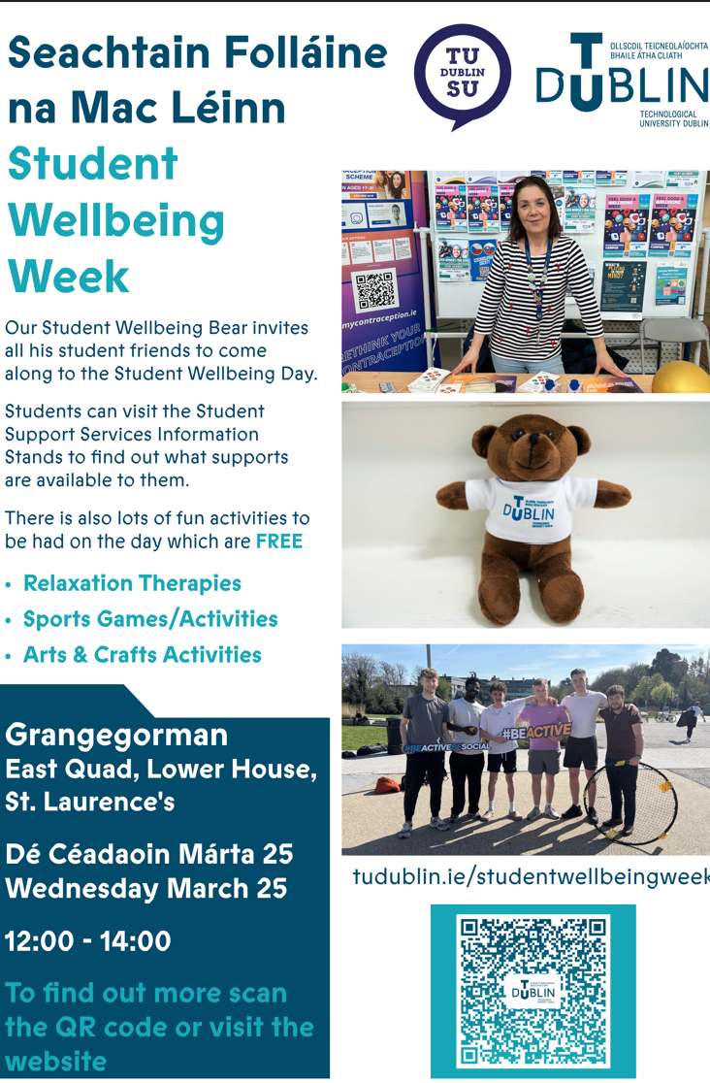  Promotional of Wellbeing Week  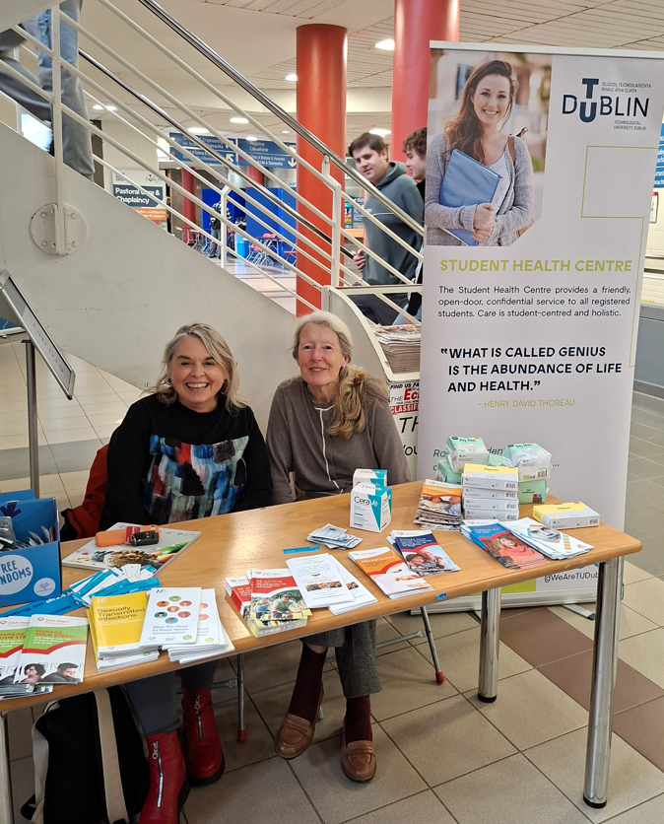  Student Health Centre Promotional Stand  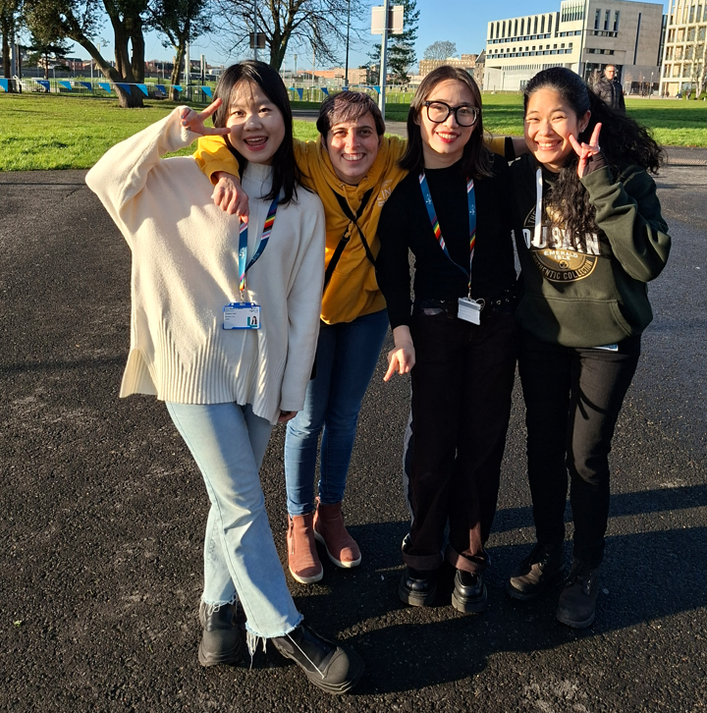  Fun Run/Walk  https://www.instagram.com/reel/DWBahX3Cs15/?igsh=MXB6N3NmdDJubHhodw==  Link to bear campaign highlighting support services

- Evaluation
How was the project evaluated?
Please check the box(es) that apply regarding the type of evaluation and data collection method
Type of Evaluation
Formative Evaluation: ☒  Conducted during development or early implementation to make improvements to the program design. | Process Evaluation: ☒  Assesses how the program is being implemented, including participation rates, quality of delivery, and whether it is reaching its target audience. | Outcome Evaluation: ☒  Focuses on the results—the changes in behaviors, attitudes, or conditions—at the end of a project. | Summative Evaluation: ☒  Assesses the overall effectiveness of a program after its completion to determine if it achieved its intended goals.
Data Collection Method
Survey/Questionnaire ☐  Document Review ☒ (project reports, financial data, attendance logs, etc.)  Direct Observations ☒ | Focus Groups ☐  Interviews ☐  Case Studies ☒  Other____________
High-Level Outcome and Impact
Please include high-level outcomes and impact if not already covered in the summary above.

- Contact Details
Contact Name/s | Jennifer Scott, Paul Duffy, Teresa Hurley
Date | 2/4/2026
Email Address | jennifer.scott@tudublin.ie

