HEA Healthy Campus Case Study Template 2026

NOTES FOR COMPLETION
Context
- Case studies should relate to your institution's progression of the following policies:
  - HEA Healthy Campus Charter and Framework
  - HEA Healthy Campus Self-Evaluation Tool
  - National Student Mental Health and Suicide Prevention Framework
  - The Limerick Framework for Action: Advancing the Health Promoting Campus Agenda
- Case studies can include a wide range of work including those relating to governance and oversight, planning, strategy, policy, research, implementation, as well as others.
- We encourage examples that also showcase the interaction of wellbeing and other areas for example sustainability, belonging, progression, teaching and learning.
Template
- Please be as concise and clear as possible and consider the use of bullet points to summarise information.
- All sections must be completed.
- Case studies should be written in the third person and anonymous when it comes to participants’ names.
- Case studies will be used as part of HEA communications including email, website, and social media.
Submission
- Please submit your case study to healthycampus@hea.ie by COB Friday, April 3rd for display at the 2026 Health and Wellbeing Conference.

HEALTHY CAMPUS CASE STUDY
- Project Title | Quit Smoking & Vaping Programme
- Institution/ Organisation | TU Dublin
- Who leads/ led the project? | Healthy Campus Working Group, Sustainability Council Steering Group
- Date and timeframe | Autumn and Spring each year
- Population Group (tick all that apply) | - Students ☒  - Staff ☒  - Wider community ☐  - Other ☐
- Health Topic (tick all that apply) | - Alcohol ☐  - Substance Misuse ☐  - Healthy Eating / Food ☐  - Mental Health & Wellbeing ☐  - Sexual Health & Wellbeing ☐  - Tobacco/ Vape Free Campus ☒  - Physical Activity / Active Transport ☐  - Wellbeing and the Curriculum ☐  - Health & Sustainability ☐  - Other ☐

- Project Alignment

Use the categories below to highlight the alignment of the project with national policy. Please tick all that apply.

Limerick Framework for Action - 10 Actions  LFfA pg. 12 | Healthy Campus Process  HCCF pg. 4 | Whole Campus Approach  HC Tool pg. 8 | Principles of a Healthy Campus  HC Tool + HCCF | National Student Mental Health and Suicide Prevention Framework NSMHSPF
1.Ethos ☐ | Commit ☐ | Leadership, Strategy & Governance  (Pillar 1) ☐ | Participation ☒ | Lead ☐
2.Act ☒ | Coordinate ☐ | Campus Environment (Facilities & Services) (Pillar 2) ☒ | Partnership ☒ | Collaborate ☐
3.Localise ☐ | Consult ☒ | Campus Culture & Communications (Pillar 3) ☒ | Evidence Based ☒ | Educate ☐
4.Leadership ☐ | Create ☒ | Personal & Professional Development  (Pillar 4) ☐ | Sustainability (Longevity) ☐ | Engage ☐
5.Policies ☐ | Celebrate & continue ☐ | Health Focused Area (Pillar 5) ☒ |  | Identify ☐
6.Culture ☒ |  |  |  | Support ☐
7.Partnership ☒ |  |  |  | Respond ☐
8.Students ☒ |  |  |  | Transition ☐
9.Research ☐ |  |  |  | Improve ☐
10.Celebrate ☐

- Project Rationale | Educate students and staff of the harmful effects of smoking and vaping and to encourage registration to the Quit Smoking/Vaping Programme.
- Aims and Objectives | Word count 100 - 400 words (approx.)  The aim of the project is to educate students and staff of the harmful effects of smoking and vaping and to encourage registration to the Quit Smoking/Vaping Programme.  Objectives include creating awareness of the harmful effect of smoking/vaping for users and for the wider TU Dublin community and environment, to recruit smokers and vapers to the Quit Smoking/Vaping programme, to inform University policy in this area.
- Project Overview/ Summary | .  - The project takes place each year in Autumn (to recruit new 1st year students) & Spring (to coincide with ASH Wednesday, National No Smoking/Vaping Day and Lent) and is promoted to students and staff for 1 month duration in October and March  - The project is run in conjunction with the HSE, Slaintecare and Healthy Ireland and is approved by the Sustainability Council  - The HSE provide a FREE 10 -12 week Quit Smoking/Vaping proramme with FREE Nicotine Replacement Therapy and trained facilitator  - Promotional stands are organised across campuses in October and March to recruit smokers and vapers along with communication through social media, screens and in all TU Dublin newsletters. Promotion also takes place during health-related events in the University including Mental Health Week, Financial Wellbeing Week and Wellbeing Week  - Mini surveys ascertaining student and staff views on smoking/vaping on campus are used to gather data and inform policy in the University  - Awareness campaigns are run alongside the smoking/vaping recruitment promotions through TU Dublin Update and on the University website
- Collaboration | Please include stakeholders collaborated with including internal and/ or external.  Internal include the Student Health Centres, Students Union, Communications Team, Health & Safety, Sport, Campus Planning & Estates  External include the Health Service Executive, Tobacco Free Ireland, Slaintecare, Healthy Ireland, County Dublin Partnerships and Councils, Irish Heart Foundation
- Resource Requirements | Where appropriate please include an overview of resources required to deliver the project.  Funding, leadership, management, collaboration and financial support
- What are the next steps for the project? | Include plans for sustainability (longevity) and any resources needed/ obtained.  Input to smoking/vaping policy in TU Dublin, development of further awareness campaigns
- Key Learning Points | - Establish working or steering group  - Develop links with health-related partners  - Plan well in advance of launch, allowing time to recruit smokers and vapers  - Run over 1 month duration minimum to make it worthwhile and to allow time to recruit smokers and vapers  - Coincide with other wellbeing events such as mental health week, wellbeing week, financial awareness week, national no smoking/vaping day, lent etc.  - Involve other health related internal partners such as student health centres, communications team, students’ union, sport  - Measure impact in terms of numbers recruited for each campaign  - Gather testimonials of successful recruits
- Images and Links | Please include 1/2 images related to the project, this can include document cover pages, logos, a picture of a team meeting etc.  Please include links to webpages/ documents related to the project.  See below extract from TU Dublin News, Healthy Campus Quiz and Quiz Winner.

Smoking is the single largest cause of preventable ill health and premature death in Ireland and is a major cause of lung cancer, chronic bronchitis, emphysema and coronary heart disease. Passive smoking is the involuntary intake of smoke or vapour by a person other than the actual smoker. When non-smokers share a space with someone who is smoking, they are exposed to passive smoking, vapours, second-hand smoke or Environmental Tobacco Smoke (ETS).
The University is fully committed to establishing a healthy environment for all staff and students by eliminating exposure to environmental tobacco smoke and vapour.

Therefore, as per the University Smoke Free Policy:
Smoking, including vaping and the use of electronic cigarettes, is prohibited inside all buildings and in all University owned and/or leased vehicles. A vehicle is a ‘place of work’ as specified in the Safety, Health and Welfare at Work Act 2005; and
Smoking is prohibited externally in the immediate vicinity of all buildings e.g. adjacent to doors and windows

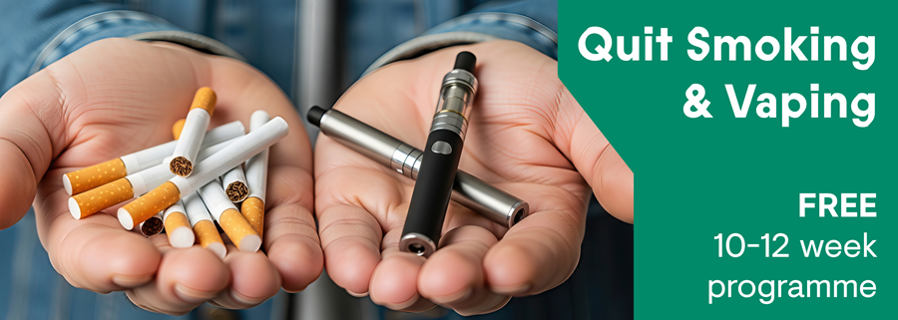
Quit Smoking/Vaping Programme
Would you like to quit smoking/vaping? The Healthy Campus Quit Smoking & Vaping Programme provides a FREE 10-12 week stop smoking/vaping programme to students and staff in TU Dublin.
Trained advisors work with you at every stage of your quit journey. You will be offered free stop smoking aids (such as nicotine patches and gum), and the service is tailored to suit your own personal needs.
The programme is open for registrations now. Find out more here

TU Dublin Healthy Campus Quiz

Did You Know....
1.TU Dublin Healthy Campus, in conjunction with the HSE, is providing a Free Quit Smoking & Vaping Programme with Free Nicotine Replacement Therapy for students and staff for the month of October?
- Yes
- No
2.The average smoker smoking 20 cigarettes or vaping regularly per day can save a total of €4,380 per year.
- Yes
- No
3.Cigarette butts and vape waste won’t biodegrade and eventually break down into microplastics and chemicals that are a threat to the environment and human health.
- Yes
- No
4.For cleaner air and environmental protection, which would you be in favour of:
- A smoke and vape free campus?
- Partially smoke and vape free with smoking and vaping shelters?

Full name
________________________________________________________
TU Dublin email address
________________________________________________________
Mobile number
________________________________________________________
Campus Location
- Grangegorman
- Blanchardstown
- Tallaght
- Aungier St.
- Boltan St.
Are you a student or staff (circle)

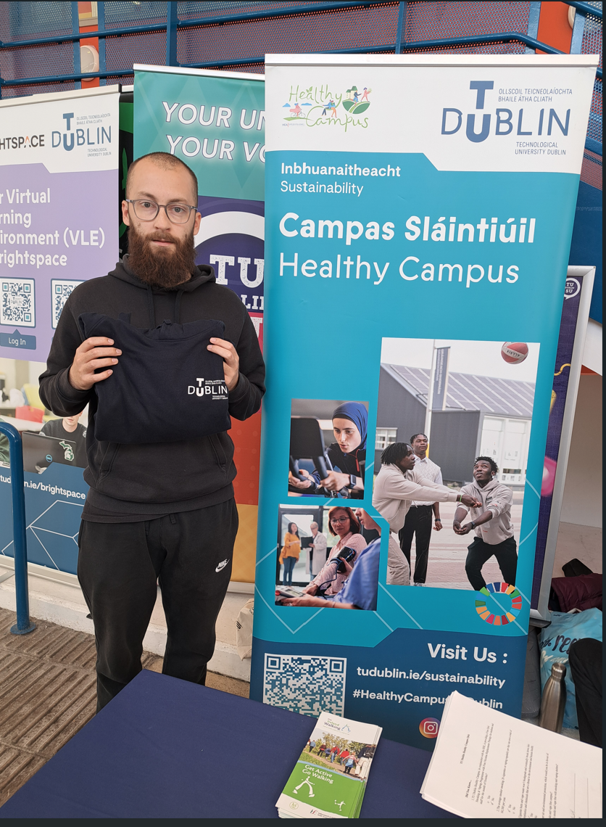
Healthy Campus Quiz winner Blanchardstown Campus

- Evaluation
How was the project evaluated?
Please check the box(es) that apply regarding the type of evaluation and data collection method
Type of Evaluation
Formative Evaluation: ☐  Conducted during development or early implementation to make improvements to the program design. | Process Evaluation: ☒  Assesses how the program is being implemented, including participation rates, quality of delivery, and whether it is reaching its target audience. | Outcome Evaluation: ☒  Focuses on the results—the changes in behaviors, attitudes, or conditions—at the end of a project. | Summative Evaluation: ☒  Assesses the overall effectiveness of a program after its completion to determine if it achieved its intended goals.
Data Collection Method
Survey/Questionnaire ☒  Document Review ☒ (project reports, financial data, attendance logs, etc.)  Direct Observations ☒ | Focus Groups ☐  Interviews ☐  Case Studies ☒  Other____________
High-Level Outcome and Impact
Please include high-level outcomes and impact if not already covered in the summary above.

- Contact Details
Contact Name/s | Dr Teresa Hurley
Date | 1/4/2026
Email Address | teresa.hurley@tudublin.ie

