HEA Healthy Campus Case Study Template 2026

NOTES FOR COMPLETION
Context
- Case studies should relate to your institution's progression of the following policies:
  - HEA Healthy Campus Charter and Framework
  - HEA Healthy Campus Self-Evaluation Tool
  - National Student Mental Health and Suicide Prevention Framework
  - The Limerick Framework for Action: Advancing the Health Promoting Campus Agenda
- Case studies can include a wide range of work including those relating to governance and oversight, planning, strategy, policy, research, implementation, as well as others.
- We encourage examples that also showcase the interaction of wellbeing and other areas for example sustainability, belonging, progression, teaching and learning.
Template
- Please be as concise and clear as possible and consider the use of bullet points to summarise information.
- All sections must be completed.
- Case studies should be written in the third person and anonymous when it comes to participants’ names.
- Case studies will be used as part of HEA communications including email, website, and social media.
Submission
- Please submit your case study to healthycampus@hea.ie by COB Friday, April 3rd for display at the 2026 Health and Wellbeing Conference.

HEALTHY CAMPUS CASE STUDY
- Project Title | Mental Health Week
- Institution/ Organisation | TU Dublin
- Who leads/ led the project? | Student Counselling Service and Staff Development
- Date and timeframe | October 6th-10th 2025
- Population Group (tick all that apply) | - Students ☒  - Staff ☒  - Wider community ☒  - Other ☐
- Health Topic (tick all that apply) | - Alcohol ☐  - Substance Misuse ☐  - Healthy Eating / Food ☐  - Mental Health & Wellbeing ☒  - Sexual Health & Wellbeing ☐  - Tobacco/ Vape Free Campus ☐  - Physical Activity / Active Transport ☐  - Wellbeing and the Curriculum ☐  - Health & Sustainability ☐  - Other ☐

- Project Alignment

Use the categories below to highlight the alignment of the project with national policy. Please tick all that apply.

Limerick Framework for Action - 10 Actions  LFfA pg. 12 | Healthy Campus Process  HCCF pg. 4 | Whole Campus Approach  HC Tool pg. 8 | Principles of a Healthy Campus  HC Tool + HCCF | National Student Mental Health and Suicide Prevention Framework NSMHSPF
1.Ethos ☐ | Commit ☒ | Leadership, Strategy & Governance  (Pillar 1) ☒ | Participation ☒ | Lead ☒
2.Act ☒ | Coordinate ☒ | Campus Environnent (Facilities & Services) (Pillar 2) ☐ | Partnership ☒ | Collaborate ☒
3.Localise ☒ | Consult ☒ | Campus Culture & Communications (Pillar 3) ☒ | Evidence Based ☒ | Educate ☒
4.Leadership ☐ | Create ☒ | Personal & Professional Development  (Pillar 4) ☐ | Sustainability (Longevity) ☒ | Engage ☐
5.Policies ☒ | Celebrate & continue ☒ | Health Focused Area (Pillar 5) ☒ |  | Identify ☒
6.Culture ☒ |  |  |  | Support ☐
7.Partnership ☒ |  |  |  | Respond ☐
8.Students ☐ |  |  |  | Transition ☐
9.Research ☐ |  |  |  | Improve ☐
10.Celebrate ☐

- Project Rationale | To promote mental health awareness and access to supports among the whole university community
- Aims and Objectives | - To raise mental health awareness and promote discussion around it.  - To provide the University community with information on mental health and wellbeing services both within TU Dublin and externally within the wider community.  - To celebrate World Mental Health day.  - To launch the University’s new Student Mental Health Policy and Guides  - To launch the ‘Elephant in the room’ campaign  - To collaborate with external mental health and wellbeing agencies and strengthen links with them; Mental Health Ireland, Jigsaw, NOSP, HSE etc..
- Project Overview/ Summary | - Planning commenced in July with bi-monthly meetings with wide participation from local stakeholders on multiple campuses  - Student Counselling Service and staff development lead the initiative with ongoing support and collaboration from students support services, healthy campus, estates and the marketing and comms team.  - The event was promoted via website, emailing campaign, social media, campus screens, newsletters  - Events were held for both students and staff across different campuses on different days across the week, to reach the whole university community and promote discussion and awareness around the area of mental health  - Local external stakeholders participated in promotional stands and events across 3 campuses throughout the week, along with internal stakeholders to provide information on mental health topics and access to available support services.  - An official launch of the new Student Mental Health Policy and Elephant in the Room Campaign was held with participation from the university Executive Team and the HEA.  - Mental health cafés were held on three campuses, across three days of the week.  - The launch of the new Student Mental Health Policy was supplemented by an online series of ‘Lite bite’ talks for staff, that outlined different aspects of the policy and guides.
- Collaboration | Internally - Student Support Services Teams, Staff Development. Healthy Campus, Sustainability, Engagement, Sports Clubs & Societies, Estates, Library, Volunteering, Academics, Students’ Union, Employees Engagement/Staff Development.  Externally – Mental Health Ireland, NOSP, HSE suicide prevention and Health Promotion Teams, Volunteer Organisations, Sexual Health, Elephant in the Room, Cornmarket, and Jigsaw.
- Resource Requirements | Financial support from the TU Dublin HEA Mental Health and Wellbeing funding allocation. Input from stakeholders. Time, organisation and coordination of staff across multiple areas and multiple campuses both before and during the events throughout the week. Participation and support from local external agencies and voluntary organisations.
- What are the next steps for the project? | Review and refine processes to improve for the next annual mental health week.
- Key Learning Points | - There is a high level of planning needed to implement a large-scale initiative across multiple campuses. This requires a long lead in time to organise, coordinate and promote.  - Evaluation is important to improve processes and planning for future iterations of the event  - Division of tasks and labour among key staff on each campus is essential.  - The involvement of internal and external key stakeholders is essential in the delivery of this initiative  - Planning the day around related campaigns/events such as launch of new Student Mental Health Policy, World Mental Health Day, Elephant in the Room etc works effectively.
- Images and Links | 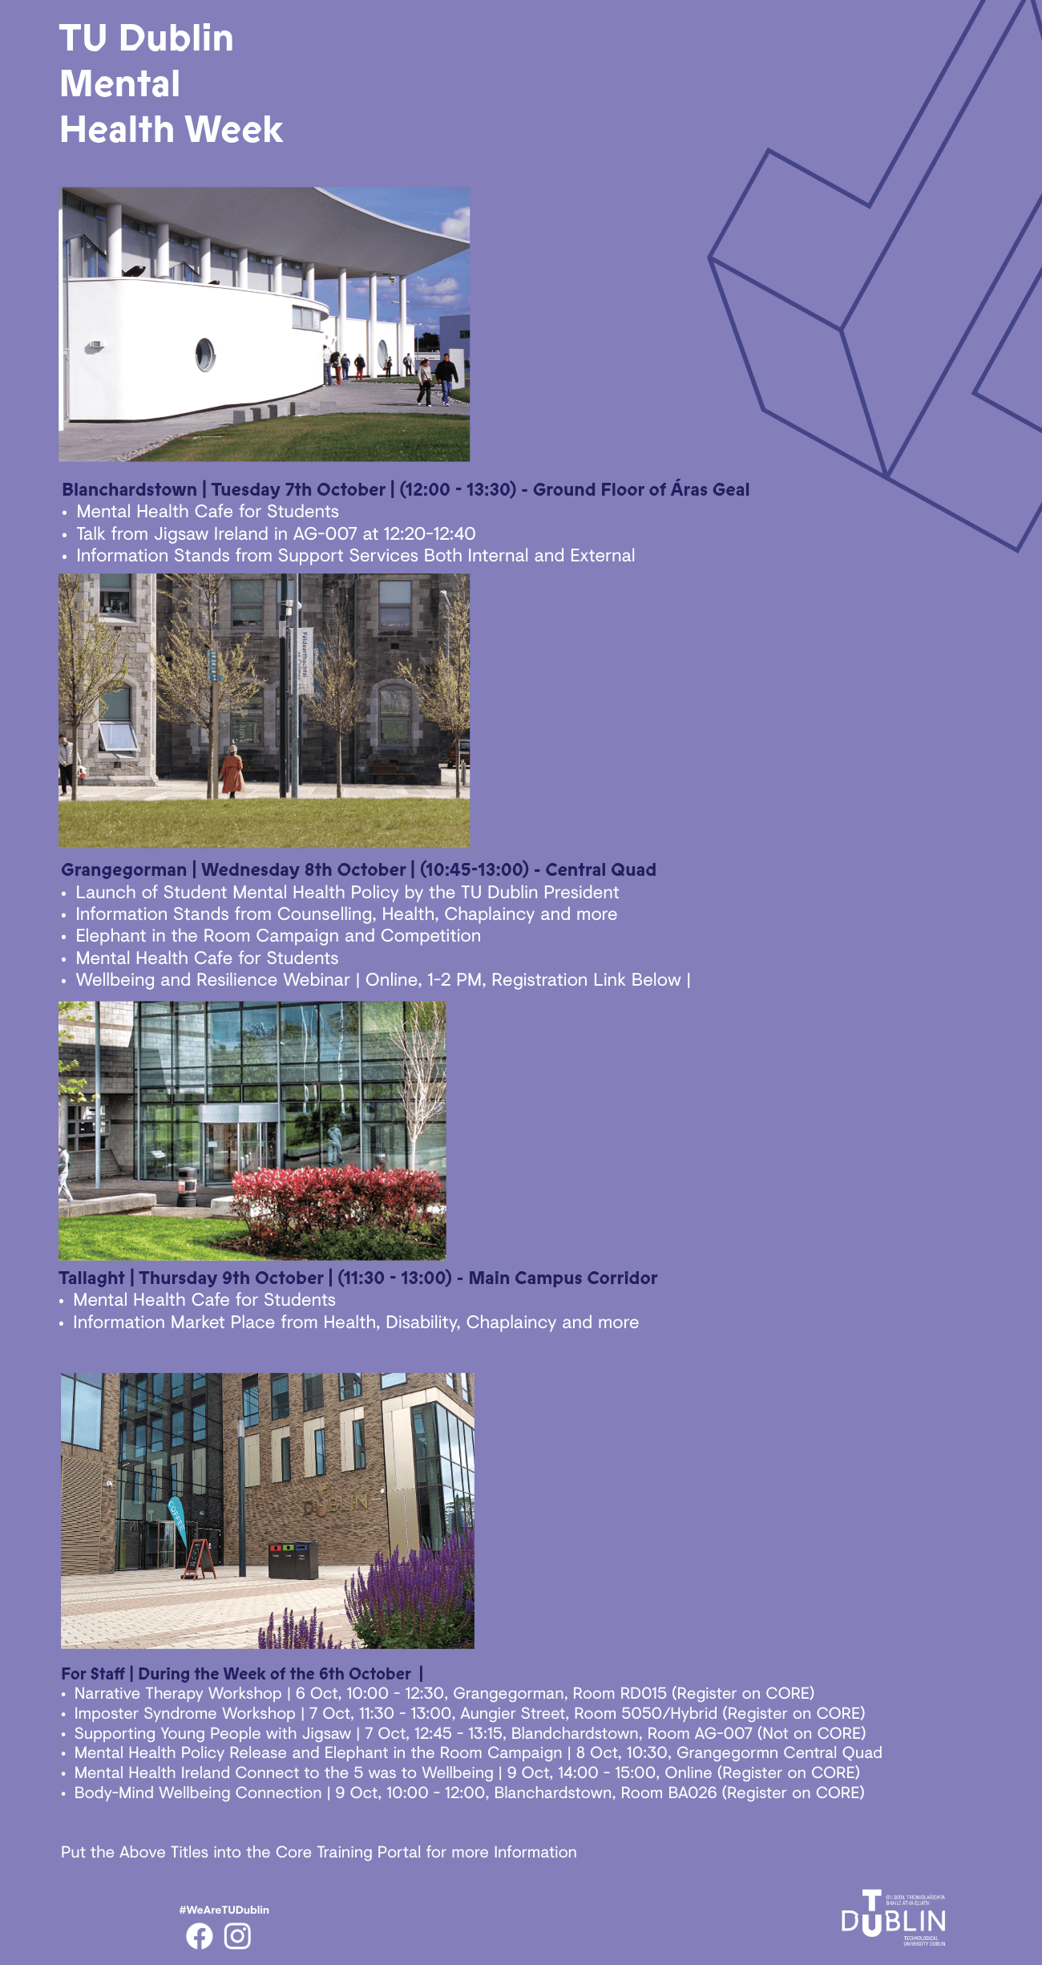  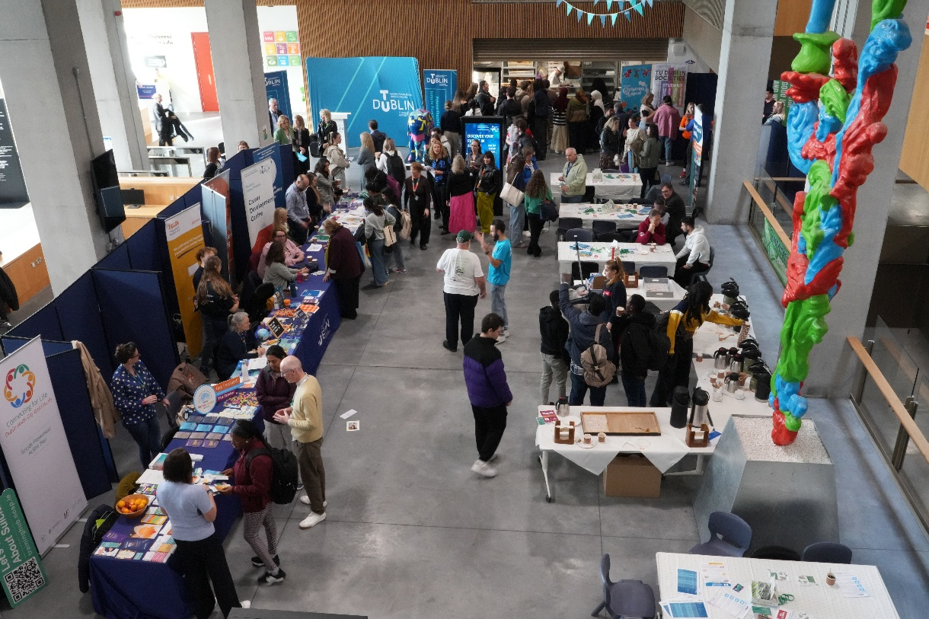  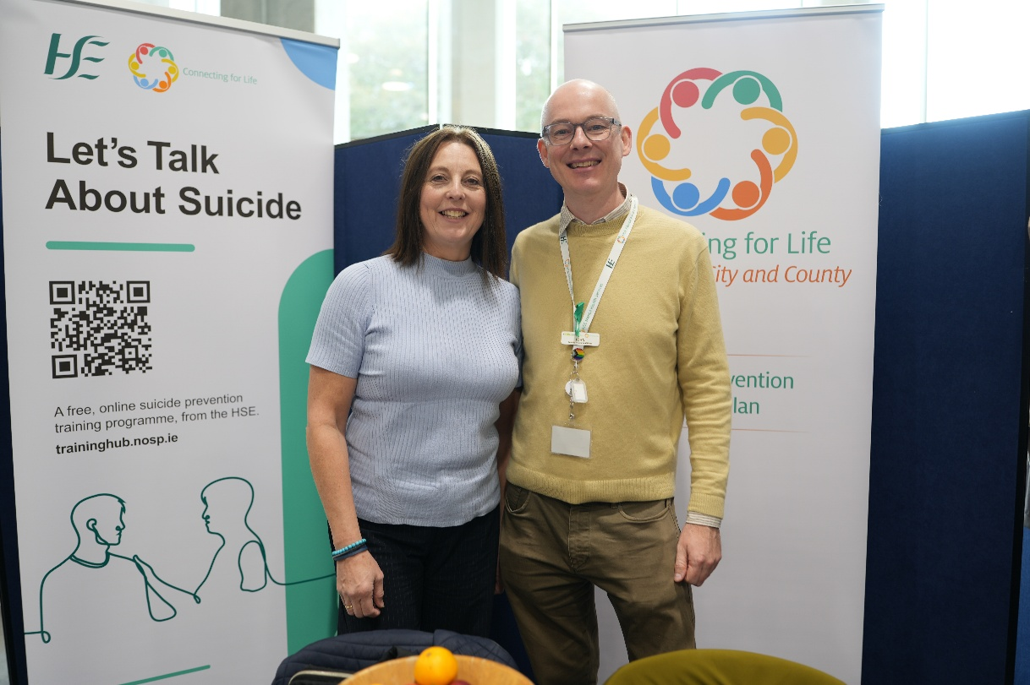  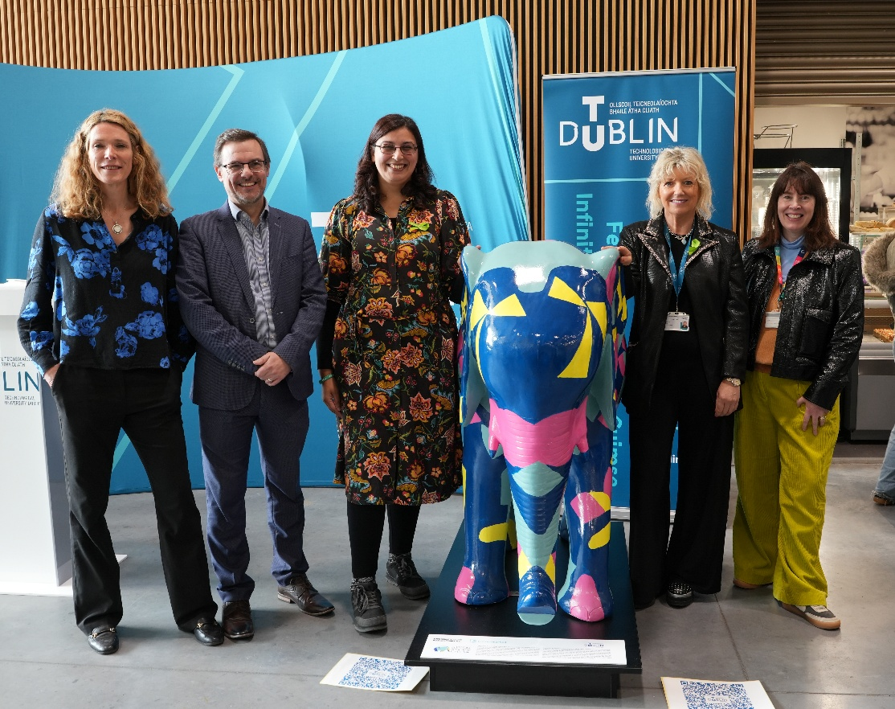  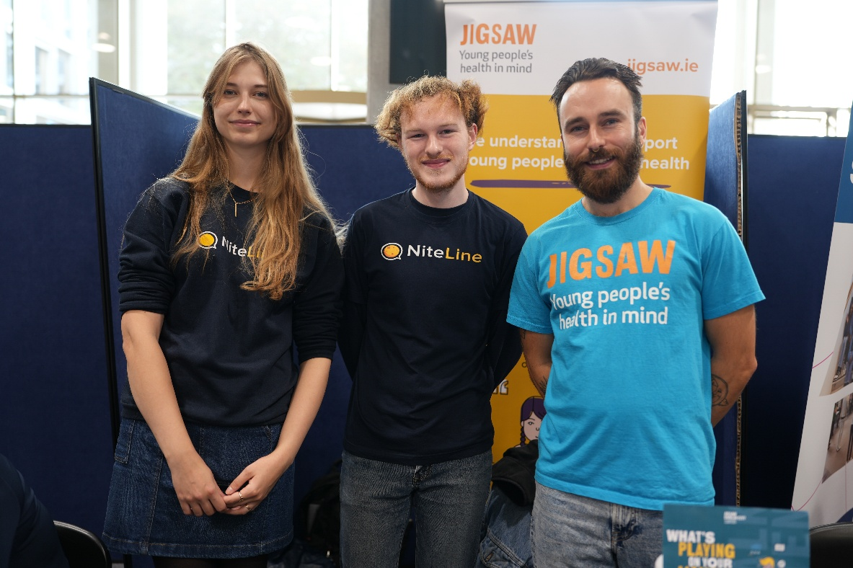  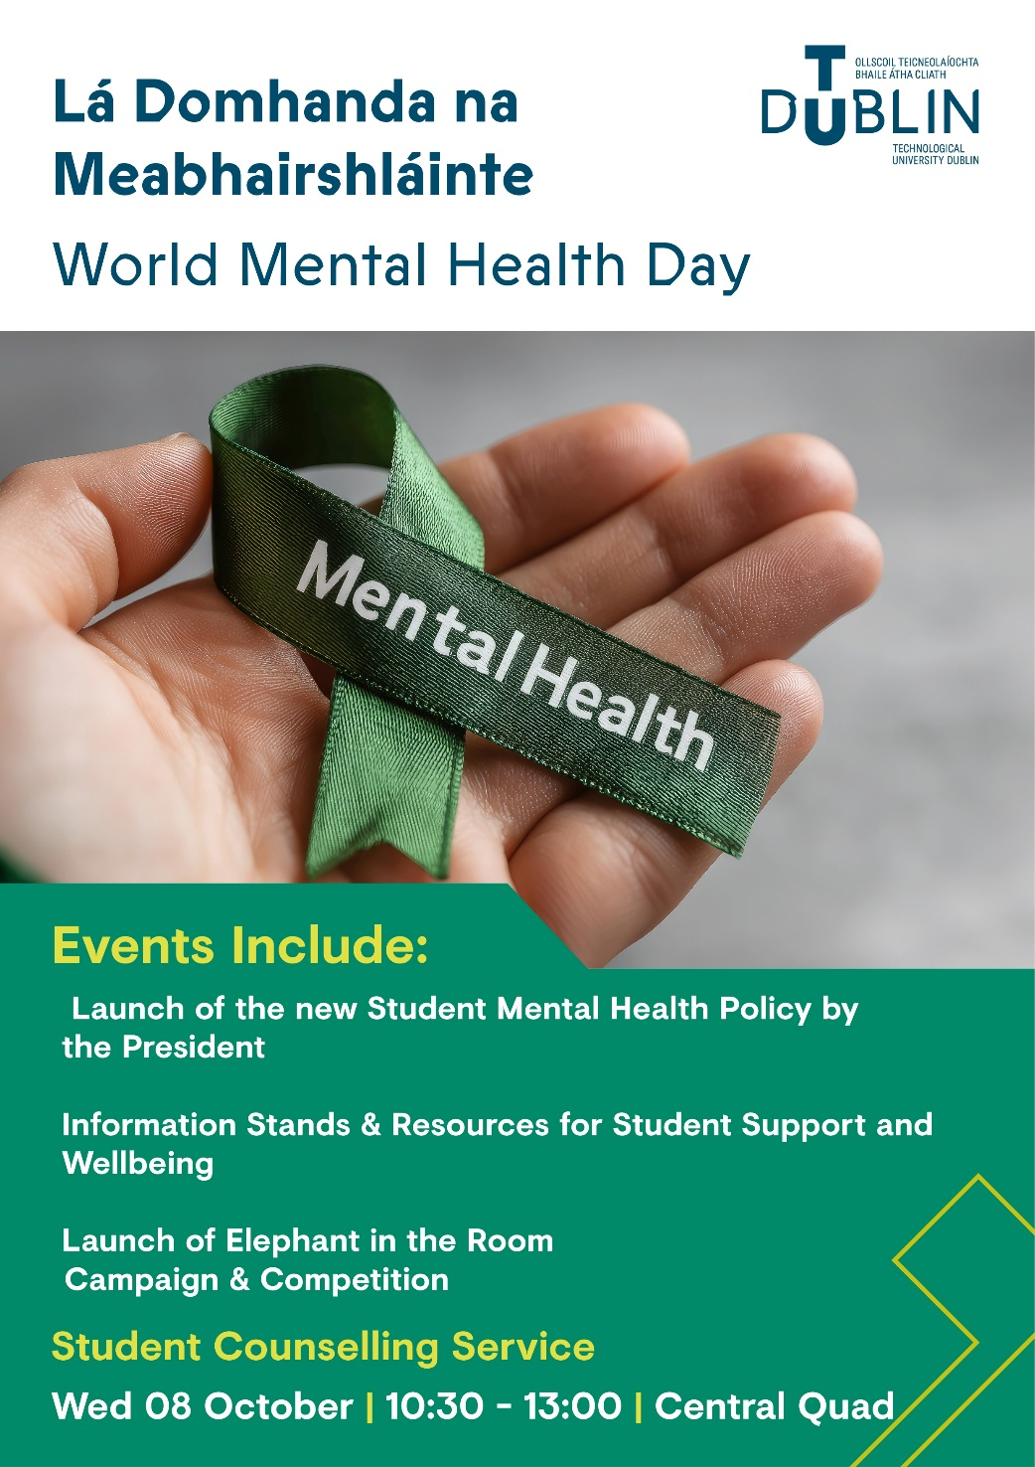  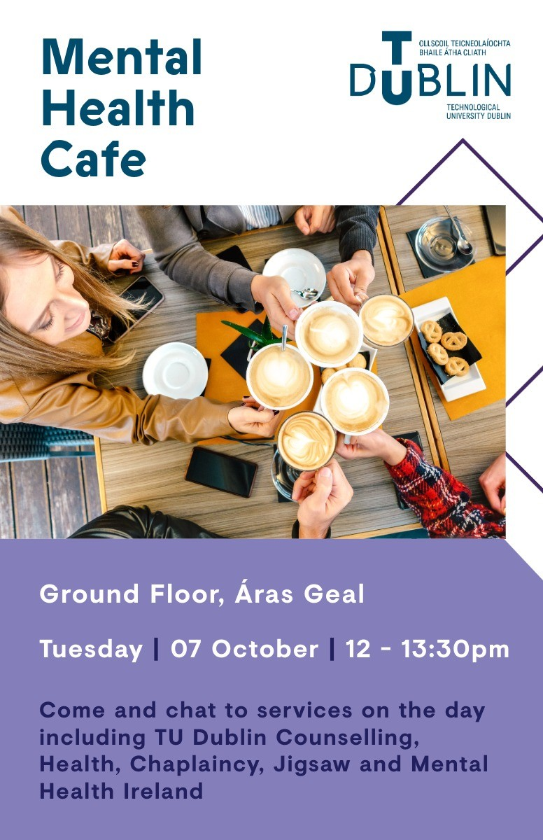

- Evaluation
How was the project evaluated?
Please check the box(es) that apply regarding the type of evaluation and data collection method
Type of Evaluation
Formative Evaluation: ☒  Conducted during development or early implementation to make improvements to the program design. | Process Evaluation: ☒  Assesses how the program is being implemented, including participation rates, quality of delivery, and whether it is reaching its target audience. | Outcome Evaluation: ☒  Focuses on the results—the changes in behaviors, attitudes, or conditions—at the end of a project. | Summative Evaluation: ☒  Assesses the overall effectiveness of a program after its completion to determine if it achieved its intended goals.
Data Collection Method
Survey/Questionnaire ☐  Document Review ☒ (project reports, financial data, attendance logs, etc.)  Direct Observations ☒ | Focus Groups ☐  Interviews ☐  Case Studies ☒  Other____________
High-Level Outcome and Impact
Please include high-level outcomes and impact if not already covered in the summary above.

- Contact Details
Contact Name/s | Aisling O Brien, Head of Counselling  Anima Ganguly, Professional Training and Development Manager  Dr Rachael O’ Connor, Deputy Head of Student Support  Dr Teresa Hurley, Healthy Campus Project Manager  Jennifer Farrell, Head of Student Services and Wellbeing
Date | 2/4/26
Email Address | aisling.obrien@tudublin.ie

