HEA Healthy Campus Case Study Template 2026

NOTES FOR COMPLETION
Context
- Case studies should relate to your institution's progression of the following policies:
  - HEA Healthy Campus Charter and Framework
  - HEA Healthy Campus Self-Evaluation Tool
  - National Student Mental Health and Suicide Prevention Framework
  - The Limerick Framework for Action: Advancing the Health Promoting Campus Agenda
- Case studies can include a wide range of work including those relating to governance and oversight, planning, strategy, policy, research, implementation, as well as others.
- We encourage examples that also showcase the interaction of wellbeing and other areas for example sustainability, belonging, progression, teaching and learning.
Template
- Please be as concise and clear as possible and consider the use of bullet points to summarise information.
- All sections must be completed.
- Case studies should be written in the third person and anonymous when it comes to participants’ names.
- Case studies will be used as part of HEA communications including email, website, and social media.
Submission
- Please submit your case study to healthycampus@hea.ie by COB Friday, April 3rd for display at the 2026 Health and Wellbeing Conference.

HEALTHY CAMPUS CASE STUDY
- Project Title | Becoming vape free – a whole university response to e-cigarettes for a healthy planet and healthy people
- Institution/ Organisation | Trinity College Dublin
- Who leads/ led the project? | Healthy Trinity: Tobacco Group
- Date and timeframe | 2022-2026
- Population Group (tick all that apply) | - Students ☒  - Staff ☒  - Wider community ☒  - Other ☐
- Health Topic (tick all that apply) | - Alcohol ☐  - Substance Misuse ☐  - Healthy Eating / Food ☐  - Mental Health & Wellbeing ☐  - Sexual Health & Wellbeing ☐  - Tobacco/ Vape Free Campus ☒  - Physical Activity / Active Transport ☐  - Wellbeing and the Curriculum ☐  - Health & Sustainability ☐  - Other ☐

- Project Alignment

Use the categories below to highlight the alignment of the project with national policy. Please tick all that apply.

Limerick Framework for Action - 10 Actions  LFfA pg. 12 | Healthy Campus Process  HCCF pg. 4 | Whole Campus Approach  HC Tool pg. 8 | Principles of a Healthy Campus  HC Tool + HCCF | National Student Mental Health and Suicide Prevention Framework NSMHSPF
1.Ethos ☒ | Commit ☒ | Leadership, Strategy & Governance  (Pillar 1) ☒ | Participation ☐ | Lead ☒
2.Act ☒ | Coordinate ☐ | Campus Environment (Facilities & Services) (Pillar 2) ☒ | Partnership ☐ | Collaborate ☐
3.Localise ☐ | Consult ☐ | Campus Culture & Communications (Pillar 3) ☐ | Evidence Based ☒ | Educate ☐
4.Leadership ☐ | Create ☐ | Personal & Professional Development  (Pillar 4) ☐ | Sustainability (Longevity) ☐ | Engage ☐
5.Policies ☐ | Celebrate & continue ☐ | Health Focused Area (Pillar 5) ☐ |  | Identify ☐
6.Culture ☐ |  |  |  | Support ☐
7.Partnership ☐ |  |  |  | Respond ☐
8.Students ☐ |  |  |  | Transition ☐
9.Research ☐ |  |  |  | Improve ☐
10.Celebrate ☐

- Project Rationale | After a six-year negotiation, Trinity became a tobacco-free campus and showed a 79% reduction in observed smoking from 2016 to 2020. Smoking was observed through a Living Lab approach that employed student Ambassadors to count smokers on campus 6-8 times per week during semester, while reminding them of the tobacco-free policy. Post COVID-19, Ambassadors observed increased vaping but had no remit to approach vapers because the protracted negotiation to become tobacco-free excluded e-cigarettes. Trinity’s Sustainability Strategy included the development of an e-cigarettes policy for Trinity under a Healthy Planet, Healthy People ethos.
- Aims and Objectives | Aim:  To create a supportive environment for nature, climate and people in Trinity by responding to the emerging practice of e-cigarette use on campus.  Objectives:  - Observe vaping on campus  - Measure the prevalence of vaping on campus through an all-college survey  - Support students to challenge the emerging vape culture on campus  - Support students to quit vaping  - Unify Trinity’s academics, professionals and students to use the campus and institutional structures to call for the government to protect people and planet from e-cigarettes through stronger legislation.
- Project Overview/ Summary | The Living Lab approach to tobacco-free Trinity already in place was extended to include vaping as follows:  - Vaping observed on campus as part of Tobacco Free Trinity's Living Lab found an increase from 0.9 vapers per check (609 checks) in 2022/2023 to 2.1 vapers per check in 2024/2025 (350 checks). In 2024/2025, 1,749 nicotine users were observed on campus, with 42% (n=728) using e-cigarettes. 59% of vapers (n=430) were using disposable vapes.  - Vaping prevalence survey taken in 2023 by 2,683 students and staff (RR=12%) found vaping is highly prevalent. 1539 (57%) had vaped at least once and 838 (31%) currently vaped. 42% of current vapers were dual cigarette and e-cigarette users. 57%, n=1013, supported on-campus restrictions. Factors for lifetime/current vaping included younger age, undergraduate status, cigarette smoking (AOR current=9.3, 95% CI 6.1, 14.2), and disposable vape use (AOR current = 3.18, 95% CI 1.6, 6.2)  - Stop-smoking courses were re-designed to be stop-smoking/vaping courses and two per annum were delivered with the HSE Quit team;  - Student ambassador led anti-vaping communications were launched on social media, on campus screens, email and at events with a focus upstream on politicians and downstream on students  - 300 students completed anti-vaping assignments through curriculum with a particular focus on policy makers;  - Three responses to government consultations lobbying for stronger regulation were submitted.  - An application to extend Trinity’s tobacco free campus Living Lab to e-cigarettes was made to Board and on 18th March 2026, Trinity launched its smoke/vape free campus.  - Implementation continues by student ambassadors completing weekly circuits reminding people of the policy and recording observed smoking/vaping.
- Collaboration | Please include stakeholders collaborated with including internal and/ or external.  Internal: Healthy Trinity student ambassadors, College Health Service, Trinity Sustainability, School of Medicine, Accommodation office, Safety Officer, Estates and Facilities (signage and smoking shelters), Environment and Sustainability Committee, TCD Students Union, Communications and others  External: ASH Council Ireland, Irish Heart Foundation; Climate and Health Alliance, Irish Doctors for the Environment, EU Smoke Free Partnership
- Resource Requirements | Where appropriate please include an overview of resources required to deliver the project.  - The Health Promotion Officer in College Health/Trinity Sustainability is the main resource and is tasked with delivering the tobacco/vape free campus Living Lab with the support of the Healthy Campus Manager and partners in Trinity Sustainability  - A budget of approx. €6,000 p.a. for student ambassadors, training, prizes etc.  - Support is given in kind by partners. For example, the professional lead of the Healthy Trinity Tobacco Group is the director of College Health and the academic lead is a consultant paediatrician in the School of Medicine. Along with the VP for Biodiversity and Climate Action they gave their time, expertise, legitimacy and reputation to review policy documents and evidence and to politic change through university structures.  - An Assoc. Prof in School of Medicine acted as PI for the prevalence survey and delivered it at a conference  - Assistant and Assoc Profs in Trinity Business School incorporated vaping into their curricula.  - Estates and Facilities introduced vape recycling with the group
- What are the next steps for the project? | New student ambassadors will be recruited in April 2026 and implementation of the policy as described in section 10 will continue.
- Key Learning Points | - Governance: Having e-cigarettes as a target in the Sustainability Strategy made obtaining buy-in easier and opened policy channels for change.  - Research: Working with academic partners enabled research via a prevalence survey.  - Teaching: Working with academic partners meant >300 students engaged deeply with the emerging trend of e-cigarettes. Students went from thinking that using e-cigarettes was free choice, to understanding it is a highly addictive product sold by the tobacco industry in pursuit of profit.  - Operations: Working with professional partners enabled improved support for people to quit vaping; extension of the ongoing Living Lab to vaping; vape recycling on campus, ongoing communications on campus and to policy makers.  - Community: Working with students and professional staff enabled events, communications and data collection with a particular focus on why policy makers have allowed e-cigarettes to proliferate.  - Whole university approach enabled Trinity as an institution to come to a position on e-cigarettes and to respond to government consultations calling for stronger legislation.
- Images and Links | Please include 1/2 images related to the project, this can include document cover pages, logos, a picture of a team meeting etc.  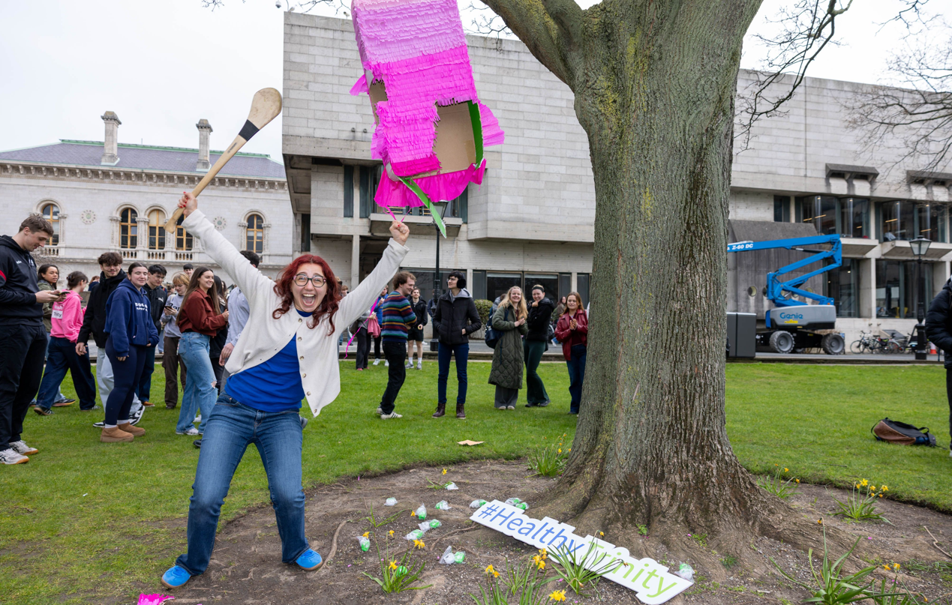  Trinity’s vape free campus was launched with a vape shaped pinata on 18th March 2026. The student pictured won a ticket to Trinity ball by striking the winning blow. It is an intentionally playful image, demonstrating health as a positive concept.  Coverage in national media here: https://www.thejournal.ie/trinity-college-dublin-vape-ban-poll-6955973-Feb2026/  Students playing with the policy here: https://www.trinitynews.ie/2026/04/trinity-seagulls-recruited-to-enforce-college-wide-vape-ban/  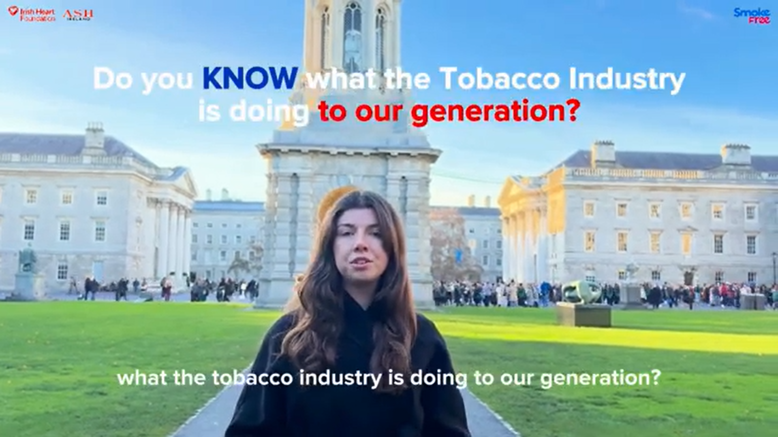  A snapshot of a student assignment lobbying the government to legislate to protect young people from vaping is above and the full video is here: https://www.youtube.com/watch?v=_u1tcUOpjBo  The policy is here: https://www.tcd.ie/media/tcd/about/policies/pdfs/Tobacco_E-Cigarette_Policy.pdf  Data that informed the policy is here:  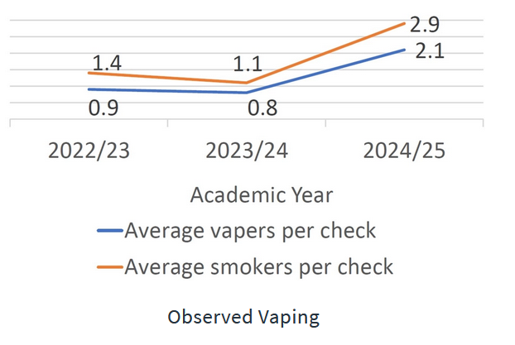  https://www.tcd.ie/healthytrinity/smoking/living-lab

- Evaluation
How was the project evaluated?
Please check the box(es) that apply regarding the type of evaluation and data collection method
Type of Evaluation
Formative Evaluation: ☐  Conducted during development or early implementation to make improvements to the program design. | Process Evaluation: ☒  Assesses how the program is being implemented, including participation rates, quality of delivery, and whether it is reaching its target audience. | Outcome Evaluation: ☒  Focuses on the results—the changes in behaviors, attitudes, or conditions—at the end of a project. | Summative Evaluation: ☒  Assesses the overall effectiveness of a program after its completion to determine if it achieved its intended goals.
Data Collection Method
Survey/Questionnaire ☒  Document Review ☒ (project reports, financial data, attendance logs, etc.)  Direct Observations ☒ | Focus Groups ☐  Interviews ☐  Case Studies ☐  Other____________
High-Level Outcome and Impact
Please include high-level outcomes and impact if not already covered in the summary above.
Observed smoking is 79% reduced.

- Contact Details
Contact Name/s | Martina Mullin
Date | 1st April 2026
Email Address | Mullinm1@tcd.ie

