HEA Healthy Campus Case Study Template 2026

NOTES FOR COMPLETION
Context
- Case studies should relate to your institution's progression of the following policies:
  - HEA Healthy Campus Charter and Framework
  - HEA Healthy Campus Self-Evaluation Tool
  - National Student Mental Health and Suicide Prevention Framework
  - The Limerick Framework for Action: Advancing the Health Promoting Campus Agenda
- Case studies can include a wide range of work including those relating to governance and oversight, planning, strategy, policy, research, implementation, as well as others.
- We encourage examples that also showcase the interaction of wellbeing and other areas for example sustainability, belonging, progression, teaching and learning.
Template
- Please be as concise and clear as possible and consider the use of bullet points to summarise information.
- All sections must be completed.
- Case studies should be written in the third person and anonymous when it comes to participants’ names.
- Case studies will be used as part of HEA communications including email, website, and social media.
Submission
- Please submit your case study to healthycampus@hea.ie by COB Friday, April 3rd for display at the 2026 Health and Wellbeing Conference.

HEALTHY CAMPUS CASE STUDY
- Project Title | Student Sport Activator
- Institution/ Organisation | South East Technological University - SETU
- Who leads/ led the project? | Department of Sport
- Date and timeframe | 2025–2026 academic year
- Population Group (tick all that apply) | - Students ☒  - Staff ☐  - Wider community ☒  - Other ☐
- Health Topic (tick all that apply) | - Alcohol ☐  - Substance Misuse ☐  - Healthy Eating / Food ☐  - Mental Health & Wellbeing ☐  - Sexual Health & Wellbeing ☐  - Tobacco/ Vape Free Campus ☐  - Physical Activity / Active Transport ☒  - Wellbeing and the Curriculum ☐  - Health & Sustainability ☐  - Other ☐

- Project Alignment

Use the categories below to highlight the alignment of the project with national policy. Please tick all that apply.

Limerick Framework for Action - 10 Actions  LFfA pg. 12 | Healthy Campus Process  HCCF pg. 4 | Whole Campus Approach  HC Tool pg. 8 | Principles of a Healthy Campus  HC Tool + HCCF | National Student Mental Health and Suicide Prevention Framework NSMHSPF
1.Ethos ☐ | Commit ☒ | Leadership, Strategy & Governance  (Pillar 1) ☐ | Participation ☒ | Lead ☐
2.Act ☒ | Coordinate ☒ | Campus Environment (Facilities & Services) (Pillar 2) ☐ | Partnership ☒ | Collaborate ☐
3.Localise ☒ | Consult ☒ | Campus Culture & Communications (Pillar 3) ☐ | Evidence Based ☒ | Educate ☐
4.Leadership ☐ | Create ☒ | Personal & Professional Development  (Pillar 4) ☐ | Sustainability (Longevity) ☒ | Engage ☐
5.Policies ☐ | Celebrate & continue ☒ | Health Focused Area (Pillar 5) ☒ |  | Identify ☐
6.Culture ☒ |  |  |  | Support ☐
7.Partnership ☒ |  |  |  | Respond ☐
8.Students ☒ |  |  |  | Transition ☐
9.Research ☐ |  |  |  | Improve ☐
10.Celebrate ☐

- Project Rationale | The Student Sport Activator programme was introduced in SETU Carlow Campus with Student Sport Ireland to increase physical activity levels and sports engagement among SETU students, with a particular focus on:  - Inclusivity, ensuring activities are accessible to students of all abilities, including those with intellectual and physical disabilities.  - Low-barrier, social, and fun participation, countering traditional performance-based sports models.  - Creating a more active campus culture, aligned with Healthy Campus and SETU Sports
- Aims and Objectives | Aims  - To increase student participation in sport and physical activity across the academic year.  - To provide inclusive opportunities for diverse student cohorts.  - To enhance student wellbeing through physical activity and social engagement.  Objectives  - Plan and facilitate at least three social sports/physical activity events annually.  - Provide a variety of activities catering to different interests and abilities.  - Maintain strong communication and coordination with campus sports offices, SSI Participation Manager and Healthy Campus Coordinator  - Collect and analyse participant feedback to improve programmes.  - Ensure safe, well-managed events including risk assessments, registrations, and venue/equipment booking.
- Project Overview/ Summary | During the 2025–2026 academic year, the Student Sport Activator delivered a series of inclusive programmes and campus-wide engagement initiatives:  Seated Volleyball Programme  - 5-week inclusive programme for able-bodied and disabled students.  - 12 students participated, generating 60 hours of increased activity.  Sports Programme for Students with Intellectual Disabilities  - 5-week recreational games programme.  - Started with 50% cohort engagement, increasing to 100% by week 3.  - Activities included bocce, cornhole, indoor hockey, obstacle courses, egg & spoon races, volleyball.  Student Sport Participation Weeks  - Supported SETU Sports Department in delivering campus-wide participation events in both semesters.  - Assisted in promotion and student engagement during the initiative.  Pop-Up Sports Programme  - 5-week pop-up initiative in high-traffic campus areas.  - Activities included boxballen, cornhole, “The Cube”.  - 89 students engaged, with sportswear prizes awarded.  Upcoming: Non-Sporty Sports Day  - To take place during Healthy Campus Week (April 2026).  - Pop-up games and fun challenges planned in partnership with SETU Sports.
- Collaboration | SETU Sports Department (venue booking, equipment, coaching, event management support.)  SSI Participation Manager (event planning alignment, reporting, and feedback.)  Students’ Union & campus common spaces (sites for pop-up initiatives. )  Students (offered feedback and guided programme development based on interests.)
- Resource Requirements | Personnel:  - Student Sport Activator  - Sports Department staff  - Occasional coaches/facilitators  Facilities:  - Indoor sports halls, green spaces, Student Union areas, tiered seating zones.  Equipment:  - Volleyball equipment, bocce sets, cornhole boards, obstacle course materials, pop-up games.  Logistics:  - Registration systems, attendance tracking, risk assessments, health & safety compliance.  Incentives:  - SETU sportswear prizes for pop-up competitions.
- What are the next steps for the project? | Next Steps:  • Deliver the Non-Sporty Sports Day as part of Wellbeing Week.  • Continue gathering participant feedback for programme enhancement.  • Expand inclusive sports opportunities, especially for students with disabilities.  • Explore partnerships for scaling up pop-up programmes and social sports offerings.  • Increase visibility of sport participation initiatives through improved campus communication.
- Key Learning Points | Inclusivity drives engagement: Programmes designed for mixed-ability cohorts saw strong and increasing participation.  Low-barrier activities work best: Simple, fun games in communal spaces attracted spontaneous involvement.  Visibility matters: Pop-up events in high-traffic areas drew more students than scheduled activities alone.  Feedback improves outcomes: Participant insights were key to improving programme design and uptake.  Collaboration enhances reach: Working closely with SETU Sports and SSI streamlined delivery and increased engagement.
- Images and Links | 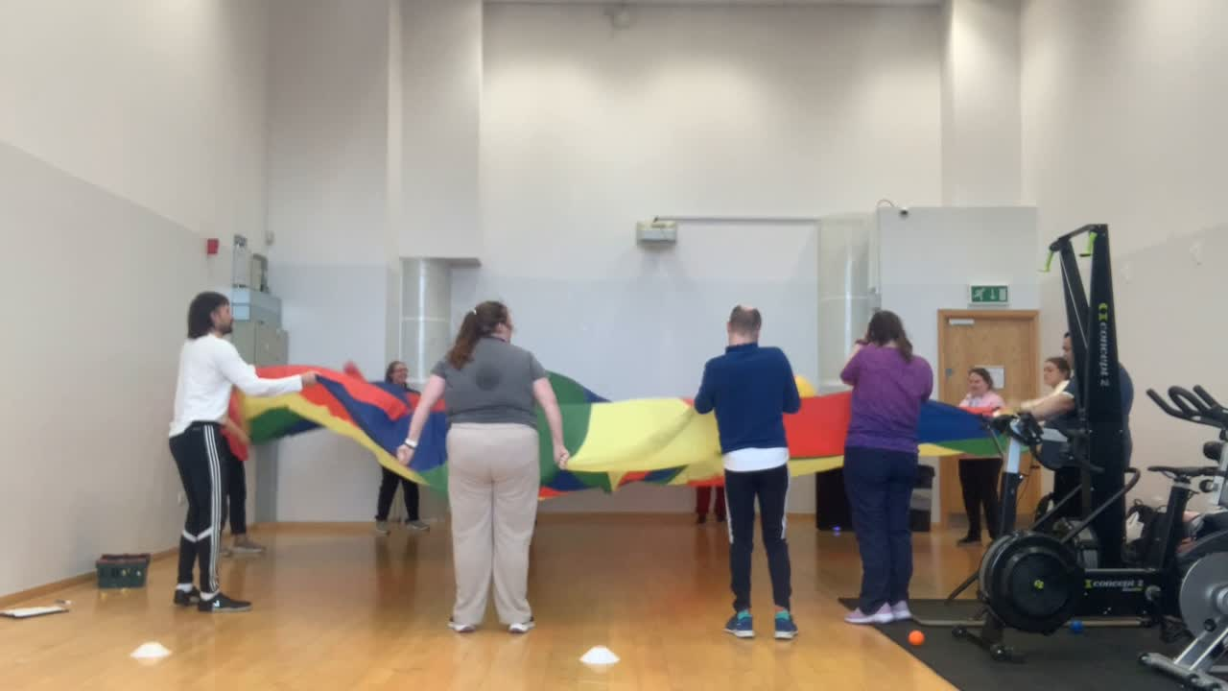

- Evaluation
How was the project evaluated?
Please check the box(es) that apply regarding the type of evaluation and data collection method
Type of Evaluation
Formative Evaluation: ☐  Conducted during development or early implementation to make improvements to the program design. | Process Evaluation: ☒  Assesses how the program is being implemented, including participation rates, quality of delivery, and whether it is reaching its target audience. | Outcome Evaluation: ☐  Focuses on the results—the changes in behaviors, attitudes, or conditions—at the end of a project. | Summative Evaluation: ☐  Assesses the overall effectiveness of a program after its completion to determine if it achieved its intended goals.
Data Collection Method
Survey/Questionnaire ☒  Document Review ☐ (project reports, financial data, attendance logs, etc.)  Direct Observations ☒ | Focus Groups ☐  Interviews ☐  Case Studies ☐  Other____________
High-Level Outcome and Impact
Please include high-level outcomes and impact if not already covered in the summary above.

- Contact Details
Contact Name/s | Ethan Scally (Student Activator)  Donal McNally (Director of Sport – Carlow)
Date | 2nd April, 2026
Email Address | C00325659@setu.ie  Donal.mcnally@setu.ie

