HEA Healthy Campus Case Study Template 2026

NOTES FOR COMPLETION
Context
- Case studies should relate to your institution's progression of the following policies:
  - HEA Healthy Campus Charter and Framework
  - HEA Healthy Campus Self-Evaluation Tool
  - National Student Mental Health and Suicide Prevention Framework
  - The Limerick Framework for Action: Advancing the Health Promoting Campus Agenda
- Case studies can include a wide range of work including those relating to governance and oversight, planning, strategy, policy, research, implementation, as well as others.
- We encourage examples that also showcase the interaction of wellbeing and other areas for example sustainability, belonging, progression, teaching and learning.
Template
- Please be as concise and clear as possible and consider the use of bullet points to summarise information.
- All sections must be completed.
- Case studies should be written in the third person and anonymous when it comes to participants’ names.
- Case studies will be used as part of HEA communications including email, website, and social media.
Submission
- Please submit your case study to healthycampus@hea.ie by COB Friday, April 3rd for display at the 2026 Health and Wellbeing Conference.

HEALTHY CAMPUS CASE STUDY
- Project Title | RCSI Step Challenge 2026
- Institution/ Organisation | RCSI
- Who leads/ led the project? | RCSI Inspire (RCSI Staff Wellbeing Programme)  Yvette Moffatt and Katie Griffin
- Date and timeframe | February 16th – March 29th
- Population Group (tick all that apply) | - Students ☐  - Staff ☒  - Wider community ☐  - Other ☐
- Health Topic (tick all that apply) | - Alcohol ☐  - Substance Misuse ☐  - Healthy Eating / Food ☐  - Mental Health & Wellbeing ☒  - Sexual Health & Wellbeing ☐  - Tobacco/ Vape Free Campus ☐  - Physical Activity / Active Transport ☒  - Wellbeing and the Curriculum ☒  - Health & Sustainability ☒  - Other ☐

- Project Alignment

Use the categories below to highlight the alignment of the project with national policy. Please tick all that apply.

Limerick Framework for Action - 10 Actions  LFfA pg. 12 | Healthy Campus Process  HCCF pg. 4 | Whole Campus Approach  HC Tool pg. 8 | Principles of a Healthy Campus  HC Tool + HCCF | National Student Mental Health and Suicide Prevention Framework NSMHSPF
1.Ethos ☒ | Commit ☐ | Leadership, Strategy & Governance  (Pillar 1) ☐ | Participation ☒ | Lead ☐
2.Act ☒ | Coordinate ☐ | Campus Environment (Facilities & Services) (Pillar 2) ☐ | Partnership ☐ | Collaborate ☐
3.Localise ☒ | Consult ☐ | Campus Culture & Communications (Pillar 3) ☐ | Evidence Based ☒ | Educate ☐
4.Leadership ☒ | Create ☒ | Personal & Professional Development  (Pillar 4) ☐ | Sustainability (Longevity) ☒ | Engage ☐
5.Policies ☒ | Celebrate & continue ☒ | Health Focused Area (Pillar 5) ☒ |  | Identify ☐
6.Culture ☒ |  |  |  | Support ☐
7.Partnership ☒ |  |  |  | Respond ☐
8.Students ☐ |  |  |  | Transition ☐
9.Research ☐ |  |  |  | Improve ☐
10.Celebrate ☒

- Project Rationale | The idea originated from the Work Well Community. The RCSI Step Challenge was introduced to promote increased physical activity and strengthen workplace connections among staff. This initiative supports RCSI’s commitment to fostering a Healthy Campus environment by enhancing staff wellbeing, building collegiality, and integrating physical activity into everyday campus life.
- Aims and Objectives | The aim of the Step Challenge was to promote physical activity and foster social connection among RCSI staff through a fun, team-oriented initiative. The project sought to encourage movement, raise awareness of the benefits of walking for wellbeing, and strengthen the culture of health across the institution.  Objectives included:  - Increasing daily step counts across the staff body.  - Encouraging teamwork and collaboration through group participation.  - Supporting mental wellbeing by promoting active breaks, fresh air and social walking.  - Embedding accessible wellbeing opportunities into the academic calendar.  - Providing a platform for staff to build sustainable, healthy routines.  - Enhancing visibility and engagement with Healthy Campus initiatives.
- Project Overview/ Summary | Planning  - The Step Challenge was organised and coordinated by the RCSI Inspire Team.  - Planning focused on ensuring accessibility, clear instructions and minimal barriers for staff.  - A six‑week challenge duration was selected, aligning with the Lenten period. Instead of focusing on giving something up, the initiative encouraged staff to take up a positive health‑enhancing activity, supporting long‑term habit formation.  - Communications included a launch announcement, leader board updates, and prizes for best step challenge photo each week.  Implementation  - A total of 28 teams participated, involving 215 staff members from across RCSI.  - A staff member in each group volunteered as a team lead to collect and record their team’s steps in the central tracker.  - Friendly competition was encouraged through weekly leader board updates.  - The Inspire Team shared tips for increasing daily movement and highlighted the mental health benefits of active breaks – e.g., lunch time walks.  - Staff were encouraged to integrate walking into their workdays through walking meetings and lunchtime walks.  Evaluation  - Step data was reviewed to assess participation and engagement.  - A postchallenge survey captured feedback on experience, wellbeing impact and suggestions.  - Observations from the Inspire Team and Challenge team leads provided insight into staff morale and engagement – captured through email responses and posts on the Step Challenge WorkVivo group page.  Key Outcomes  - An average of over ten million steps were collectively recorded for 6 weeks walking per team.  - Staff shared their activity to the group page to boost team morale.  - Challenge members shared positive experiences and how the step challenge was helping them boost their mood and increase physical activity.
- Collaboration | RCSI Inspire Team (project organisers)  Team Leads (responsible for submitting team steps)
- Resource Requirements | - Administration time from the RCSI Inspire Team  - Simple step-tracking spreadsheet and team submission process  - Internal communications support  - Budget for prizes
- What are the next steps for the project? | - Continue delivering the Step Challenge annually as a flagship wellbeing event.  - Explore new categories (e.g., “Most Improved Team”, “Best Team Spirit”).
- Key Learning Points | The most significant learning from this project was that simple, low barrier wellbeing initiatives can achieve high engagement and strong morale across staff groups. The challenge team leads played an essential role in maintaining momentum, and their involvement helped foster accountability and community spirit. Regular, clear communication was key in sustaining motivation, while flexibility in tracking methods ensured inclusivity.  For institutions planning a similar initiative, it is recommended to prioritise ease of participation, ensure communications are frequent and encouraging, and empower team leads to champion the challenge within their groups. Celebrating milestones and sharing progress stories also played a positive role in engagement.
- Images and Links | 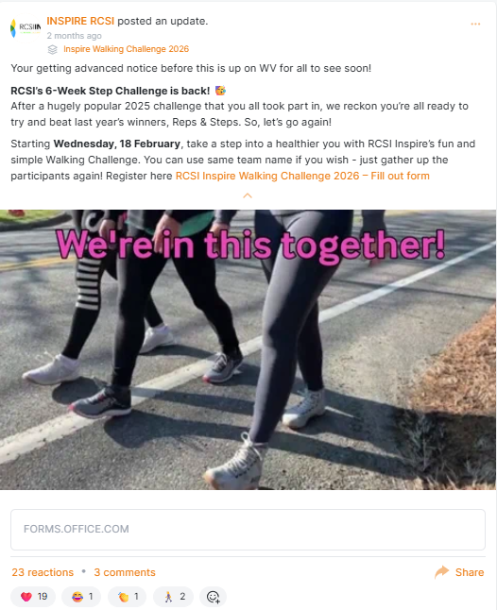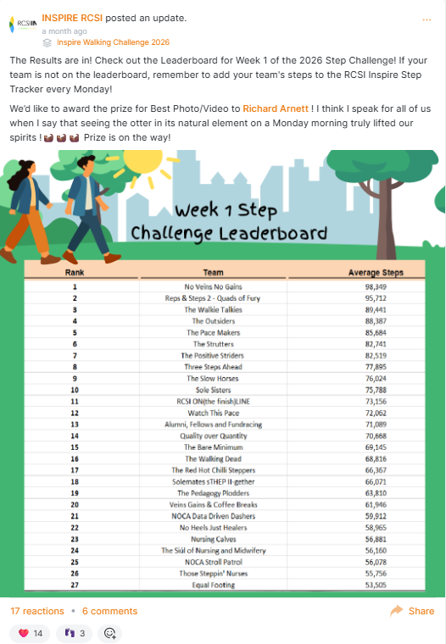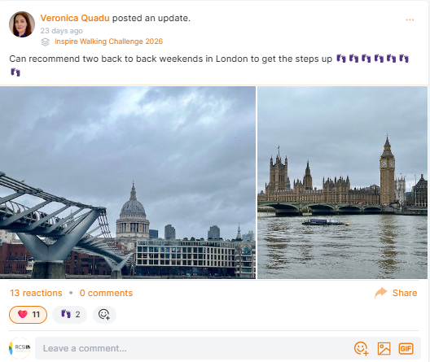  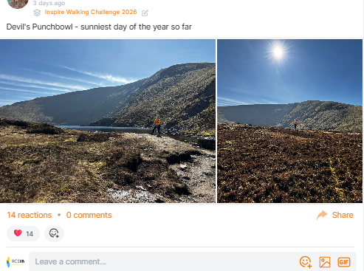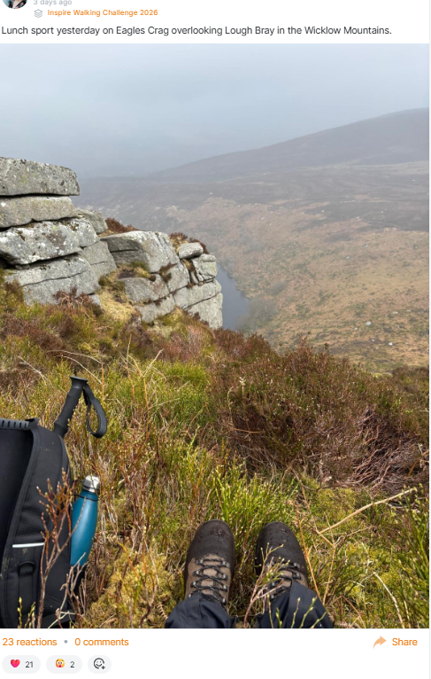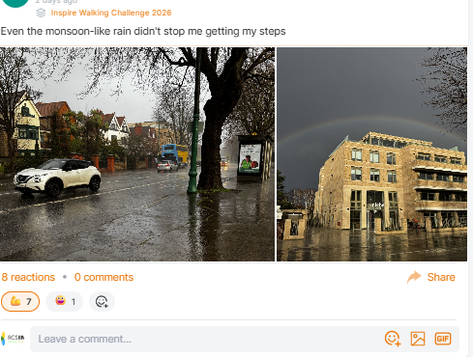  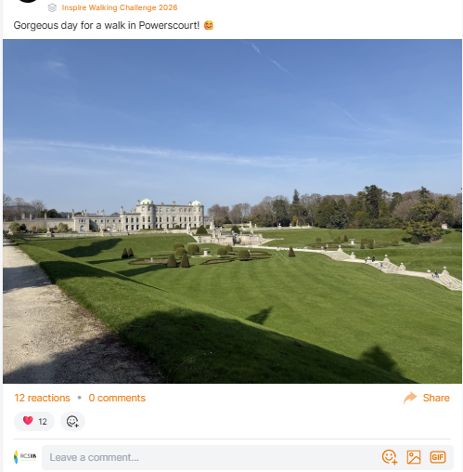  Survey Link : https://www.surveymonkey.com/r/DFG5ZK3

- Evaluation
How was the project evaluated?
Please check the box(es) that apply regarding the type of evaluation and data collection method
Type of Evaluation
Formative Evaluation: ☐  Conducted during development or early implementation to make improvements to the program design. | Process Evaluation: ☒  Assesses how the program is being implemented, including participation rates, quality of delivery, and whether it is reaching its target audience. | Outcome Evaluation: ☒  Focuses on the results—the changes in behaviors, attitudes, or conditions—at the end of a project. | Summative Evaluation: ☒  Assesses the overall effectiveness of a program after its completion to determine if it achieved its intended goals.
Data Collection Method
Survey/Questionnaire ☒  Document Review ☐ (project reports, financial data, attendance logs, etc.)  Direct Observations ☒ | Focus Groups ☐  Interviews ☐  Case Studies ☐  Other____________
High-Level Outcome and Impact
The challenge promoted sustained physical activity, improved staff morale and strengthened team cohesion. Staff reported increased energy, better mood and stronger connections with colleagues. The project also enhanced visibility of wellbeing initiatives and contributed to the overall Healthy Campus culture at RCSI.

- Contact Details
Contact Name/s | RCSI Inspire Team – Yvette Moffatt and Katie Griffin
Date | 27/03/2026
Email Address | inspire@rcsi.ie

