HEA Healthy Campus Case Study Template 2026

NOTES FOR COMPLETION
Context
- Case studies should relate to your institution's progression of the following policies:
  - HEA Healthy Campus Charter and Framework
  - HEA Healthy Campus Self-Evaluation Tool
  - National Student Mental Health and Suicide Prevention Framework
  - The Limerick Framework for Action: Advancing the Health Promoting Campus Agenda
- Case studies can include a wide range of work including those relating to governance and oversight, planning, strategy, policy, research, implementation, as well as others.
- We encourage examples that also showcase the interaction of wellbeing and other areas for example sustainability, belonging, progression, teaching and learning.
Template
- Please be as concise and clear as possible and consider the use of bullet points to summarise information.
- All sections must be completed.
- Case studies should be written in the third person and anonymous when it comes to participants’ names.
- Case studies will be used as part of HEA communications including email, website, and social media.
Submission
- Please submit your case study to healthycampus@hea.ie by COB Friday, April 3rd for display at the 2026 Health and Wellbeing Conference.

HEALTHY CAMPUS CASE STUDY
- Project Title | Changing Place at RCSI
- Institution/ Organisation | RCSI
- Who leads/ led the project? | Collette Power, Estate & Support Services Department.
- Date and timeframe | Official opening pending. Awaiting final registration with Changing Places Ireland
- Population Group (tick all that apply) | - Students ☐  - Staff ☐  - Wider community ☒  - Other ☐
- Health Topic (tick all that apply) | - Alcohol ☐  - Substance Misuse ☐  - Healthy Eating / Food ☐  - Mental Health & Wellbeing ☐  - Sexual Health & Wellbeing ☐  - Tobacco/ Vape Free Campus ☐  - Physical Activity / Active Transport ☐  - Wellbeing and the Curriculum ☐  - Health & Sustainability ☒  - Other ☒

- Project Alignment

Use the categories below to highlight the alignment of the project with national policy. Please tick all that apply.

Limerick Framework for Action - 10 Actions  LFfA pg. 12 | Healthy Campus Process  HCCF pg. 4 | Whole Campus Approach  HC Tool pg. 8 | Principles of a Healthy Campus  HC Tool + HCCF | National Student Mental Health and Suicide Prevention Framework NSMHSPF
1.Ethos ☐ | Commit ☒ | Leadership, Strategy & Governance  (Pillar 1) ☐ | Participation ☒ | Lead ☐
2.Act ☐ | Coordinate ☒ | Campus Environment (Facilities & Services) (Pillar 2) ☒ | Partnership ☒ | Collaborate ☐
3.Localise ☐ | Consult ☒ | Campus Culture & Communications (Pillar 3) ☐ | Evidence Based ☒ | Educate ☐
4.Leadership ☐ | Create ☒ | Personal & Professional Development  (Pillar 4) ☐ | Sustainability (Longevity) ☒ | Engage ☐
5.Policies ☐ | Celebrate & continue ☐ | Health Focused Area (Pillar 5) ☐ |  | Identify ☐
6.Culture ☐ |  |  |  | Support ☐
7.Partnership ☒ |  |  |  | Respond ☐
8.Students ☐ |  |  |  | Transition ☐
9.Research ☐ |  |  |  | Improve ☐
10.Celebrate ☐

- Project Rationale | The Royal College of Surgeons in Ireland is committed to the provision of a centrally located Changing Places toilet at 118 St Stephen’s Green. This facility will not only meet statutory planning requirements but will also meaningfully enhance accessibility across the city-centre campus and support the delivery of inclusive, dignified amenities in the heart of Dublin.
- Aims and Objectives | - To deliver a Changing Places facility that meets all relevant statutory requirements, technical standards, and best practice guidance for accessibility and universal design.  - To provide appropriate, dignified, and safe facilities that support people with complex care needs to participate more fully in everyday life, including activities such as family outings, shopping, and attendance at cultural or social events.  - To support individuals with profound and multiple disabilities, along with their carers, by providing adequate space, specialist equipment, and safe, hygienic conditions.  - To enhance the overall accessibility of the Royal College of Surgeons in Ireland city-centre campus, ensuring it is inclusive and welcoming to all users, including students, staff, and visitors.  - To ensure that, while the facility is located within 118 St Stephen’s Green—which also accommodates the Humanarium exhibition space and café—it operates as a wider University resource and is not restricted to Humanarium opening hours.  - To contribute to the wider provision of inclusive public infrastructure within Dublin, addressing the recognised need for centrally located Changing Places facilities.  - To promote dignity, equality, and independence by enabling users to remain in the city centre for longer periods without barriers to essential personal care.
- Project Overview/ Summary | - The provision of a Changing Places facility forms part of the overall development of the new seven-storey, c.13,000 sq.m building at 118 St Stephen’s Green, developed by the Royal College of Surgeons in Ireland as a key component of its city-centre campus. The building accommodates students, staff, and researchers and has been designed to support a modern, inclusive academic environment.  - From the outset, the project design team placed a strong emphasis on Universal Design principles, ensuring that accessibility and inclusivity are embedded throughout the building. This approach is reflected in the incorporation of key provisions such as the Changing Places facility, alongside additional supports including expressing rooms and dedicated mindfulness spaces.  - A Changing Places toilet is a specialist accessible sanitary facility designed to meet the needs of people with a range of disabilities who may require assistance. It typically includes a height-adjustable adult-sized changing bench, ceiling-mounted hoist system, accessible toilet, washbasin, all within a layout that allows sufficient space for carers and safe manoeuvring.  - The facility is located at Level -1 within 118 St Stephen’s Green and represents one of the most centrally located Changing Places toilets in Dublin. It will be available seven days a week from 07:00 to 22:00, with limited exceptions (e.g. Christmas Day). While situated within a building that also houses the Humanarium exhibition space and café.  - The project is currently in the final stages of registration with Changing Places Ireland. Upon completion of this process, the facility will be formally included on the national register, followed by an official opening.
- Collaboration | The Royal College of Surgeons in Ireland is actively engaging with a range of accessibility stakeholders, both within Dublin and nationally, to support awareness and uptake of the new Changing Places facility at 118 St Stephen’s Green. This collaborative approach is intended to maximise the facility’s visibility and ensure it meets the needs of its intended users.  Engagement to date includes collaboration with accessibility advocates such as Vicki Casserly, alongside national tourism and development bodies including Fáilte Ireland, as well as local community groups and businesses. These partnerships are supporting targeted outreach and the dissemination of information to relevant user groups.  In addition, the Royal College of Surgeons in Ireland is working in conjunction with nearby cultural and entertainment venues, including the Gaiety Theatre, to align promotional activity with scheduled events and performances. This coordinated approach will help ensure that individuals attending cultural and social activities in the city centre are aware of, and can benefit from, the availability of the facility.
- Resource Requirements | The delivery of this facility has been fully backed by RCSI Senior Management with commitment to the required space and budgetary fit out etc.
- What are the next steps for the project? | Next steps are to finalise the registration process with Changing Places and continue to promote the availability of the facility.
- Key Learning Points | - The development and delivery of the Changing Places facility at 118 St Stephen’s Green has provided a number of important insights that may inform future projects undertaken by the Royal College of Surgeons in Ireland and others:  - Early integration of Universal Design: Embedding accessibility and Universal Design principles from the outset of the project was critical to ensuring that the Changing Places facility, along with other inclusive features, could be delivered effectively without retrofitting or compromise.  - Value of stakeholder engagement: Ongoing collaboration with accessibility groups, advocates, and end users has been essential in shaping the design, functionality, and promotion of the facility, ensuring it responds to real and practical needs.  - Importance of central location: Locating the facility within a highly accessible, city-centre setting enhances its usability and impact, supporting broader participation in education, work, and social and cultural activities within Dublin.  - Operational considerations: Planning for extended opening hours, clear access arrangements, and integration within overall building management is key to ensuring the facility is reliable, usable, and genuinely accessible to the public.  - Awareness and visibility: The effectiveness of such facilities is closely linked to awareness. Proactive communication and partnerships with local organisations and venues are essential to ensure that potential users know the facility exists and how to access it.  - Beyond compliance: While the provision of the facility meets statutory planning requirements, the project demonstrates the added value of going beyond minimum compliance to deliver meaningful, dignity-led accessibility outcomes.
- Images and Links | Please include 1/2 images related to the project, this can include document cover pages, logos, a picture of a team meeting etc.  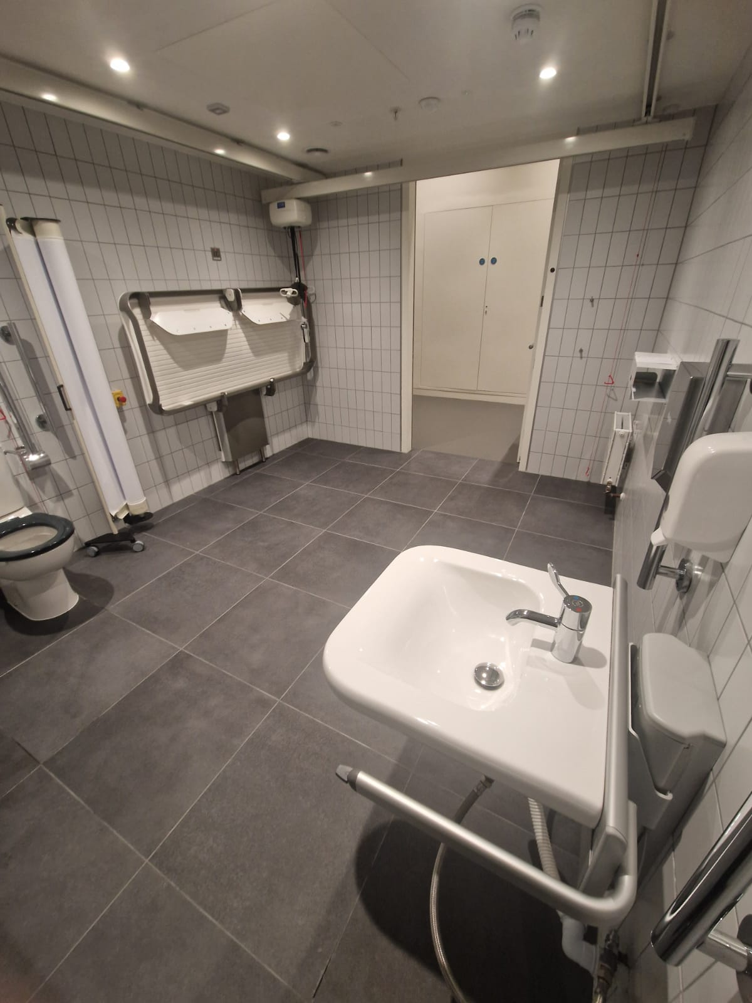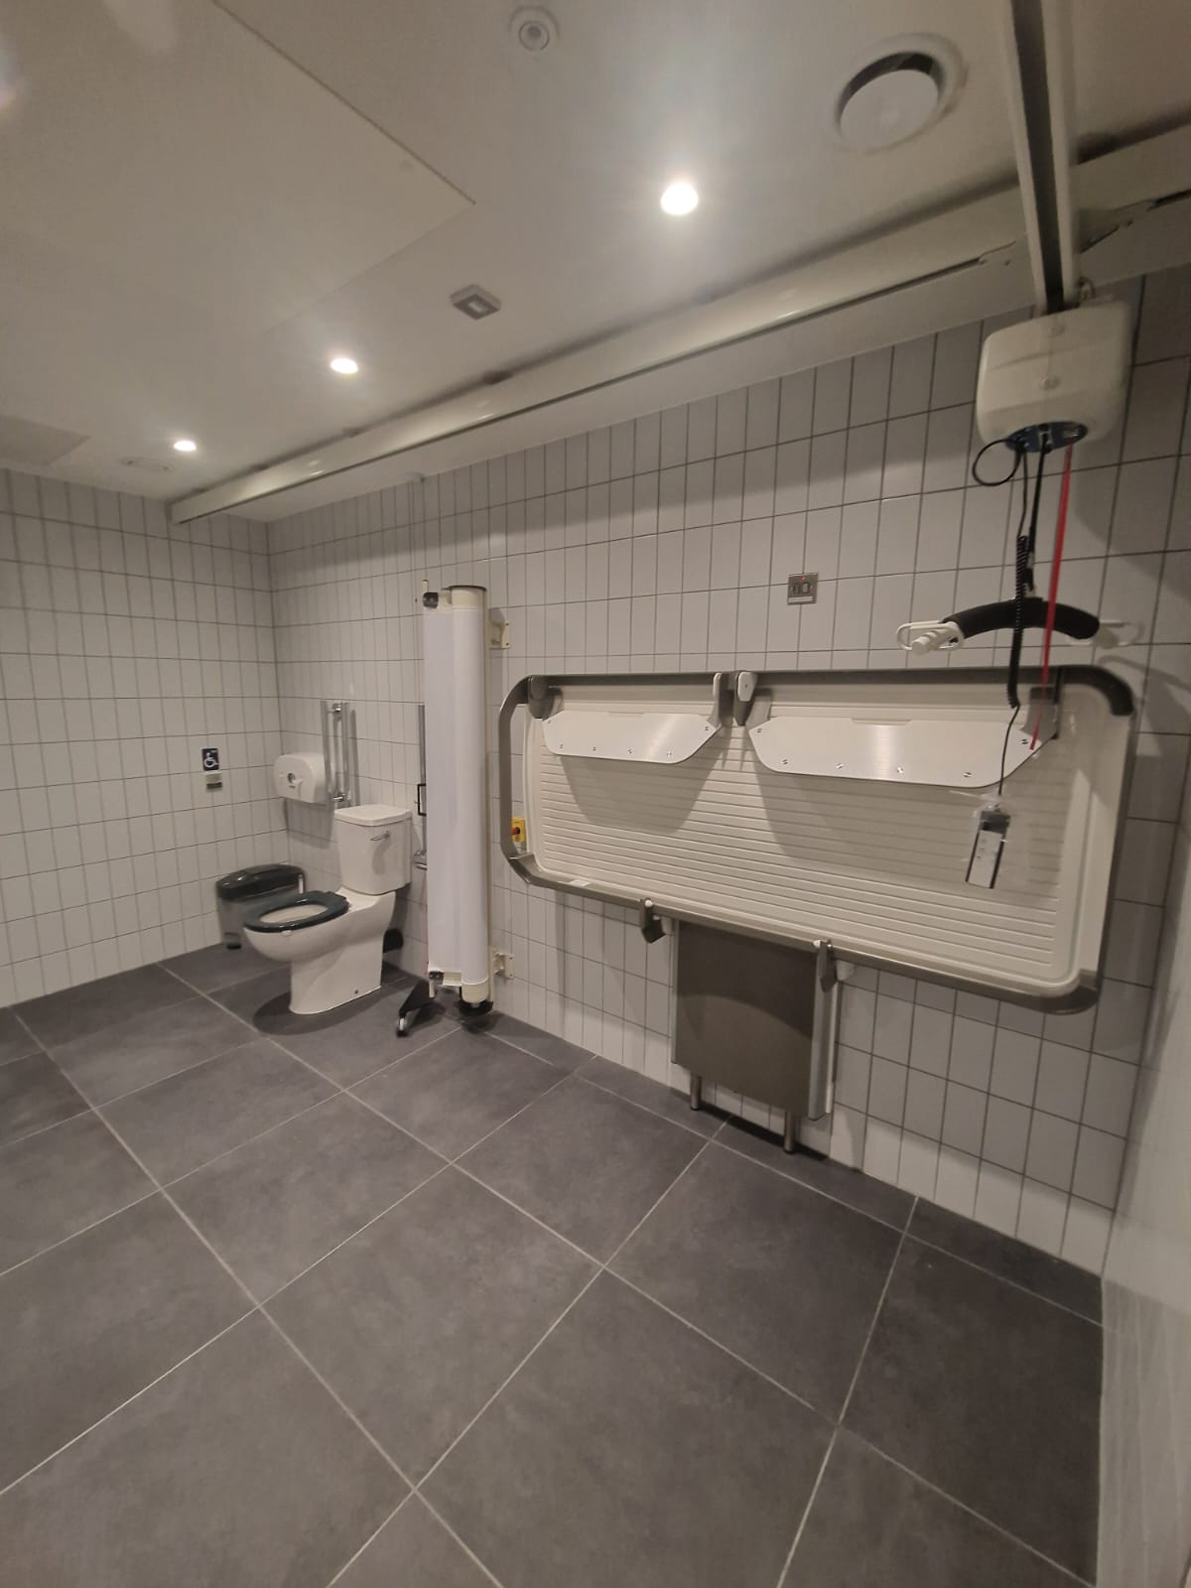  This facility will be advertised on www.rcsi.com and Changing Places Ireland – WeAllGottaGo once it is registered with Changing Places Ireland

- Evaluation
How was the project evaluated?
Please check the box(es) that apply regarding the type of evaluation and data collection method
Type of Evaluation
Formative Evaluation: ☐  Conducted during development or early implementation to make improvements to the program design. | Process Evaluation: ☐  Assesses how the program is being implemented, including participation rates, quality of delivery, and whether it is reaching its target audience. | Outcome Evaluation: ☐  Focuses on the results—the changes in behaviors, attitudes, or conditions—at the end of a project. | Summative Evaluation: ☒  Assesses the overall effectiveness of a program after its completion to determine if it achieved its intended goals.
Data Collection Method
Survey/Questionnaire ☐  Document Review ☒ (project reports, financial data, attendance logs, etc.)  Direct Observations ☐ | Focus Groups ☐  Interviews ☐  Case Studies ☐  Other: Though collaboration with Vicky Casserly and Failte Ireland
High-Level Outcome and Impact
Please include high-level outcomes and impact if not already covered in the summary above.

- Contact Details
Contact Name/s | Collette Power
Date | 31/03/2026
Email Address | collettepower@rcsi.com

