HEA Healthy Campus Case Study Template 2026

NOTES FOR COMPLETION
Context
- Case studies should relate to your institution's progression of the following policies:
  - HEA Healthy Campus Charter and Framework
  - HEA Healthy Campus Self-Evaluation Tool
  - National Student Mental Health and Suicide Prevention Framework
  - The Limerick Framework for Action: Advancing the Health Promoting Campus Agenda
- Case studies can include a wide range of work including those relating to governance and oversight, planning, strategy, policy, research, implementation, as well as others.
- We encourage examples that also showcase the interaction of wellbeing and other areas for example sustainability, belonging, progression, teaching and learning.
Template
- Please be as concise and clear as possible and consider the use of bullet points to summarise information.
- All sections must be completed.
- Case studies should be written in the third person and anonymous when it comes to participants’ names.
- Case studies will be used as part of HEA communications including email, website, and social media.
Submission
- Please submit your case study to healthycampus@hea.ie by COB Friday, April 3rd for display at the 2026 Health and Wellbeing Conference.

HEALTHY CAMPUS CASE STUDY
- Project Title | Approaching Student Mental Health workshops
- Institution/ Organisation | RCSI Dublin
- Who leads/ led the project? | RCSI Student Welfare Team, Comppas.
- Date and timeframe | Academic Year 2024 ongoing
- Population Group (tick all that apply) | - Students ☒  - Staff ☒  - Wider community ☐  - Other ☐
- Health Topic (tick all that apply) | - Alcohol ☐  - Substance Misuse ☐  - Healthy Eating / Food ☐  - Mental Health & Wellbeing ☒  - Sexual Health & Wellbeing ☐  - Tobacco/ Vape Free Campus ☐  - Physical Activity / Active Transport ☐  - Wellbeing and the Curriculum ☐  - Health & Sustainability ☐  - Other ☐

- Project Alignment

Use the categories below to highlight the alignment of the project with national policy. Please tick all that apply.

Limerick Framework for Action - 10 Actions  LFfA pg. 12 | Healthy Campus Process  HCCF pg. 4 | Whole Campus Approach  HC Tool pg. 8 | Principles of a Healthy Campus  HC Tool + HCCF | National Student Mental Health and Suicide Prevention Framework NSMHSPF
1.Ethos ☐ | Commit ☐ | Leadership, Strategy & Governance  (Pillar 1) ☐ | Participation ☒ | Lead ☐
2.Act ☐ | Coordinate ☒ | Campus Environment (Facilities & Services) (Pillar 2) ☐ | Partnership ☒ | Collaborate ☒
3.Localise ☐ | Consult ☒ | Campus Culture & Communications (Pillar 3) ☒ | Evidence Based ☐ | Educate ☒
4.Leadership ☐ | Create ☒ | Personal & Professional Development  (Pillar 4) ☐ | Sustainability (Longevity) ☐ | Engage ☒
5.Policies ☐ | Celebrate & continue ☐ | Health Focused Area (Pillar 5) ☐ |  | Identify ☐
6.Culture ☐ |  |  |  | Support ☒
7.Partnership ☒ |  |  |  | Respond ☐
8.Students ☒ |  |  |  | Transition ☐
9.Research ☐ |  |  |  | Improve ☐
10.Celebrate ☐

- Project Rationale | The rationale for the project, including any identified health needs.  The Student Welfare Team identified a need in the staff and student population for support in approaching mental health conversations. This was represented in referrals to the Student Welfare Team over time, measuring this from 2024.  Referrals from staff looking for advice in supporting student wellbeing and mental health was continually requested from the Student Welfare Team. Staff faced challenges in managing situations that presented to them, not feeling equipped to manage and contain theses situations prior to Student Welfare Referral.  An initial project targeted student facing staff in 2023 titled ‘Responding to Students in Distress’ was a workshop facilitated online using evidence based information to provide the tools to support staff to approach a mental health conversation, and gain an understanding of signposting information. Evidence through evaluation showed this increased staff’s confidence in addressing the topic.  In 2024 The Student Welfare Team redesigned this project and brought this to an in-person workshop targeting general student facing staff. This was facilitated on two occasions in academic year 2024/2025, and later being rebranded to ‘Approaching Student Mental Health’ in 2025/2026 to reflect the tone of the workshops.  The rationale is to support RCSI mental health literacy developing a whole campus culture of reducing stigma around mental health by making connections in everyday moments with those facing a mental health challenge.  Ongoing referrals from students requesting advice in how to support a peer going through a mental health challenge were also evident for the Student Welfare Team.  Based on this, the Student Welfare Team assessed the need as broader than the staff population and used an RCSI StEP project in 2024 as an opportunity initiate a collaboration with students to redevelop that staff workshop into a ‘Students supporting Students’ workshop.
- Aims and Objectives | - To increase RCSI campus mental health literacy.  - To provide staff and students with the skills to approach someone presenting with a mental health challenge.  - To increase staff and students’ confidence to have a conversation around a mental health challenge.  - To reduce stigma and provide awareness around mental health.  - To have awareness of available supports and recognise when to signpost for support.  - To provide a safe space for staff to discuss concerns and needs in regards to managing a mental health situation safely, using case examples.  - T provide a safe space for students to discuss issues around mental health impacting their peers and increasing confidence in managing this safely.
- Project Overview/ Summary | In bullet point format, please provide a high-level overview/ summary of your project covering elements such as planning, implementation and evaluation.  Planning  Approaching Student Mental Health Workshop;  - Evidence based counselling skills and tools were used in the creation of the workshops aligning with specific Social Work experience in Mental Health First Aid & Marte Meo Therapy communication skills. These skills and approaches were tailored to the needs of the population in light of received referrals and Senior Social Workers experience in working with students and staff.  - Over the course of academic year 2024/2025, and 2025/2026 there were three facilitated workshops targeting student facing staff population with a mix of professional services, academics, and clinical staff.  - One of these groups were targeted to professional services on clinical sites due to the complexity of referrals identified amongst this student group.  - Student Welfare are targeting the Estates Team including Security for the upcoming group in June 2026 to further collaborate with front of house staff and build networks.  - The Student Welfare Team advertised staff workshops on the social media Workvivo platform, with the support of HR Learning and Development.  Student Supporting Students Workshop;  - Student Welfare collaborated with Student Societies (i.e Psychiatry Soc & Health & Wellbeing Soc), Student Union Welfare Office, and Student Niteline representative for the development of the content of this peer support workshop.  - Students advertised the ‘Students Supporting Students’ workshop on their ‘Student Life’ social medial platform and RCSI Instagram.  Implementation  - Student Welfare Team coordinated the workshops alongside suitable dates with accessible appropriate venues within RCSI.  - The workshops were initially 1hour, with later workshops being 1.5hours to include case studies at the request of both staff and students in the different workshops.  - Refreshments were provided for students, to allow some networking opportunities.  Evaluation  - Each workshop had a tailored questionnaire to obtain feedback.  - There have been 5 workshops completed between academic years 2024-2026 with majority of positive feedback, and suggestions in terms of workshops going forward – these have been implemented with each subsequent workshop e.g increase in time, inclusion of case study examples and more opportunity for discussion.
- Collaboration | Collaboration with Students during Step Project – Health and Wellbeing Society, Niteline Representatives, Student Union Welfare, with involvement in presenting initial workshop and tailoring the content.  Post Graduate Step Project expressed interest in the workshop for StEP project 2026 and collaborated with Student Welfare in regards to this. These Students tailored information specific to their needs, including a role play and case studies, completing a joint workshop with Student Welfare in March 2026.
- Resource Requirements | 2 x Senior Social Workers from the Student Welfare team.  Students representing Student Union Welfare, Psychiatric Society & Health and Wellbeing Society.  Funding for refreshments – Commpas funded for staff/StEP for student workshops.
- What are the next steps for the project? | Commitment by 2 Senior Social Workers in The Student Welfare Team to continue with generic staff groups, with a plan to target certain groups, depending on need. Plan to facilitate twice per year  Target undergraduate and postgraduate students separately in collaboration with students in relevant Societies, Student Union, and Student Representatives for Niteline to ensure joint content creation and presentations alongside these student groups, with leadership form Student Welfare. Plan to facilitate twice per year.  Access resources for refreshments via Comppas Team funding to ensure opportunities for networking & connection.
- Key Learning Points | For example, what is the most important thing you learned and what key advice you can give to others starting a similar project.  - Ensure refreshments provided and extra time to allow space for networking and connections.  - Ensure space provided meets the needs of the group – working IT equipment, appropriate size for number of people, comfortable to arrange into small groups to facilitate group conversations and learning.  - Take time with ‘ice breakers’ giving group opportunity to connect with each other.  - Minimise information on slides, to maximise time for conversation and discussion.  - Continually tailor workshop based on evaluation feedback to ensure needs of specific groups are being met e.g. adding in relevant case studies, giving opportunity to bring certain questions or case examples at time of registration.  - Continually assess needs arising via Student Welfare referral system – can target specific groups based on these needs.  - Continually engage with student & staff stakeholders, develop and create relevant content.  - Joint presentation of content with students for ‘Students Supporting Students’.
- Images and Links | 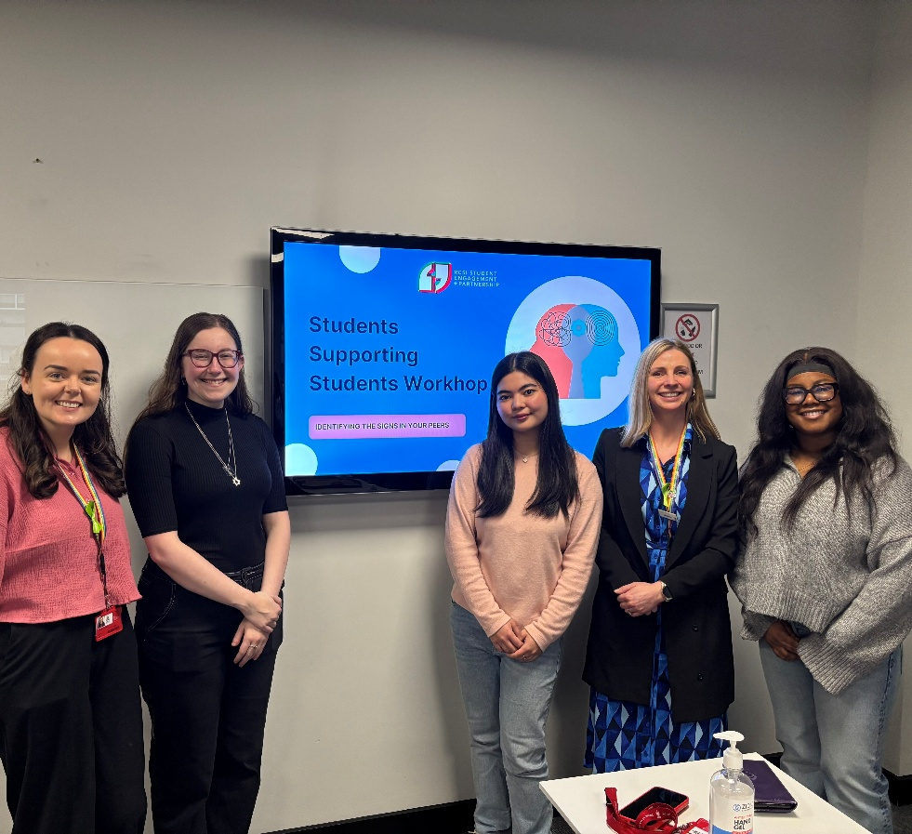  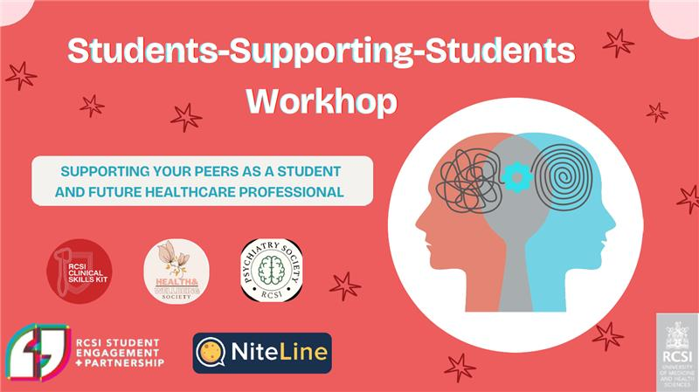

- Evaluation
How was the project evaluated?
Please check the box(es) that apply regarding the type of evaluation and data collection method
Type of Evaluation
Formative Evaluation: ☐  Conducted during development or early implementation to make improvements to the program design. | Process Evaluation: ☐  Assesses how the program is being implemented, including participation rates, quality of delivery, and whether it is reaching its target audience. | Outcome Evaluation: ☒  Focuses on the results—the changes in behaviors, attitudes, or conditions—at the end of a project. | Summative Evaluation: ☒  Assesses the overall effectiveness of a program after its completion to determine if it achieved its intended goals.
Data Collection Method
Survey/Questionnaire ☒  Document Review ☐ (project reports, financial data, attendance logs, etc.)  Direct Observations ☐ | Focus Groups ☐  Interviews ☐  Case Studies ☐  Other____________
High-Level Outcome and Impact
Please include high-level outcomes and impact if not already covered in the summary above.
As above – increase in mental health literacy in RCSI campus.

- Contact Details
Contact Name/s | Michelle Burnett & Gráinne Corcoran
Date | 1/04/2026
Email Address | michelleburnett@rcsi.ie

