HEA Healthy Campus Case Study Template 2026

NOTES FOR COMPLETION
Context
- Case studies should relate to your institution's progression of the following policies:
  - HEA Healthy Campus Charter and Framework
  - HEA Healthy Campus Self-Evaluation Tool
  - National Student Mental Health and Suicide Prevention Framework
  - The Limerick Framework for Action: Advancing the Health Promoting Campus Agenda
- Case studies can include a wide range of work including those relating to governance and oversight, planning, strategy, policy, research, implementation, as well as others.
- We encourage examples that also showcase the interaction of wellbeing and other areas for example sustainability, belonging, progression, teaching and learning.
Template
- Please be as concise and clear as possible and consider the use of bullet points to summarise information.
- All sections must be completed.
- Case studies should be written in the third person and anonymous when it comes to participants’ names.
- Case studies will be used as part of HEA communications including email, website, and social media.
Submission
- Please submit your case study to healthycampus@hea.ie by COB Friday, April 3rd for display at the 2026 Health and Wellbeing Conference.

HEALTHY CAMPUS CASE STUDY
- Project Title | MU Healthy Campus Try Tennis – Tennis Lessons
- Institution/ Organisation | Maynooth University
- Who leads/ led the project? | Healthy Campus (Sinéad McNulty, Healthy Campus Manager)
- Date and timeframe | Semester 2 – Academic Year 2025-2026
- Population Group (tick all that apply) | - Students ☒  - Staff ☒  - Wider community ☐  - Other ☐
- Health Topic (tick all that apply) | - Alcohol ☐  - Substance Misuse ☐  - Healthy Eating / Food ☐  - Mental Health & Wellbeing ☒  - Sexual Health & Wellbeing ☐  - Tobacco/ Vape Free Campus ☐  - Physical Activity / Active Transport ☒  - Wellbeing and the Curriculum ☐  - Health & Sustainability ☐  - Other ☐

- Project Alignment

Use the categories below to highlight the alignment of the project with national policy. Please tick all that apply.

Limerick Framework for Action - 10 Actions  LFfA pg. 12 | Healthy Campus Process  HCCF pg. 4 | Whole Campus Approach  HC Tool pg. 8 | Principles of a Healthy Campus  HC Tool + HCCF | National Student Mental Health and Suicide Prevention Framework NSMHSPF
1.Ethos ☐ | Commit ☒ | Leadership, Strategy & Governance  (Pillar 1) ☐ | Participation ☒ | Lead ☒
2.Act ☒ | Coordinate ☒ | Campus Environment (Facilities & Services) (Pillar 2) ☒ | Partnership ☒ | Collaborate ☒
3.Localise ☒ | Consult ☐ | Campus Culture & Communications (Pillar 3) ☐ | Evidence Based ☐ | Educate ☐
4.Leadership ☐ | Create ☒ | Personal & Professional Development  (Pillar 4) ☐ | Sustainability (Longevity) ☐ | Engage ☒
5.Policies ☐ | Celebrate & continue ☐ | Health Focused Area (Pillar 5) ☒ |  | Identify ☐
6.Culture ☒ |  |  |  | Support ☐
7.Partnership ☒ |  |  |  | Respond ☐
8.Students ☒ |  |  |  | Transition ☐
9.Research ☐ |  |  |  | Improve ☐
10.Celebrate ☐

- Project Rationale | MU Healthy Campus developed an activity in partnership with Tennis Ireland, to provide tennis lessons, enhancing skills, developing community, and improving use of on campus facilities through physical activity, with sustainability through linking with existing student and staff tennis clubs.  The initial pilot developed into a longer-term relationship providing coach education qualifications to MU Student teachers, as well as increasing physical activity participation on campus.
- Aims and Objectives | The aims of the project were:  - To introduce Tennis to students and staff  - To provide outdoor physical activity participation opportunities to staff and students  - To develop partnership with Tennis Ireland  - To enhance membership of student and staff tennis clubs/ groups  - To enhance usage of on campus tennis facilities.  - To deliver on healthy campus and mental health and wellbeing frameworks  - To enhance long term tennis opportunities on campus, for students, staff and local community.
- Project Overview/ Summary | The Try Tennis Coaching initiative ran across February and March with 20 participants completing 6 weeks of tennis lessons.  Participants at the end were directed to the Staff social tennis group, to continue their participation, and satisfaction levels were assessed, with strong demand for further lessons.  All participants learned how to Hit, Volley and Serve, and were educated in the rules of tennis, playing singles and doubles games by the end of the 6 weeks.  Individuals have progressed to join social tennis, and book courts themselves to play tennis on campus around their working hours.  Tennis Ireland were very satisfied with the programme, and are happy to extend it, running an additional set of lessons later in 2026, and put plans in place for 2026-2027 academic year.  An additional significant development has been the development of additional education programmes, whereby final year student teachers, through the development of a new programme, will be able to undertake training, and obtain coaching qualification to introduce tennis in primary, Froebel and post primary schools' environments. Additionally, the early years educators working in the creche will also be enabled to undertake the teacher training so that they can introduce tennis to the children in the Maynooth University on campus creche.  Further engagement with Kildare Sports partnership will work to develop additional programmes on campus, enhancing participation in the wider community.
- Collaboration | MU Healthy Campus, Tennis Ireland, MU Sports, MU Finance, MU IT, MU Campus Services/ Estates, Kildare LSP
- Resource Requirements | Tennis Courts  Collaboration with internal and external stakeholders – Tennis Ireland KSP  Staff time to prepare promotional materials, co-ordinate sign-ups,  Partnership with Internal Departments  Development of a Payment mechanism – to eliminate cash handling  Leadership and Sponsorship of initiative  Timetabling
- What are the next steps for the project? | - additional set of lessons later in 2026 (beginner and Beginner improver)  - plans in place for 2026-2027 academic year.  - Student teacher training as tennis coaches – pilot Sem 2 AY 26/27, to be embedded in AY 2027-208 and beyond, facilitating tennis to be rolled out in primary and secondary schools across the country through placements and employed teaching positions  - Coach training for early years educators in MU on campus Creche  - Development of Partnerships with Kildare Sports Partnership
- Key Learning Points | - Planning time – particularly to get the online payment system set up, estates/ insurance, risk assessments etc., Booking facilities well ahead of time  - Identifying strong and open project partners  - Engagement with participants throughout & encouragement  - Need Stronger standardised approach to research/ feedback collation  - ‘Next steps’ – where participants can progress to at end of programme  - High quality coaches – positive learning experience – (Adult learners, staff, people returning to the sport activity after 20/30 years)  - Consider who else on campus can benefit  - Keep it Fun
- Images and Links | Please include 1/2 images related to the project, this can include document cover pages, logos, a picture of a team meeting etc.  Please include links to webpages/ documents related to the project.  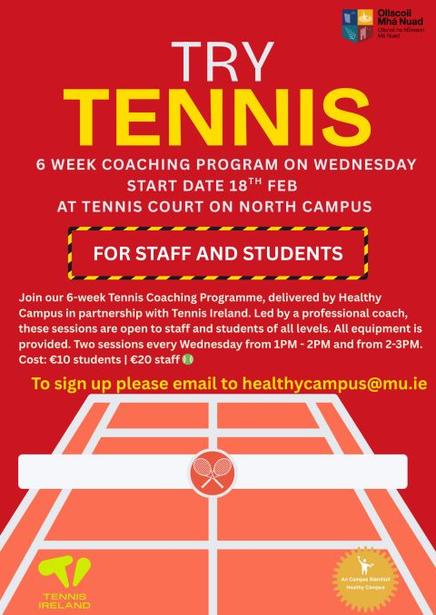  Post | LinkedIn  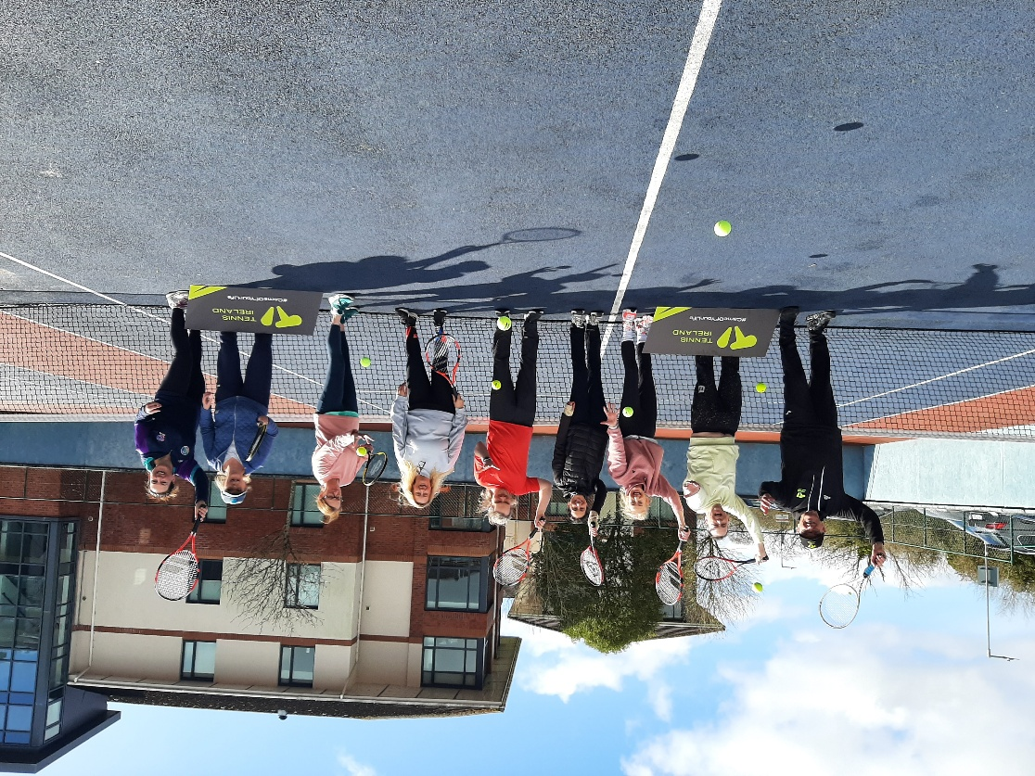  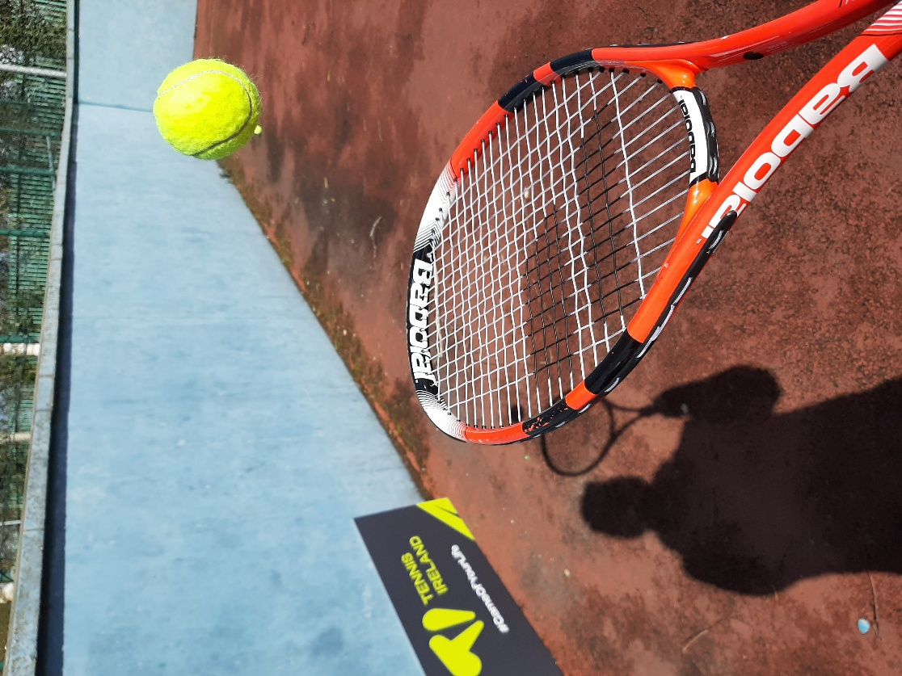
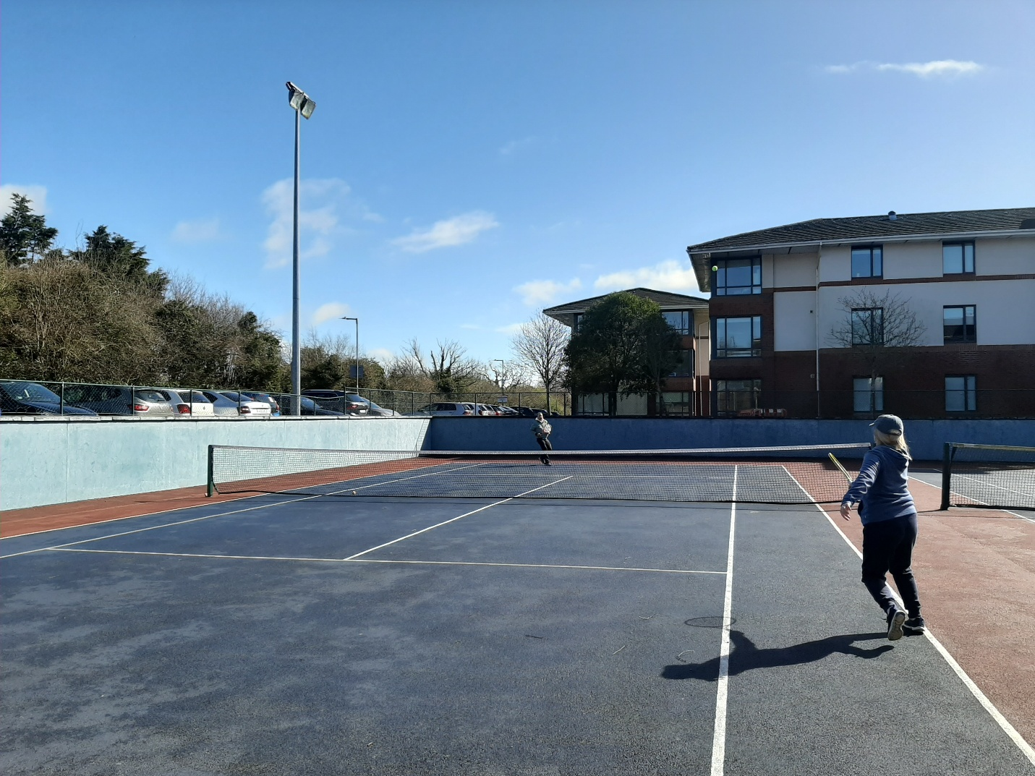

- Evaluation
How was the project evaluated?
Please check the box(es) that apply regarding the type of evaluation and data collection method
Type of Evaluation
Formative Evaluation: ☐  Conducted during development or early implementation to make improvements to the program design. | Process Evaluation: ☒  Assesses how the program is being implemented, including participation rates, quality of delivery, and whether it is reaching its target audience. | Outcome Evaluation: ☒  Focuses on the results—the changes in behaviors, attitudes, or conditions—at the end of a project. | Summative Evaluation: ☐  Assesses the overall effectiveness of a program after its completion to determine if it achieved its intended goals.
Data Collection Method
Survey/Questionnaire ☒  Document Review ☐ (project reports, financial data, attendance logs, etc.)  Direct Observations ☒ | Focus Groups ☐  Interviews ☐  Case Studies ☐  Other____________
High-Level Outcome and Impact
Demand for further lessons
Individuals participating in tennis themselves
Individuals progressing to social tennis group
Development of Teacher Coach education – to enhance curriculum
Partnership with Tennis Ireland and Kildare Sports partnership

- Contact Details
Contact Name/s | Sinead McNulty, Healthy Campus Manager, Maynooth University
Date | 25/03/2026
Email Address | Sinead.mcnulty@mu.ie

