HEA Healthy Campus Case Study Template 2026

NOTES FOR COMPLETION
Context
- Case studies should relate to your institution's progression of the following policies:
  - HEA Healthy Campus Charter and Framework
  - HEA Healthy Campus Self-Evaluation Tool
  - National Student Mental Health and Suicide Prevention Framework
  - The Limerick Framework for Action: Advancing the Health Promoting Campus Agenda
- Case studies can include a wide range of work including those relating to governance and oversight, planning, strategy, policy, research, implementation, as well as others.
- We encourage examples that also showcase the interaction of wellbeing and other areas for example sustainability, belonging, progression, teaching and learning.
Template
- Please be as concise and clear as possible and consider the use of bullet points to summarise information.
- All sections must be completed.
- Case studies should be written in the third person and anonymous when it comes to participants’ names.
- Case studies will be used as part of HEA communications including email, website, and social media.
Submission
- Please submit your case study to healthycampus@hea.ie by COB Friday, April 3rd for display at the 2026 Health and Wellbeing Conference.

HEALTHY CAMPUS CASE STUDY
- Project Title | Maynooth University – Circular Economy Collage Workshop
- Institution/ Organisation | Maynooth University
- Who leads/ led the project? | Sinead McNulty, Maynooth University Healthy Campus Manager – in Collaboration with Maynooth Green Campus
- Date and timeframe | E.g. academic year 2022 – 2023/ 2025 - ongoing.
- Population Group (tick all that apply) | - Students ☒  - Staff ☒  - Wider community ☐  - Other ☐
- Health Topic (tick all that apply) | - Alcohol ☐  - Substance Misuse ☐  - Healthy Eating / Food ☐  - Mental Health & Wellbeing ☐  - Sexual Health & Wellbeing ☐  - Tobacco/ Vape Free Campus ☐  - Physical Activity / Active Transport ☐  - Wellbeing and the Curriculum ☐  - Health & Sustainability ☒  - Other ☒

- Project Alignment

Use the categories below to highlight the alignment of the project with national policy. Please tick all that apply.

Limerick Framework for Action - 10 Actions  LFfA pg. 12 | Healthy Campus Process  HCCF pg. 4 | Whole Campus Approach  HC Tool pg. 8 | Principles of a Healthy Campus  HC Tool + HCCF | National Student Mental Health and Suicide Prevention Framework NSMHSPF
1.Ethos X | Commit ☒ | Leadership, Strategy & Governance  (Pillar 1) ☐ | Participation ☒ | Lead ☐
2.Act x | Coordinate ☒ | Campus Environment (Facilities & Services) (Pillar 2) ☒ | Partnership ☒ | Collaborate ☐
3.Localise x | Consult ☒ | Campus Culture & Communications (Pillar 3) ☒ | Evidence Based ☒ | Educate ☐
4.Leadership x | Create ☒ | Personal & Professional Development  (Pillar 4) ☐ | Sustainability (Longevity) ☒ | Engage ☐
5.Policies x | Celebrate & continue ☐ | Health Focused Area (Pillar 5) ☐ |  | Identify ☐
6.Culture x |  |  |  | Support ☐
7.Partnership x |  |  |  | Respond ☐
8.Students ☐ |  |  |  | Transition ☐
9.Research x |  |  |  | Improve ☐
10.Celebrate ☐

- Project Rationale | As part of the Healthy Campus ‘Healthy Physical Environments’ work area, an event was delivered in MU Green Week, to develop a greater understanding of the Circular Economy Concept, and identify opportunities to build on current Circular Economy work across Maynooth University
- Aims and Objectives | This event is a licensed, game style workshop designed to develop participants understanding of economy, impact and opportunity in relation to climate change.  To provide an opportunity to MU students and staff to  - compare linear economy and circular economy concepts,  - understand circular economy current status and offerings re. in Maynooth University, and  - co create opportunities to develop circular economy activities in collaboration Healthy Campus and Green Campus  - Circular Economy Collage
- Project Overview/ Summary | A circular economy collage workshop was planned, delivered by an external facilitator which provided an interactive way of considering circular economy. Through the process participants increased their awareness of circular economy projects and practices (local, national and personal. The workshop provided a forum to deepen understanding of impact and potential of circular economy and to co-create Maynooth University Specific actions to progress the circular economy as part of sustainability agenda.,  At the end of the workshop participants were invited to suggest actions and projects that MU could undertake to further enhance circular economy practise.
- Collaboration | The workshop was a collaborative project driven by MU Healthy Campus in collaboration with Maynooth Green Campus as part of MU Green Week. It was supported by MU Student Services and Green Campus (Funders), and delivered by Waggle Learning (External Facilitator of Circular Economy Collage)
- Resource Requirements | The resources required were  - Staff time,  - Development of promotional materials, and promotion  - Recruitment of attendees  - Develop of pre and post event questions, ,  - Room booking and set up event  - funding partners to pay for external facilitators, external Company
- What are the next steps for the project? | The next steps are to review output from event, and feedback from questionnaires, to create an action plan for circular economy which will be proposed to MU Healthy Campus Steering Group for action.  Circular Economy Collage is one event in a series related to Climate Fresk and there are opportunities to run further workshop events on campus (Climate Fresk, Digital Collage etc.) as well as opportunities to train university colleages (Faculty and professional services) to deliver these workshops in house.  Climate Fresk (world) - Climate Fresk  The Digital Collage - A workshop to understand the impact of AI and other digital technologies on the environment and how to reduce it
- Key Learning Points | Duration of Event – 3-hour requirement limited student attendance  Timing of event – day before start of holidays was not ideal  Funding – multi partner funding was required  Capacity building – building skills in house to be able to roll out programmes will be a vital next step  Partnership and building on existing work – green week and estates  Ideally integrating the workshops into academic programmes and / or including in an accreditation/ digital badge model will broaden the reach and enhance participation levels.
- Images and Links | Please include 1/2 images related to the project; this can include document cover pages, logos, a picture of a team meeting, etc.  Maynooth Healthy Campus | LinkedIn  Circular Economy Collage Workshop Tickets, Thursday, Apr 2 from 10 am to 1 pm | Eventbrite  (18) Post | Feed | LinkedIn  Climate Fresk (world) - Climate Fresk  The Digital Collage - A workshop to understand the impact of AI and other digital technologies on the environment and how to reduce it  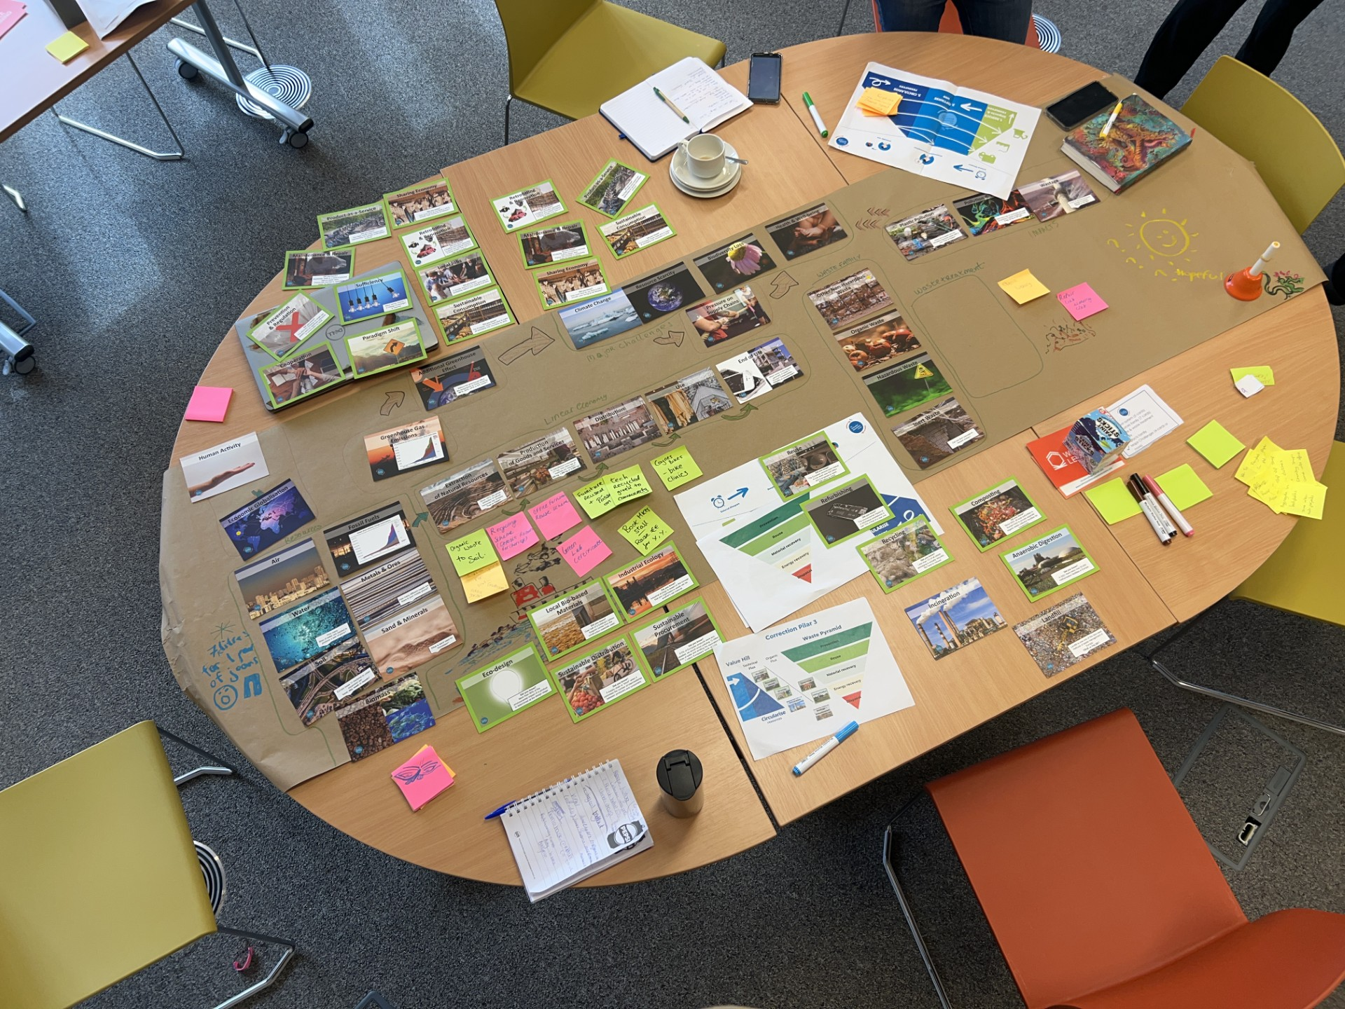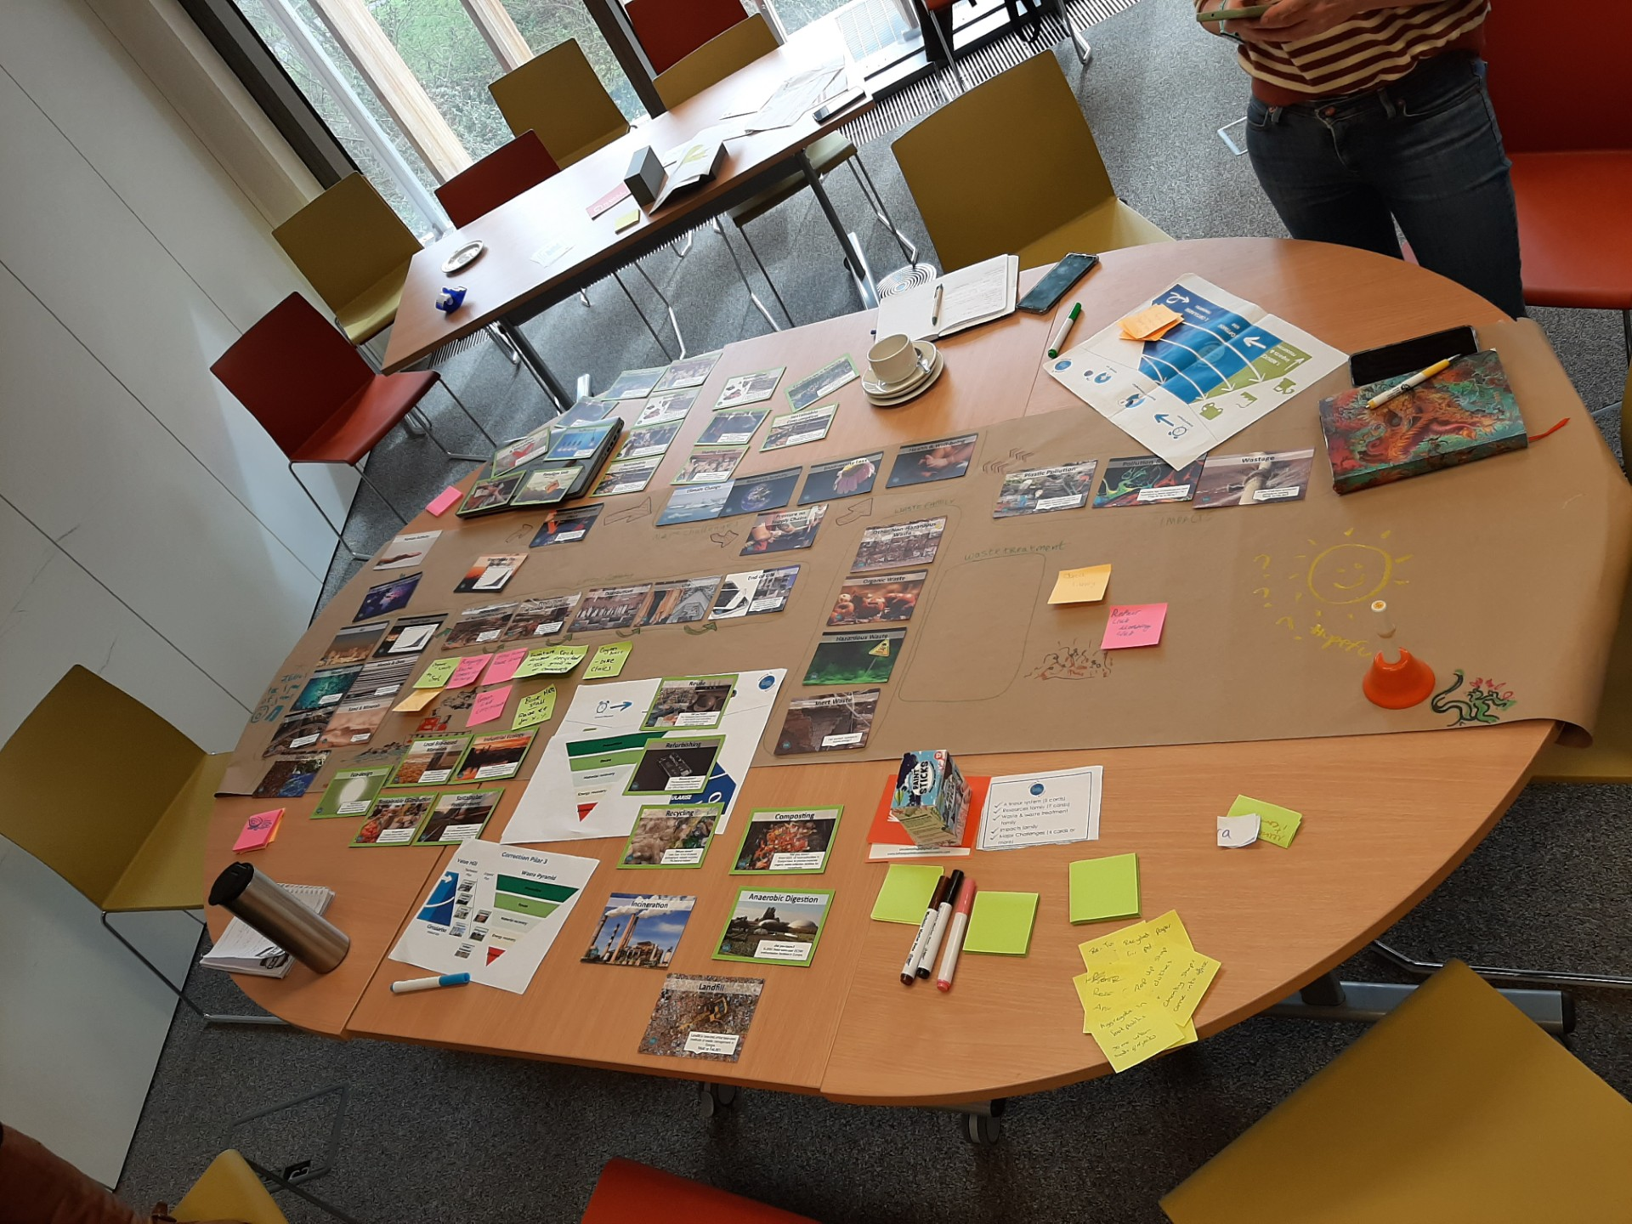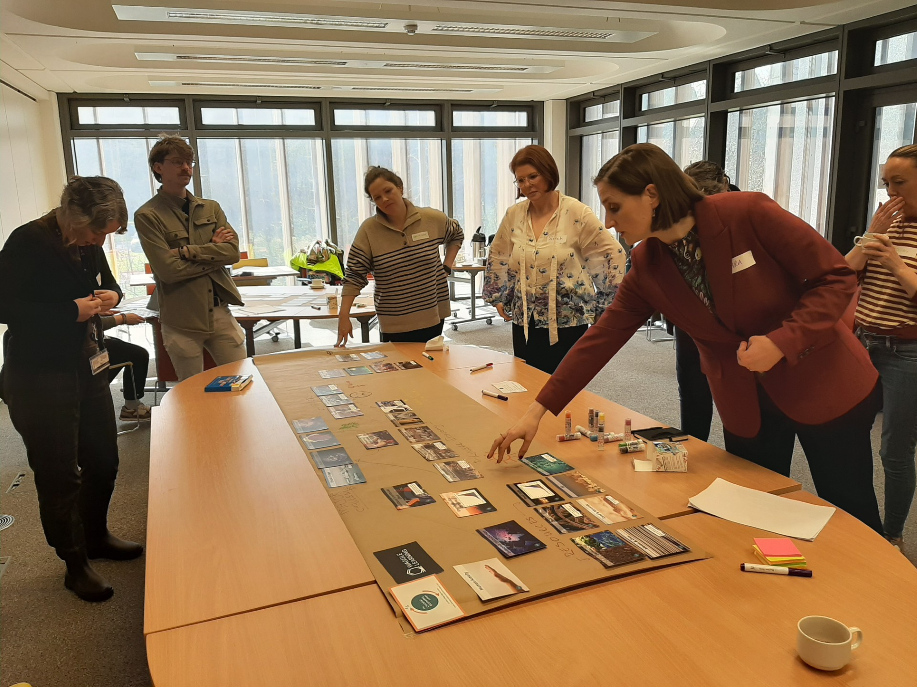  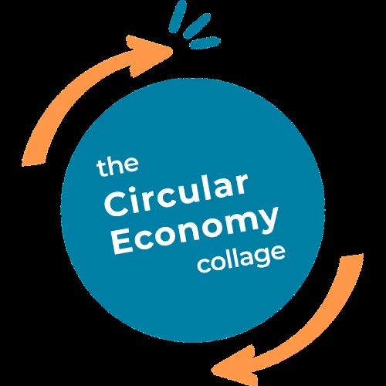  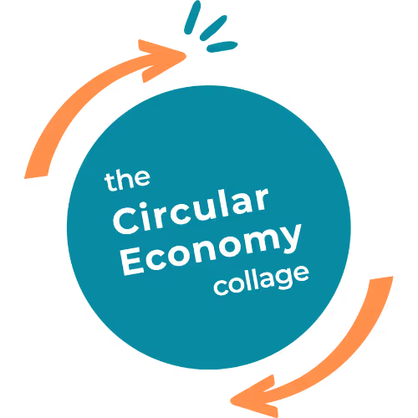

- Evaluation
How was the project evaluated?
Please check the box(es) that apply regarding the type of evaluation and data collection method
Type of Evaluation
Formative Evaluation: ☐  Conducted during development or early implementation to make improvements to the program design. | Process Evaluation: ☐  Assesses how the program is being implemented, including participation rates, quality of delivery, and whether it is reaching its target audience. | Outcome Evaluation: ☒  Focuses on the results—the changes in behaviors, attitudes, or conditions—at the end of a project. | Summative Evaluation: ☐  Assesses the overall effectiveness of a program after its completion to determine if it achieved its intended goals.
Data Collection Method
Survey/Questionnaire ☒  Document Review ☒ (project reports, financial data, attendance logs, etc.)  Direct Observations ☒ | Focus Groups ☐  Interviews ☐  Case Studies ☐  Other____________
High-Level Outcome and Impact
Increased awareness of
- Circular Economy Concept as part of Sustainability Action
- Current Actions underway in Maynooth University and wider Maynooth and Kildare Community
- Opportunities to embed Circular Economy thinking from project concept and design stage
- Actions that individuals, and Maynooth University As a whole can contribute to as part of circular economy and application of Value HIll

- Contact Details
Contact Name/s | Sinead McNulty, Healthy Campus Manager, Maynooth University
Date | 03/04/2026
Email Address | Sinead.mcnulty@mu.ie

