HEA Healthy Campus Case Study Template 2026

NOTES FOR COMPLETION
Context
- Case studies should relate to your institution's progression of the following policies:
  - HEA Healthy Campus Charter and Framework
  - HEA Healthy Campus Self-Evaluation Tool
  - National Student Mental Health and Suicide Prevention Framework
  - The Limerick Framework for Action: Advancing the Health Promoting Campus Agenda
- Case studies can include a wide range of work including those relating to governance and oversight, planning, strategy, policy, research, implementation, as well as others.
- We encourage examples that also showcase the interaction of wellbeing and other areas for example sustainability, belonging, progression, teaching and learning.
Template
- Please be as concise and clear as possible and consider the use of bullet points to summarise information.
- All sections must be completed.
- Case studies should be written in the third person and anonymous when it comes to participants’ names.
- Case studies will be used as part of HEA communications including email, website, and social media.
Submission
- Please submit your case study to healthycampus@hea.ie by COB Friday, April 3rd for display at the 2026 Health and Wellbeing Conference.

HEALTHY CAMPUS CASE STUDY
- Project Title | “DkITs Fittest” STEPS Challenge 2026
- Institution/ Organisation | Dundalk Institute of Technology (DkIT)
- Who leads/ led the project? | Dr. Sinéad O’Connor, Dr. Seán Kilroy, Noeleen Gregory and Fiona Hackett: The BSc (Hons) in Health and Physical Activity lecturing team from the Department of Life & Health Sciences, DkIT.
- Date and timeframe | The first semester of the academic years 2024 – 2025, 2025 - 2026 and ongoing.
- Population Group (tick all that apply) | - Students ☒  - Staff ☒  - Wider community ☐  - Other ☐
- Health Topic (tick all that apply) | - Alcohol ☐  - Substance Misuse ☐  - Healthy Eating / Food ☐  - Mental Health & Wellbeing ☒  - Sexual Health & Wellbeing ☐  - Tobacco/ Vape Free Campus ☐  - Physical Activity / Active Transport ☒  - Wellbeing and the Curriculum ☐  - Health & Sustainability ☒  - Other ☐

- Project Alignment

Use the categories below to highlight the alignment of the project with national policy. Please tick all that apply.

Limerick Framework for Action - 10 Actions  LFfA pg. 12 | Healthy Campus Process  HCCF pg. 4 | Whole Campus Approach  HC Tool pg. 8 | Principles of a Healthy Campus  HC Tool + HCCF | National Student Mental Health and Suicide Prevention Framework NSMHSPF
1.Ethos ☐ | Commit ☒ | Leadership, Strategy & Governance  (Pillar 1) ☐ | Participation ☒ | Lead ☐
2.Act ☒ | Coordinate ☒ | Campus Environment (Facilities & Services) (Pillar 2) ☐ | Partnership ☒ | Collaborate ☐
3.Localise ☒ | Consult ☒ | Campus Culture & Communications (Pillar 3) ☒ | Evidence Based ☒ | Educate ☐
4.Leadership ☒ | Create ☒ | Personal & Professional Development  (Pillar 4) ☒ | Sustainability (Longevity) ☒ | Engage ☐
5.Policies ☐ | Celebrate & continue ☒ | Health Focused Area (Pillar 5) ☒ |  | Identify ☐
6.Culture ☒ |  |  |  | Support ☐
7.Partnership ☒ |  |  |  | Respond ☐
8.Students ☐ |  |  |  | Transition ☐
9.Research ☐ |  |  |  | Improve ☐
10.Celebrate ☒

- Project Rationale | Following on from the success of “DkITs Fittest” 2024, “DkITs Fittest” 2025 adopted a settings-based approach in the promotion of physical activity engagement in both staff and students of DkIT in a sustainable way. This is in line with the Healthy Campus framework by “aspiring to create a learning environment and organizational culture that enhances the health and wellbeing of its’ community” (Higher Education Healthy Campus Charter & Framework for Ireland 2020-2025).
- Aims and Objectives | The aims of “DkITs Fittest” are as follows:  - Use a settings-based approach to promote physical activity engagement in both staff and students of DkIT.  - Promote an increase in sustainable physical activity by encouraging physical activity engagement in a fun and inclusive manner.  - Generate a greater awareness of the positive impact of physical activity on both physical and mental health.  - Foster and encourage staff and student development, as well as the growth and strengthening of relationships between both cohorts, in a meaningful way.
- Project Overview/ Summary | - Following on from the success of “DkITs Fittest” 2024, “DkITs Fittest” STEPS Challenge 2025 continued to use a settings-based approach to promote physical activity engagement in both staff and students of DkIT.  - 28 teams, including 168 participants (both staff and students), cross-campus, took part in this year’s Steps Challenge over a 4-week period.  - Over 9.5 million steps were logged (cumulative total of each team’s average weekly steps), demonstrating a clear collaborative effort from both staff and students involved.  - During this period, motivational emails (including relevant health information, weekly leaderboards) were sent to all involved in the challenge to encourage and motivate participants to stay engaged. Participants said that these emails acted as an incentive for them to stay engaged.  - Also, participants themselves identified that being part of a team-based challenge encouraged them to engage with the challenge. In addition, participants were encouraged to upload active photos of themselves, with the majority of these showing the participant outside enjoying nature, with the mental health benefits of exercising in nature being well documented.  - A finale and prize-giving ceremony celebrated the end of “DkITs Fittest” STEPS Challenge 2025 and was a lovely opportunity to celebrate everyone involved and to encourage participants to sustain their modified / new physical activity behaviors into the future.
- Collaboration | Internal: DkITs Healthy Campus group  External: Healthy Louth
- Resource Requirements | Financial: €700 funding was received from DkITs Healthy Campus committee. This was used to employ a graphic designer to generate promotional material and social media content, as well as the securing of prizes for the winning teams.  Personnel: 4 lecturing staff of the BSc (Hons) in Health and Physical Activity degree programme to market the challenge on an on-going basis, to log the team’s weekly step counts and to organise and host a finale and prize-giving event.
- What are the next steps for the project? | Following on from the success of “DkITs Fittest” 2024 and 2025, we envisage continuing to make “DkITs Fittest” STEPS Challenge a yearly event with the view to promoting and encouraging the sustainable participation of both staff and students in physical activity through inclusion and socialisation. In particular, we plan on recruiting new, incoming students during induction week with the hope of making the new first-year students feel part of the DkIT community right from the beginning of their studies. The continuation of the initiative will be contingent on securing funding to operationalise the challenge.
- Key Learning Points | - Integrating physical activity into the campus environment enhanced both the physical activity levels of students and staff, as well as fostering greater social interaction among them. Gaining insight into the motivators and barriers that influence sustained participation can inform the development of future health promotion initiatives aimed at creating a healthier campus community.  - Time Constraints: There was a lot of administration work associated with getting started and the logging of participant steps on a weekly basis was very time consuming. Moving forward with this challenge, additional administrative personnel would be recommended.  - Participant retention and long-term engagement: It is important to understand why some individuals are disengaged from the challenge and how adjustments to the challenge in the future might help to negate this.
- Images and Links | Examples of Resources generated:  Participation Invitation: Appendix 1  Finale and Prize-giving Invitation: DkITs Fittest Steps Challenge 2025 - Finale & Prize giving | DkIT  Example of Weekly Leaderboard: Appendix 2  Write-up of “DkITs Fittest”:  Dundalk IT website: DkITs Fittest 2025 | DkIT  Dundalk IT website: Staff and students go the distance in “DkITs Fittest” 2025 Competition | DkIT

- Evaluation
How was the project evaluated?
Please check the box(es) that apply regarding the type of evaluation and data collection method
Type of Evaluation
Formative Evaluation: ☐  Conducted during development or early implementation to make improvements to the program design. | Process Evaluation: ☐  Assesses how the program is being implemented, including participation rates, quality of delivery, and whether it is reaching its target audience. | Outcome Evaluation: ☒  Focuses on the results—the changes in behaviors, attitudes, or conditions—at the end of a project. | Summative Evaluation: ☐  Assesses the overall effectiveness of a program after its completion to determine if it achieved its intended goals.
Data Collection Method
Survey/Questionnaire ☐  Document Review ☐ (project reports, financial data, attendance logs, etc.)  Direct Observations ☒ | Focus Groups ☐  Interviews ☐  Case Studies ☐  Other____________
High-Level Outcome and Impact
As per the summary above.

- Contact Details
Contact Name/s | Dr. Sinéad O’Connor
Date | 31/03/26
Email Address | sinead.oconnor@dkit.ie

Appendix 1: Participation Invitation
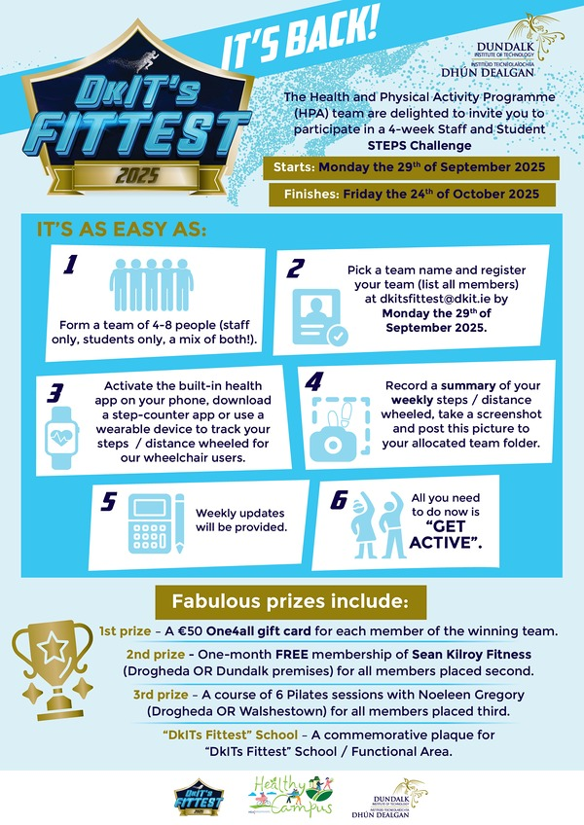

Appendix 2: Example of End of Week 4 Leaderboard
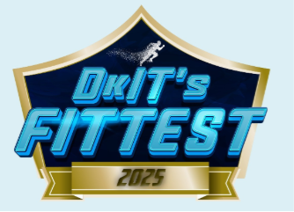
Position | Team | School/ Functional Area | Cumulative Average Weekly Step Total
1 | One Step Ahead | School of Business & Humanities | 639316
2 | Step by Step (And Stop for Snacks) | School of Health & Science | 587197
3 | The PowerPuff Girls | School of Informatics & Creative Arts | 531037
4 | Can't Sit Still Crew | Mixed Schools | 489618
5 | Student Services Stompers | Student Services | 426346
6 | Walkie Talkies | School of Business & Humanities | 409821
7 | Nurses on the Run | School of Health & Science | 409048
8 | Fur and Field Squad | School of Health & Science | 407849
9 | Pod 3 Team 2 | School of Informatics & Creative Arts | 374140
10 | United Nations | School of Business & Humanities | 364828
11 | Humanity and Beyond | School of Business & Humanities | 362358
12 | Netwell Pacers | Netwell Casala | 352336
13 | Scrambled Legs | Mixed Schools | 346311
14 | The Walking Dead | Mixed Schools | 340552
15 | DkIT Athletics Club | Mixed Schools | 336353
16 | The Born to Runners | School of Health & Science | 321000
17 | Pod 2 | School of Informatics & Creative Arts | 301717
18 | Hospitality in Motion | School of Business & Humanities | 297361
19 | Student Services Sprinters | Student Services | 295460
20 | Pod 3 Team 1 | School of Informatics & Creative Arts | 293344
21 | Student Services Striders | Student Services | 284156
22 | Bright Room Ramblers | Cross Functional Team | 274606
23 | We need a Logo | Marketing & Communications | 271246
24 | The Sleepwalkers | School of Business & Humanities | 229749
25 | CFES Fittest | School of Health & Science | 207795
26 | The Motley Crew | Mixed Schools | 160129
27 | Scrubs on the Go | School of Health & Science | 147286
28 | Rice Bowls | Mixed Schools | 103431

