HEA Healthy Campus Case Study Template 2026

NOTES FOR COMPLETION
Context
- Case studies should relate to your institution's progression of the following policies:
  - HEA Healthy Campus Charter and Framework
  - HEA Healthy Campus Self-Evaluation Tool
  - National Student Mental Health and Suicide Prevention Framework
  - The Limerick Framework for Action: Advancing the Health Promoting Campus Agenda
- Case studies can include a wide range of work including those relating to governance and oversight, planning, strategy, policy, research, implementation, as well as others.
- We encourage examples that also showcase the interaction of wellbeing and other areas for example sustainability, belonging, progression, teaching and learning.
Template
- Please be as concise and clear as possible and consider the use of bullet points to summarise information.
- All sections must be completed.
- Case studies should be written in the third person and anonymous when it comes to participants’ names.
- Case studies will be used as part of HEA communications including email, website, and social media.
Submission
- Please submit your case study to healthycampus@hea.ie by COB Friday, April 3rd for display at the 2026 Health and Wellbeing Conference.

HEALTHY CAMPUS CASE STUDY
- Project Title | Teaching Healthy Cooking in Practice: A Case Study of the Hospitality Department Demonstration Series at DkIT
- Institution/ Organisation | Dundalk Institute of Technology (DkIT)
- Who leads/ led the project? | Healthy Campus Nutrition Sub-Working Group and School of Business, Department of Hospitality Studies
- Date and timeframe | 2026/ 2026
- Population Group (tick all that apply) | - Students ☒  - Staff ☒  - Wider community ☐  - Other ☐
- Health Topic (tick all that apply) | - Alcohol ☐  - Substance Misuse ☐  - Healthy Eating / Food ☒  - Mental Health & Wellbeing ☐  - Sexual Health & Wellbeing ☐  - Tobacco/ Vape Free Campus ☐  - Physical Activity / Active Transport ☐  - Wellbeing and the Curriculum ☐  - Health & Sustainability ☐  - Other ☐

- Project Alignment

Use the categories below to highlight the alignment of the project with national policy. Please tick all that apply.

Limerick Framework for Action - 10 Actions  LFfA pg. 12 | Healthy Campus Process  HCCF pg. 4 | Whole Campus Approach  HC Tool pg. 8 | Principles of a Healthy Campus  HC Tool + HCCF | National Student Mental Health and Suicide Prevention Framework NSMHSPF
1.Ethos ☐ | Commit ☐ | Leadership, Strategy & Governance  (Pillar 1) ☐ | Participation ☐ | Lead ☐
2.Act ☐ | Coordinate ☐ | Campus Environment (Facilities & Services) (Pillar 2) ☒ | Partnership ☒ | Collaborate ☒
3.Localise ☐ | Consult ☐ | Campus Culture & Communications (Pillar 3) ☐ | Evidence Based ☐ | Educate ☒
4.Leadership ☐ | Create ☒ | Personal & Professional Development  (Pillar 4) ☒ | Sustainability (Longevity) ☒ | Engage ☒
5.Policies ☐ | Celebrate & continue ☐ | Health Focused Area (Pillar 5) ☒ |  | Identify ☐
6.Culture ☒ |  |  |  | Support ☐
7.Partnership ☐ |  |  |  | Respond ☐
8.Students ☒ |  |  |  | Transition ☐
9.Research ☐ |  |  |  | Improve ☐
10.Celebrate ☐

- Project Rationale | The project was developed by the Hospitality Department at Dundalk Institute of Technology (DkIT) to support positive mental health and wellbeing among students and the wider campus community. It directly addressed the interconnected challenges of low energy, poor nutrition habits, stress, and social isolation that are commonly experienced in higher education settings. Research consistently highlights that healthy eating, social connection, and active lifestyles play a significant role in improving mental wellbeing, motivation, and overall quality of life. However, many students face real barriers to maintaining healthy routines, including busy academic schedules, financial pressures, limited cooking skills, and few opportunities for meaningful social engagement.  This initiative responded to those needs by delivering a series of accessible, hands-on demonstration events within the Hospitality Department's professional kitchen environment. The series covered a range of themes including healthy meal preparation, high-protein foods, nutritious breakfast options, and bread making - each designed to equip students with practical skills they could apply in their everyday lives. Short talks on healthy eating principles accompanied each session, helping participants build both knowledge and confidence around food and nutrition. By combining practical cooking demonstrations with short educational talks and opportunities for social interaction, the project sought to enhance students' awareness of healthy lifestyle choices, strengthen community connections on campus, and foster a culture of wellbeing aligned with the Healthy Campus framework.
- Aims and Objectives | Aims  The aim of the project was to promote positive mental health and wellbeing among students and members of the campus community by developing practical cooking skills, increasing nutritional awareness, and encouraging healthy eating habits through an engaging series of hands-on demonstration events. The initiative also sought to foster social connection and a sense of belonging through shared food experiences within a supportive and inclusive campus environment.  Objectives  - To increase students' awareness of the relationship between nutrition and mental wellbeing through short educational talks accompanying each demonstration event.  - To develop practical cooking skills in areas including healthy meal preparation, high-protein food preparation, nutritious breakfast options, and bread making through interactive kitchen demonstrations.  - To provide students with accessible, budget-friendly, and replicable recipes that support healthy eating in their daily lives.  - To create inclusive and engaging social spaces that encourage peer interaction and reduce feelings of isolation among students.  - To improve participants' self-reported energy levels, motivation, and sense of belonging through positive shared food experiences.  - To support the Healthy Campus initiative by embedding wellbeing-focused, practical activities into campus life.
- Project Overview/ Summary | Planning: The project was planned and led by the Hospitality Department at DkIT in collaboration with the Healthy Campus initiative and Healthy Louth. The planning stage involved designing a structured series of demonstration events that would be both educationally valuable and practically engaging for students. Suitable facilities, including the Hospitality Department's professional demonstration kitchen, were identified and scheduled across the academic term. Events were promoted across campus to maximise participation and reach a diverse range of students.  Implementation: A series of hands-on demonstration events were delivered, each focusing on a distinct healthy eating theme. Sessions covered healthy meal preparation, high-protein food preparation, nutritious breakfast options, and bread making. Each event combined live cooking demonstrations with short informative talks on healthy eating, giving participants both practical skills and evidence-based nutritional knowledge. The informal and welcoming atmosphere of the demonstration kitchen encouraged students to engage actively, ask questions, taste the prepared dishes, and take away ideas they could apply at home.  Engagement: The series attracted strong participation from students across a range of programmes, as well as members of the wider campus community. Hospitality students played an active supporting role in the delivery of events, gaining valuable hands-on experience while contributing meaningfully to a campus wellbeing initiative.  Evaluation: Feedback was collected through short online surveys using the Vevox platform, with participants accessing the survey by scanning a QR code during each event. Participants were invited to reflect on their experience, their awareness of healthy eating, and any changes in their energy levels, motivation, and sense of social connection.  Outcomes: Participant feedback was very positive. Attendees particularly valued the hands-on, practical nature of the demonstrations and the opportunity to taste a variety of healthy, accessible dishes. Many reported increased confidences in preparing healthy meals, improved awareness of nutrition, and a greater sense of energy and motivation. The shared experience of cooking and eating together also contributed to a stronger sense of community and belonging on campus.
- Collaboration | The project was delivered through collaboration between a range of internal and external stakeholders, which was central to its success. Internally, the Hospitality Department at DkIT led the initiative, providing professional expertise, kitchen facilities, and overall coordination of the demonstration series. Academic staff with expertise in food preparation and nutrition took the lead in designing and delivering the events, ensuring each session was both practically engaging and educationally grounded. Hospitality students actively supported the planning and running of the events, contributing to a rich learning-by-doing experience that benefited both themselves and the attendees.  The project also worked closely with the Healthy Campus initiative and Student Services, both of which played an important role in promoting the events and encouraging broad student participation across the campus community. Externally, the project collaborated with Healthy Louth, which supported the initiative through the Healthy Ireland Fund and aligned with its broader public health and wellbeing objectives. Nutrition experts and guest speakers contributed to the short educational talks that accompanied each demonstration, providing participants with accessible, evidence-based guidance on healthy eating and lifestyle choices. This multi-stakeholder approach ensured the initiative was well-resourced, widely promoted, and delivered to a high standard.
- Resource Requirements | The delivery of the project drew on a combination of physical, human, and financial resources. The Hospitality Department at DkIT provided access to its professional demonstration kitchen and teaching facilities, which formed the central venue for all events in the series. Fresh food ingredients, kitchen equipment, and healthy refreshments were sourced and prepared for each session, covering the range of themes across healthy meals, high-protein foods, nutritious breakfasts, and bread making.  Human resources were fundamental to the project's success. Academic staff from the Hospitality Department contributed their expertise in food preparation, nutrition, and event coordination, while hospitality students provided essential hands-on support in the preparation and running of each event. Additional expertise was brought in through collaboration with Healthy Louth and visiting nutrition speakers who delivered the educational talk components of the programme.  Financially, the project was supported through a €1,000 Healthy Ireland Fund allocation, with additional €500 from the healthy campus initiative which helped cover the costs of food ingredients, beverages, and consumable materials required across all events. Digital tools, including QR codes and the Vevox survey platform, were used to collect participant feedback efficiently and to evaluate the overall impact of the initiative.
- What are the next steps for the project? | Building on the strong participation and positive feedback generated by the demonstration series, the next steps for the project focus on expanding its reach and embedding it more firmly within campus life. Future events will continue to develop the practical cooking demonstration format, with plans to introduce additional themes and seasonal content that keep the programme fresh and relevant to students' everyday lives.  To ensure long-term sustainability, the project team will seek to integrate the demonstration series into the regular campus academic and events calendar, working in closer alignment with the Healthy Campus programme, Student Services, and other academic departments. This will help ensure that wellbeing-focused cooking activities are not treated as one-off events but as an ongoing and valued part of the campus experience. Continued involvement of hospitality students in planning and delivery will remain a priority, supporting both the sustainability of the programme and the development of students' professional and practical skills.  Efforts will also be made to secure continued and additional funding, including through future applications to the Healthy Ireland Fund and Healthy Campus grants. Potential collaborations with local food producers and suppliers will be explored to enhance the quality and variety of ingredients available, while making best use of the Hospitality Department's in-house resources to manage costs effectively.
- Key Learning Points | A central learning from this project was that hands-on, practical cooking demonstrations are significantly more engaging and impactful for students than passive information sessions. By giving participants, the opportunity to observe, participate in, and taste dishes prepared across themes such as healthy meal prep, high-protein cooking, nutritious breakfasts, and bread making, the events made healthy eating feel achievable, enjoyable, and directly relevant to students' lives. The short educational talks that accompanied each session also proved effective in contextualising the practical activity within broader nutritional knowledge, striking a good balance between doing and learning.  The importance of the physical environment also stood out as a key factor. The professional demonstration kitchen provided a credible and inspiring setting that motivated students and added a sense of occasion to each event. At the same time, the informal and welcoming atmosphere encouraged participation, reduced any anxiety around cooking, and created natural opportunities for social interaction among attendees.  For those planning similar initiatives, early cross-departmental collaboration is essential. Engaging academic staff, student services, and external partners from the outset helps to maximise both the quality of delivery and the reach of promotion. Scheduling events at times that suit students' timetables, keeping recipes practical and budget-conscious, and actively involving students in the delivery of events are all factors that significantly improve engagement and ensure the initiative resonates with its intended audience.
- Images and Links | 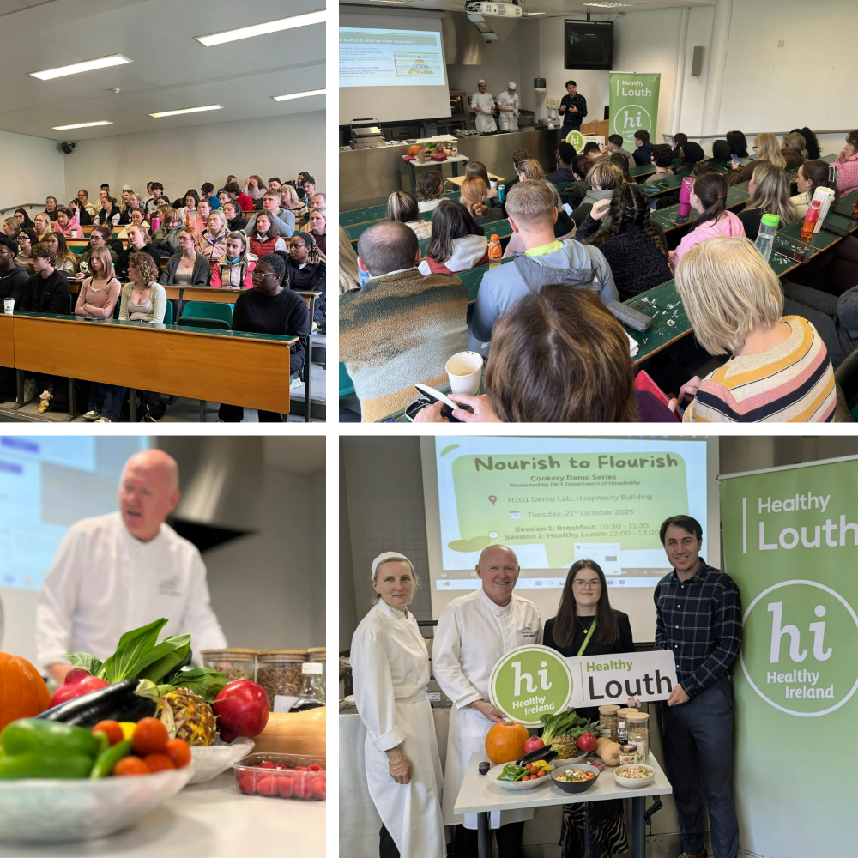

- Evaluation
How was the project evaluated?
Please check the box(es) that apply regarding the type of evaluation and data collection method
Type of Evaluation
Formative Evaluation: ☐  Conducted during development or early implementation to make improvements to the program design. | Process Evaluation: ☒  Assesses how the program is being implemented, including participation rates, quality of delivery, and whether it is reaching its target audience. | Outcome Evaluation: ☒  Focuses on the results—the changes in behaviors, attitudes, or conditions—at the end of a project. | Summative Evaluation: ☒  Assesses the overall effectiveness of a program after its completion to determine if it achieved its intended goals.
Data Collection Method
Survey/Questionnaire ☒  Document Review ☐ (project reports, financial data, attendance logs, etc.)  Direct Observations ☐ | Focus Groups ☐  Interviews ☐  Case Studies ☒  Other____________
High-Level Outcome and Impact
Please include high-level outcomes and impact if not already covered in the summary above.

- Contact Details
Contact Name/s | Dr. Diako Khodaei; Rosemary Leonard; Derick Englishby; Dr. Kevin Burns
Date | 27/03/2026
Email Address | Diako.khodaei@dkit.ie

