HEA Healthy Campus Case Study Template 2026

NOTES FOR COMPLETION
Context
- Case studies should relate to your institution's progression of the following policies:
  - HEA Healthy Campus Charter and Framework
  - HEA Healthy Campus Self-Evaluation Tool
  - National Student Mental Health and Suicide Prevention Framework
  - The Limerick Framework for Action: Advancing the Health Promoting Campus Agenda
- Case studies can include a wide range of work including those relating to governance and oversight, planning, strategy, policy, research, implementation, as well as others.
- We encourage examples that also showcase the interaction of wellbeing and other areas for example sustainability, belonging, progression, teaching and learning.
Template
- Please be as concise and clear as possible and consider the use of bullet points to summarise information.
- All sections must be completed.
- Case studies should be written in the third person and anonymous when it comes to participants’ names.
- Case studies will be used as part of HEA communications including email, website, and social media.
Submission
- Please submit your case study to healthycampus@hea.ie by COB Friday, April 3rd for display at the 2026 Health and Wellbeing Conference.

HEALTHY CAMPUS CASE STUDY
- Project Title | Make One, Donate One – Bread Making Workshop
- Institution/ Organisation | Dundalk Institute of Technology
- Who leads/ led the project? | Maeve McArdle, Alan McCabe & Rosemary Leonard (School of Business and Humanities)
- Date and timeframe | Academic year 2025 – 2026 - ongoing.
- Population Group (tick all that apply) | - Students ☒  - Staff ☒  - Wider community ☐  - Other ☐
- Health Topic (tick all that apply) | - Alcohol ☐  - Substance Misuse ☐  - Healthy Eating / Food ☐  - Mental Health & Wellbeing ☒  - Sexual Health & Wellbeing ☐  - Tobacco/ Vape Free Campus ☐  - Physical Activity / Active Transport ☐  - Wellbeing and the Curriculum ☐  - Health & Sustainability ☐  - Other ☐

- Project Alignment

Use the categories below to highlight the alignment of the project with national policy. Please tick all that apply.

Limerick Framework for Action - 10 Actions  LFfA pg. 12 | Healthy Campus Process  HCCF pg. 4 | Whole Campus Approach  HC Tool pg. 8 | Principles of a Healthy Campus  HC Tool + HCCF | National Student Mental Health and Suicide Prevention Framework NSMHSPF
1.Ethos ☐ | Commit ☐ | Leadership, Strategy & Governance  (Pillar 1) ☐ | Participation ☒ | Lead ☐
2.Act ☐ | Coordinate ☐ | Campus Environment (Facilities & Services) (Pillar 2) ☒ | Partnership ☒ | Collaborate ☒
3.Localise ☐ | Consult ☐ | Campus Culture & Communications (Pillar 3) ☒ | Evidence Based ☐ | Educate ☐
4.Leadership ☐ | Create ☒ | Personal & Professional Development  (Pillar 4) ☐ | Sustainability (Longevity) ☐ | Engage ☒
5.Policies ☐ | Celebrate & continue ☐ | Health Focused Area (Pillar 5) ☒ |  | Identify ☐
6.Culture ☒ |  |  |  | Support ☒
7.Partnership ☒ |  |  |  | Respond ☐
8.Students ☒ |  |  |  | Transition ☐
9.Research ☐ |  |  |  | Improve ☐
10.Celebrate ☐

- Project Rationale | Bread making offers therapeutic benefits. Fostering mindfulness, stress reduction, and a sense of accomplishment when the bread is baked and fresh from the oven. The act of giving a handmade item also promotes empathy and social bonding. The workshop was accessible, inclusive, and supported by simple ingredients and guidance by expert chefs in the hospitality department. The workshop also encourages healthier eating practical skills and fun interaction in a relaxed, supportive environment.
- Aims and Objectives | 1. To engage staff and students (n=20) in enhancing wellbeing and mental health - Participants will experience improved mental well-being through hands-on mindful activity. Bread making fosters calm, focus and stress relief, supporting Healthy Ireland's objective.  2. To strengthen social connection by baking one loaf to give away, participants actively engage in a small act of kindness. This cultivates empathy, generosity, and social bonds within the college community.
- Project Overview/ Summary | Planning for the workshop began in early October 2025, when the team chose a suitable date in November that worked with staff availability and access to the professional kitchen facilities. Once the date was confirmed, Alan Mc Cabe and Rosemary Leonard, both professional chefs from the Department of Hospitality Studies, designed a detailed menu card to guide the session.  The workshop was then promoted across the DkIT community, and interested individuals were asked to submit an expression of interest form. Due to high demand, both the November workshop and the upcoming May 2026 session were oversubscribed, and a lottery system was introduced to ensure a fair selection process. Ultimately, twenty participants were chosen to attend the first workshop.  The initial session took place on Thursday, 13th November 2025, in the professional kitchen located in the Faulkner Building at DkIT. Lasting approximately 2 ½ hours, the workshop provided participants with a hands-on opportunity to develop practical baking skills. Under the guidance of the chefs, attendees prepared two types of bread: wheaten bread and focaccia, while also learning essential baking techniques.  The format of the workshop fostered a collaborative atmosphere, with participants working in pairs, allowing individuals to meet new people and share the experience together. The session concluded with a small tea party, where participants enjoyed freshly baked scones in a relaxed setting.  Following the success of the November workshop, a second session has been scheduled for May 2026, continuing the initiative and building on its strong level of interest and engagement.
- Collaboration | Collaboration between staff in Department of Management and Financial Studies and Department of Hospitality studies. The event was open to all students and staff. Some staff and students visited the Faulkner building and kitchens for the first time.
- Resource Requirements | A budget of €500 was provided to cover costs of ingredients, aprons, kitchen and cleaning costs.
- What are the next steps for the project? | To host a second workshop in May 2026.
- Key Learning Points | - Based on the experience of hosting the first workshop, the team would suggest the following.  - Begin planning early to secure suitable dates, staff availability, and access to appropriate facilities. It is important to promote the event widely across all relevant audiences to maximize interest and engagement. An Expression of Interest (EOI) process is useful in case the event is oversubscribed. However, based on our experience we suggest you plan for potential no-shows on the day. Implement a fair selection method, such as a lottery system to choose participants.  - Provide a clear structure and engaging content (e.g., hands-on activities led by experienced facilitators). Provide menu cards. Encourage participant interaction through collaborative tasks to enhance the overall experience.  - We would recommend gathering participant feedback to inform future improvements. (i.e. MS Forms)  - Finally, remind participants in advance to bring an apron and a bag to take their bread home.
- Images and Links | Please include links to webpages/ documents related to the project.  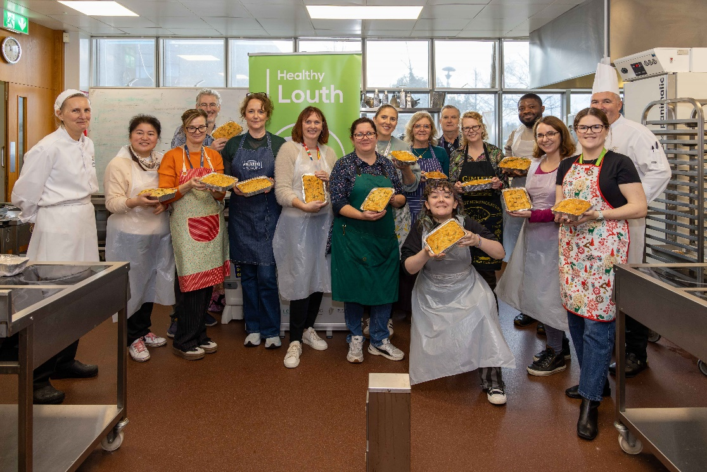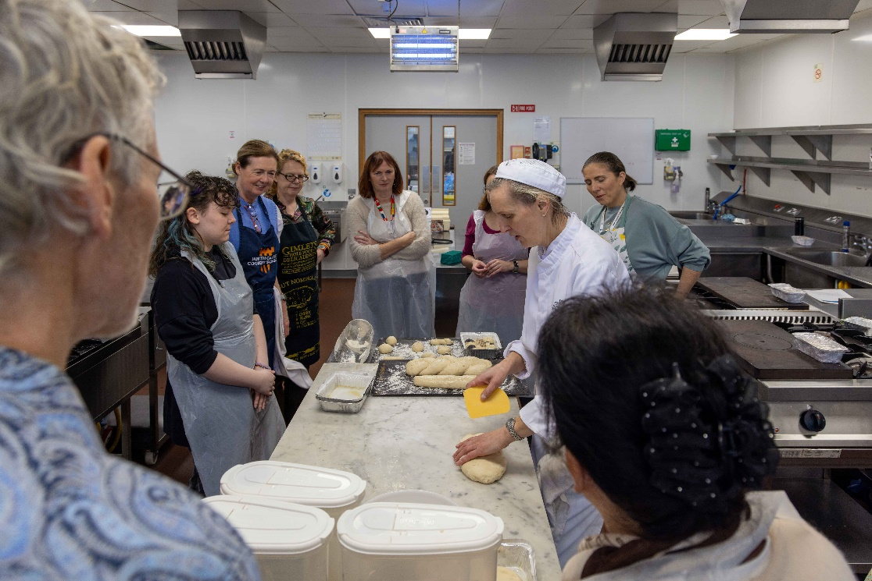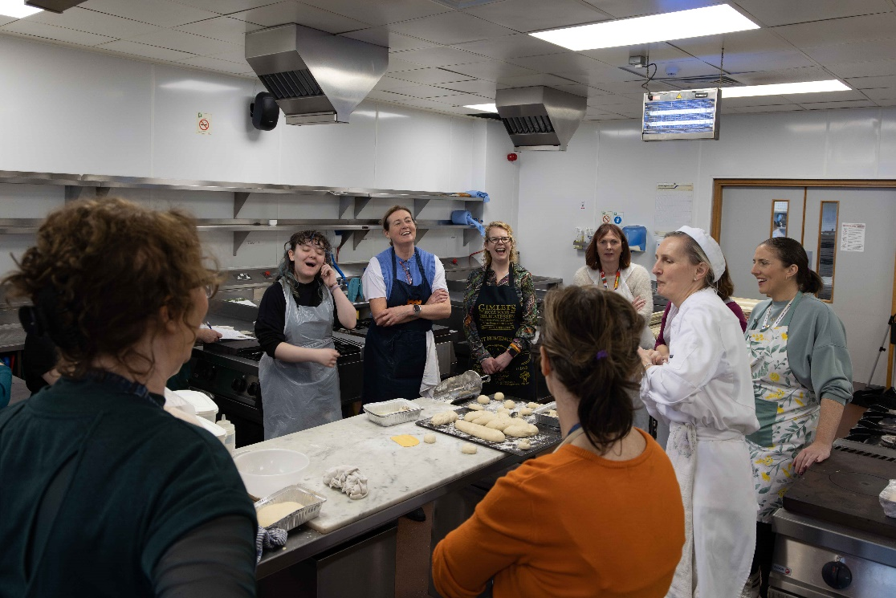

- Evaluation
How was the project evaluated?
Please check the box(es) that apply regarding the type of evaluation and data collection method
Type of Evaluation
Formative Evaluation: ☒  Conducted during development or early implementation to make improvements to the program design. | Process Evaluation: ☒  Assesses how the program is being implemented, including participation rates, quality of delivery, and whether it is reaching its target audience. | Outcome Evaluation: ☐  Focuses on the results—the changes in behaviors, attitudes, or conditions—at the end of a project. | Summative Evaluation: ☐  Assesses the overall effectiveness of a program after its completion to determine if it achieved its intended goals.
Data Collection Method
Survey/Questionnaire ☐  Document Review ☐ (project reports, financial data, attendance logs, etc.)  Direct Observations ☒ | Focus Groups ☐  Interviews ☐  Case Studies ☐  Other____________  Post workshop chat over tea and scones. Follow up team meeting
High-Level Outcome and Impact
Please include high-level outcomes and impact if not already covered in the summary above.

- Contact Details
Contact Name/s | Maeve Mc Ardle, Alan Mc Cabe & Rosemary Leonard
Date | 30.03.2026
Email Address | Maeve.mcardle@dkit.ie

