HEA Healthy Campus Case Study Template 2026

NOTES FOR COMPLETION
Context
- Case studies should relate to your institution's progression of the following policies:
  - HEA Healthy Campus Charter and Framework
  - HEA Healthy Campus Self-Evaluation Tool
  - National Student Mental Health and Suicide Prevention Framework
  - The Limerick Framework for Action: Advancing the Health Promoting Campus Agenda
- Case studies can include a wide range of work including those relating to governance and oversight, planning, strategy, policy, research, implementation, as well as others.
- We encourage examples that also showcase the interaction of wellbeing and other areas for example sustainability, belonging, progression, teaching and learning.
Template
- Please be as concise and clear as possible and consider the use of bullet points to summarise information.
- All sections must be completed.
- Case studies should be written in the third person and anonymous when it comes to participants’ names.
- Case studies will be used as part of HEA communications including email, website, and social media.
Submission
- Please submit your case study to healthycampus@hea.ie by COB Friday, April 3rd for display at the 2026 Health and Wellbeing Conference.

HEALTHY CAMPUS CASE STUDY
- Project Title | DCU Human Library
- Institution/ Organisation | Dublin City University
- Who leads/ led the project? | DCU Healthy
- Date and timeframe | 5th March 2026 and 20th March 2024
- Population Group (tick all that apply) | - Students ☒  - Staff ☒  - Wider community ☒  - Other ☐
- Health Topic (tick all that apply) | - Alcohol ☐  - Substance Misuse ☐  - Healthy Eating / Food ☐  - Mental Health & Wellbeing ☒  - Sexual Health & Wellbeing ☐  - Tobacco/ Vape Free Campus ☐  - Physical Activity / Active Transport ☐  - Wellbeing and the Curriculum ☐  - Health & Sustainability ☐  - Other ☒

- Project Alignment

Use the categories below to highlight the alignment of the project with national policy. Please tick all that apply.

Limerick Framework for Action - 10 Actions  LFfA pg. 12 | Healthy Campus Process  HCCF pg. 4 | Whole Campus Approach  HC Tool pg. 8 | Principles of a Healthy Campus  HC Tool + HCCF | National Student Mental Health and Suicide Prevention Framework NSMHSPF
1.Ethos ☐ | Commit ☐ | Leadership, Strategy & Governance  (Pillar 1) ☐ | Participation ☒ | Lead ☐
2.Act ☐ | Coordinate ☐ | Campus Environment (Facilities & Services) (Pillar 2) ☒ | Partnership ☒ | Collaborate ☐
3.Localise ☐ | Consult ☐ | Campus Culture & Communications (Pillar 3) ☒ | Evidence Based ☐ | Educate ☐
4.Leadership ☐ | Create ☒ | Personal & Professional Development  (Pillar 4) ☐ | Sustainability (Longevity) ☒ | Engage ☒
5.Policies ☐ | Celebrate & continue ☐ | Health Focused Area (Pillar 5) ☒ |  | Identify ☐
6.Culture ☒ |  |  |  | Support ☐
7.Partnership ☒ |  |  |  | Respond ☐
8.Students ☒ |  |  |  | Transition ☐
9.Research ☐ |  |  |  | Improve ☐
10.Celebrate ☐

- Project Rationale | Implement the Human Library as a learning platform in the University Community to raise cultural awareness and diversity. It's a "library" where people, instead of books, are on loan to readers. Its purpose is to challenge stereotypes and prejudices through open, honest conversation in a safe environment.
- Aims and Objectives | Core Aims  - Challenge Prejudice & Stereotypes: The central mission is to "unjudge" people by providing a safe space for personal dialogue about difficult and stigmatising topics.  - Foster Social Cohesion: The project aims to build bridges across cultural, religious, social, and ethnic divides by bringing together people who would otherwise never speak.  - Promote Human Rights: It seeks to protect the right to speak freely and be heard, especially for marginalised groups.  - Develop Empathy & Understanding: By sharing first-hand experiences, the library helps "readers" gain a deeper, more human knowledge of subjects they may be ignorant of.  Key Objectives  - Create Safe Spaces for Dialogue: Establish environments where "difficult questions are expected, appreciated, and answered" without condemnation.  - Empower Stigmatised Groups: Provide a platform for people facing social exclusion (e.g., due to their lifestyle, diagnosis, or belief) to tell their own stories and be seen as complex individuals.  - Educate Communities: Implement the Human Library as a learning platform to raise cultural awareness and diversity in the DCU Community and Local Community.  - Promote Social Justice: Use direct, one-on-one communication as a tool to dismantle barriers by humanising "the other" and giving a safe space for people to educate themselves about marginalised groups.  - Foster a culture of health and wellbeing in the DCU Community: Create a sense of belonging for staff and students by providing a space to grow and learn through positive and open dialogue of difficult topics, thus contributing to a positive community culture.
- Project Overview/ Summary | Planning  The organising committee consisted of staff across Student Support and Development, DCU Library and the Students’ Union. Planning started six months in advance of the event being held in accordance with the Human Library  Organisation Guidelines. This ensures their brand was protected and to implement best practice for a human library event.  • Recruitment of Books: To be published, a Book should have an aspect of their life that has led the Book to experience stereotyping, discrimination, prejudice, or stigmatisation. The committee reached out to people in their own network and books that took part in another event in Dublin to see who was interested in participating.  • Training of Books and Librarians: All books and librarians had to go through mandatory training through the Human Library Organisation. This can take up to four hours. Librarians can also attend online human libraries to get experience.  • Communication & Marketing: Prior to the event posters were designed and put up around the main campuses. All staff and all student emails were sent advertising the event and included in weekly newsletters. On social media, posts explaining what the Human Library was and how it worked were promoted. Short videos were created and used prior to and during the event.  Implementation  Event Space: It was in the exhibition and group work area of the library and Books were spaced out over three zones. Zone 3 being the quiet space at the back of the area for books who are hard of hearing and Zone 1 was wheelchair accessible. There was a reception desk that listed the names of the books and librarians could welcome readers and curious people passing by. There was an allocated quiet space for books to take time out. We had a counsellor and security on call to deal with anyone in distress.  Event Day: The books had blue T-shirts and librarians had yellow. There were pull up stands advertising DCU Healthy, Speak Out Reporting Tool, Safe Zone App, DCU Library and DCU Students Union. There were bunting and fairy lights to dress up the area. Each table had a number and there was a map of the tables and books, so readers knew where to go. Tea, coffee and cupcakes were provided for readers and books. Reader questionnaires were available on the way out.  Sample books included Homelessness, Autism & Writing, Mental Health & Recovery, Previous Drug Misuse and Gay in the 1980s.  Evaluation  Book Feedback  • “I think volunteering at the Human Library is important and meaningful - 78% said they ‘strongly agree’.  • Sharing my experiences at the Human Library has made me feel better understood – 78% said they ‘strongly agree’, 11% agree and 11% undecided.  • The methods of the Human Library are useful for fostering dialogue – 89% strongly agreed  • Comments from Books  - So positive and inspiring - Thank you too!  - One of the most interesting events I have done. Something I think everyone should try once (book or reader).  - Because I believe in advocacy, the human library is a platform to do that.  Reader Feedback  • How was your experience being a Reader at the Human Library? – 83% said Excellent, 17% said Very Good.  • I have learned new things about the topics of my Reading(s) – 75% said Strongly Agree, 25% said Agree.  • Today’s event has made me more open to exploring and asking about unfamiliar topics – 58% said Strongly Agree, 42% said Agree.  • How did you feel asking the questions you wanted at the beginning of the Reading(s)? – 33% said Very Comfortable, 33% said Comfortable and 25% said Uncomfortable.  • How did you feel asking the questions you wanted towards the end of the Reading(s)? – 75% said Very Comfortable and 25% said Comfortable  • Comments from Readers  - It was very difficult to move on. I had so many questions. A very emotional experience. I am very grateful. An amazing experience. The books were bravery personified.  - I am glad I attended. I found it difficult to ask questions first but as the conversation went on, I became more confident.
- Collaboration | DCU Student Support and Development, DCU Library Events and Engagement Team and DCU Students’ Union.
- Resource Requirements | Human Resources: Organising Committee, Human Book Volunteers, Student Ambassadors and Staff Volunteers.  Event Resources: Event space to hold the event that is suitable for up to 15 group conversations. Communications and Marketing for the event include design and printing of posters, printing of t-shirts, and printing of Human Library resources.  Budget: Covered catering for books and readers, printing of posters and t-shirts, presents for the books to thank them for their work and hiring of student ambassadors.
- What are the next steps for the project? | DCU has hosted two Human Library events now. DCU Library and Student Support and Development work really well together and aim to continue the work of the Human Library in the future. Due to the length of time it takes to organise, it was decided the event will be held every two years.
- Key Learning Points | Give a safe space to humans and they will connect: When you try to explain to another person what a Human Library is, they are always confused. Furthermore, they can feel intimidated by the topics or fear they will say the wrong thing. However, once a reader sits down and connects with the human book, magic happens. The engagement, connection and sense of belonging is so strong and positive. The book feels seen and heard and the reader gets to understand an important story and has a safe place to ask questions they would not normally do.  Key Advice: 1. Give the committee at least 6 months to organise the Human Library for the first time. It takes time to understand the concept, apply for the license and recruit books.  2. Encourage all committee members to be readers in online Human Libraries to understand the concept, the positive change that happens after you read a human book and the benefits of the concept. It will make it easier to promote it to others.  3. Encourage students, staff and the local community to take part.
- Images and Links | Website - https://www.dcu.ie/students/dcu-human-library-2026  See website above for more photos of our human books.  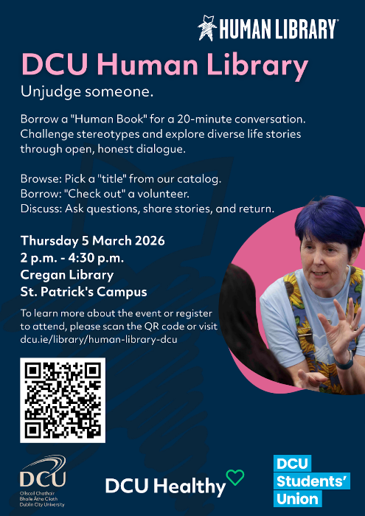  Promotional Poster for Event  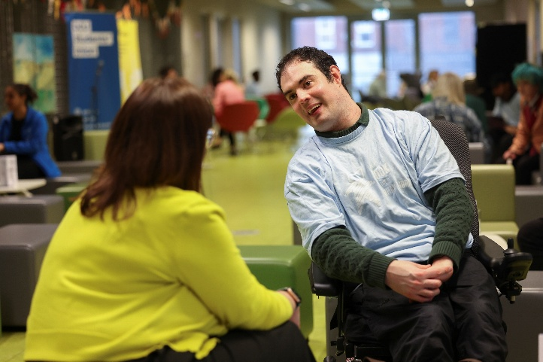  Photo of a Human Book and a Reader.
- Evaluation
How was the project evaluated?
Please check the box(es) that apply regarding the type of evaluation and data collection method
Type of Evaluation
Formative Evaluation: ☐  Conducted during development or early implementation to make improvements to the program design. | Process Evaluation: ☒  Assesses how the program is being implemented, including participation rates, quality of delivery, and whether it is reaching its target audience. | Outcome Evaluation: ☒  Focuses on the results—the changes in behaviors, attitudes, or conditions—at the end of a project. | Summative Evaluation: ☒  Assesses the overall effectiveness of a program after its completion to determine if it achieved its intended goals.
Data Collection Method
Survey/Questionnaire ☒  Document Review ☒ (project reports, financial data, attendance logs, etc.)  Direct Observations ☒ | Focus Groups ☐  Interviews ☐  Case Studies ☐  Other____________
High-Level Outcome and Impact
- Create Safe Spaces for Dialogue: Establish environments where "difficult questions are expected, appreciated, and answered" without condemnation.
  - 33% of readers felt ‘very comfortable’ asking questions to a reader before the reading compared to 75% after the reading. This is an increase of 42%.
- Promote Social Justice: Use direct, one-on-one communication as a tool to dismantle barriers by humanising "the other" and giving a safe space for people to educate themselves about marginalised groups.
  - ‘I felt very understood and it felt like a good opportunity to raise awareness and answer questions in a safe place’. (Book)
  - ‘I think it was an absolutely great idea - I enjoyed today's event! It helps to learn how diverse people are in the world!’. (Reader)
- Foster a culture of health and wellbeing in the DCU Community: Create a sense of belonging for staff and students by providing a space to grow and learn through positive and open dialogue of difficult topics, thus contributing to a positive community culture.
  - ‘Excellent to be part of it. Wonderful to have a space to have open discussion in a respectful manner’. (Book)
  - ‘It was very insightful listening to the books. I feel more compassion towards those who suffer from difficult issues.’ (Reader)

- Contact Details
Contact Name/s | Deirdre Moloney
Date | 27th March 2026
Email Address | Deirdre.moloney@dcu.ie

