HEA Healthy Campus Case Study Template 2026

NOTES FOR COMPLETION
Context
- Case studies should relate to your institution's progression of the following policies:
  - HEA Healthy Campus Charter and Framework
  - HEA Healthy Campus Self-Evaluation Tool
  - National Student Mental Health and Suicide Prevention Framework
  - The Limerick Framework for Action: Advancing the Health Promoting Campus Agenda
- Case studies can include a wide range of work including those relating to governance and oversight, planning, strategy, policy, research, implementation, as well as others.
- We encourage examples that also showcase the interaction of wellbeing and other areas for example sustainability, belonging, progression, teaching and learning.
Template
- Please be as concise and clear as possible and consider the use of bullet points to summarise information.
- All sections must be completed.
- Case studies should be written in the third person and anonymous when it comes to participants’ names.
- Case studies will be used as part of HEA communications including email, website, and social media.
Submission
- Please submit your case study to healthycampus@hea.ie by COB Friday, April 3rd for display at the 2026 Health and Wellbeing Conference.

HEALTHY CAMPUS CASE STUDY
- Project Title | Collaborating for Wellbeing
- Institution/ Organisation | ATU
- Who leads/ led the project? | Sharon Ferguson
- Date and timeframe | Ongoing
- Population Group (tick all that apply) | - Students ☒  - Staff ☒  - Wider community ☐  - Other ☐
- Health Topic (tick all that apply) | - Alcohol ☐  - Substance Misuse ☐  - Healthy Eating / Food ☐  - Mental Health & Wellbeing ☒  - Sexual Health & Wellbeing ☐  - Tobacco/ Vape Free Campus ☐  - Physical Activity / Active Transport ☐  - Wellbeing and the Curriculum ☐  - Health & Sustainability ☐  - Other ☐

- Project Alignment

Use the categories below to highlight the alignment of the project with national policy. Please tick all that apply.

Limerick Framework for Action - 10 Actions  LFfA pg. 12 | Healthy Campus Process  HCCF pg. 4 | Whole Campus Approach  HC Tool pg. 8 | Principles of a Healthy Campus  HC Tool + HCCF | National Student Mental Health and Suicide Prevention Framework NSMHSPF
1.Ethos ☐ | Commit ☒ | Leadership, Strategy & Governance  (Pillar 1) ☐ | Participation ☒ | Lead ☐
2.Act ☒ | Coordinate ☒ | Campus Environment (Facilities & Services) (Pillar 2) ☒ | Partnership ☒ | Collaborate ☐
3.Localise ☐ | Consult ☒ | Campus Culture & Communications (Pillar 3) ☐ | Evidence Based ☐ | Educate ☐
4.Leadership ☐ | Create ☒ | Personal & Professional Development  (Pillar 4) ☐ | Sustainability (Longevity) ☐ | Engage ☒
5.Policies ☐ | Celebrate & continue ☒ | Health Focused Area (Pillar 5) ☐ |  | Identify ☐
6.Culture ☒ |  |  |  | Support ☐
7.Partnership ☒ |  |  |  | Respond ☐
8.Students ☒ |  |  |  | Transition ☐
9.Research ☐ |  |  |  | Improve ☐
10.Celebrate ☒

- Project Rationale | The Peer Led Wellness Café has been operating in ATU Donegal on a weekly basis from September 2023 having benefited from N-TUTORR funding. In review and evaluation of the 24/25 academic year in Donegal 20 Wellness Cafes were co-facilitated by student and staff peer facilitators, with an average attendance of 20 students per week.  Monthly themed Wellness cafés were introduced led by students’ union welfare officer and seen average attendance of 60 students which included class groups joining to take part in events e.g. Paint & Sip. The Wellness Café also provided opportunity for other staff members and departments to host their events in the space E.g. Pastoral Service St Brigids Cross making, EDI/RESPECT Team One Million Stars workshop and Seachtain na Gaeilge  After the initial pilot testing and evaluation of the Wellness Model and it’s success in bringing the campus together “No Closed Door” it was broadly agreed that initial planning, co-design and support to implement would be carried out on various sites within ATU in the 25/26 academic year
- Aims and Objectives | Aim: To support the development and implementation of Peer Led Wellness Cafes across ATU campuses  Objectives:  - To build on the successful implementation of the Wellness Café model in ATU Donegal  - Create development groups on other ATU campuses  - Recruit and train staff and student volunteer Peer Facilitators for the Wellness café  - Identify areas within the campus that will create a social environment which supports smaller groups within the campus community  - Build on the model in Donegal to foster the development of student wellbeing through community connectedness, purpose, engagement and belonging  - create a space which reflects diversity, inclusion, and compassion  - reduce student isolation by promoting a culture of belonging
- Project Overview/ Summary | Planning  - Peer Led Wellness Café model included in PASS (Peer Assisted Study Sessions) training in ATU Galway/Mayo to support PASS leaders in signposting to Wellbeing supports on campus. 4 sessions completed to 40 student leaders to raise awareness of the model implementation for the 25/26 academic year in ATU Galway/Mayo campuses  - Needs assessments and baseline of current models of Peer Led initiatives on campuses carried out across 8 sites to ascertain readiness for a Peer Led Wellness Café  - In collaboration with student services, mental health & Wellbeing project Officer students’ union and Pastoral care identified 4 sites for initial roll out for the 25/26 academic year  - Recruitment of staff and students to complete Peer facilitation training conducted at local level  Implementation  - 6 staff members/2 student Union representatives/7 students completed facilitation skills training semester 1  - 2 development groups established to plan/develop/support/implement and evaluate Wellness Cafes locally  - Co-design to rebrand Wellness Café logos for distribution across sites  - 3 sites launched Peer Led Wellness Cafes in Semester 1  - Sites are currently running monthly wellness cafes with average attendance of 30 students and staff  - Themed Wellness cafes continue to thrive with Lego workshops, painting and poetry  - Pop up Wellness cafes were supported in all sites through Irish Language officer as part of Seachtain na Gaeilge. Attendance on each site averaged 50 staff and students participating with a total number of over 400 staff and students engaging in activities that promoted the Irish language hosted by Wellness Café development teams
- Collaboration | Mental Health & Wellbeing project officer Galway/Mayo, Pastoral team, Students Union, academic staff, students, estates & O Hehir’s
- Resource Requirements | Tea/Coffee , creative art supplies
- What are the next steps for the project? | Evaluation of impact to support roll out of the model nationally with the co-production of a Toolkit for HEI’s. A MSc Health Promotion research project currently being undertaken to assess impact
- Key Learning Points | The philosophy of the Wellness café model is based on the principles of CHIME (Leamy, Slade 2011) and a “No Closed-Door Approach” (Ferguson,2019) to social models of engagement. Whilst growing initially in the community the simplicity of the model afforded the ease with which it was able to be integrated into a 3rd level setting. Through the establishment of development teams, we have adopted a “doing with, not for” approach following the ethos of N-Step model to Student Engagement. There is real emphasis on how we hold fidelity to the model even when faced with challenges such as a space to host the Wellness café or the recruitment and retention of Peer Facilitators. Being guided by what works and not what we can change has proven successful in the growing number of sites within ATU now hosting Wellness cafes, which has seen broader buy in within the campus from various departments who host events there. It really is whole campus approach to health & wellbeing and student engagement across ATU
- Images and Links | Teaching and Learning Together in Higher Education | Vol 1 | Iss 48 "No Closed Door": How a Peer-Led Wellness Cafe Model Facilitated & Supported Staff-Student Partnerships  ATU Magazine, Issue 23, Jan/Feb 2026 by Atlantic Technological University - Issuu    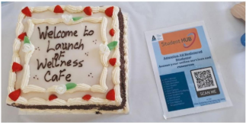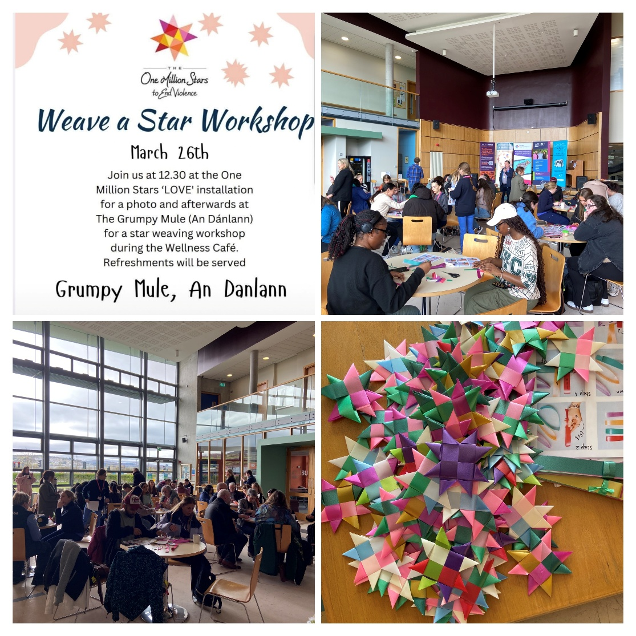  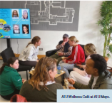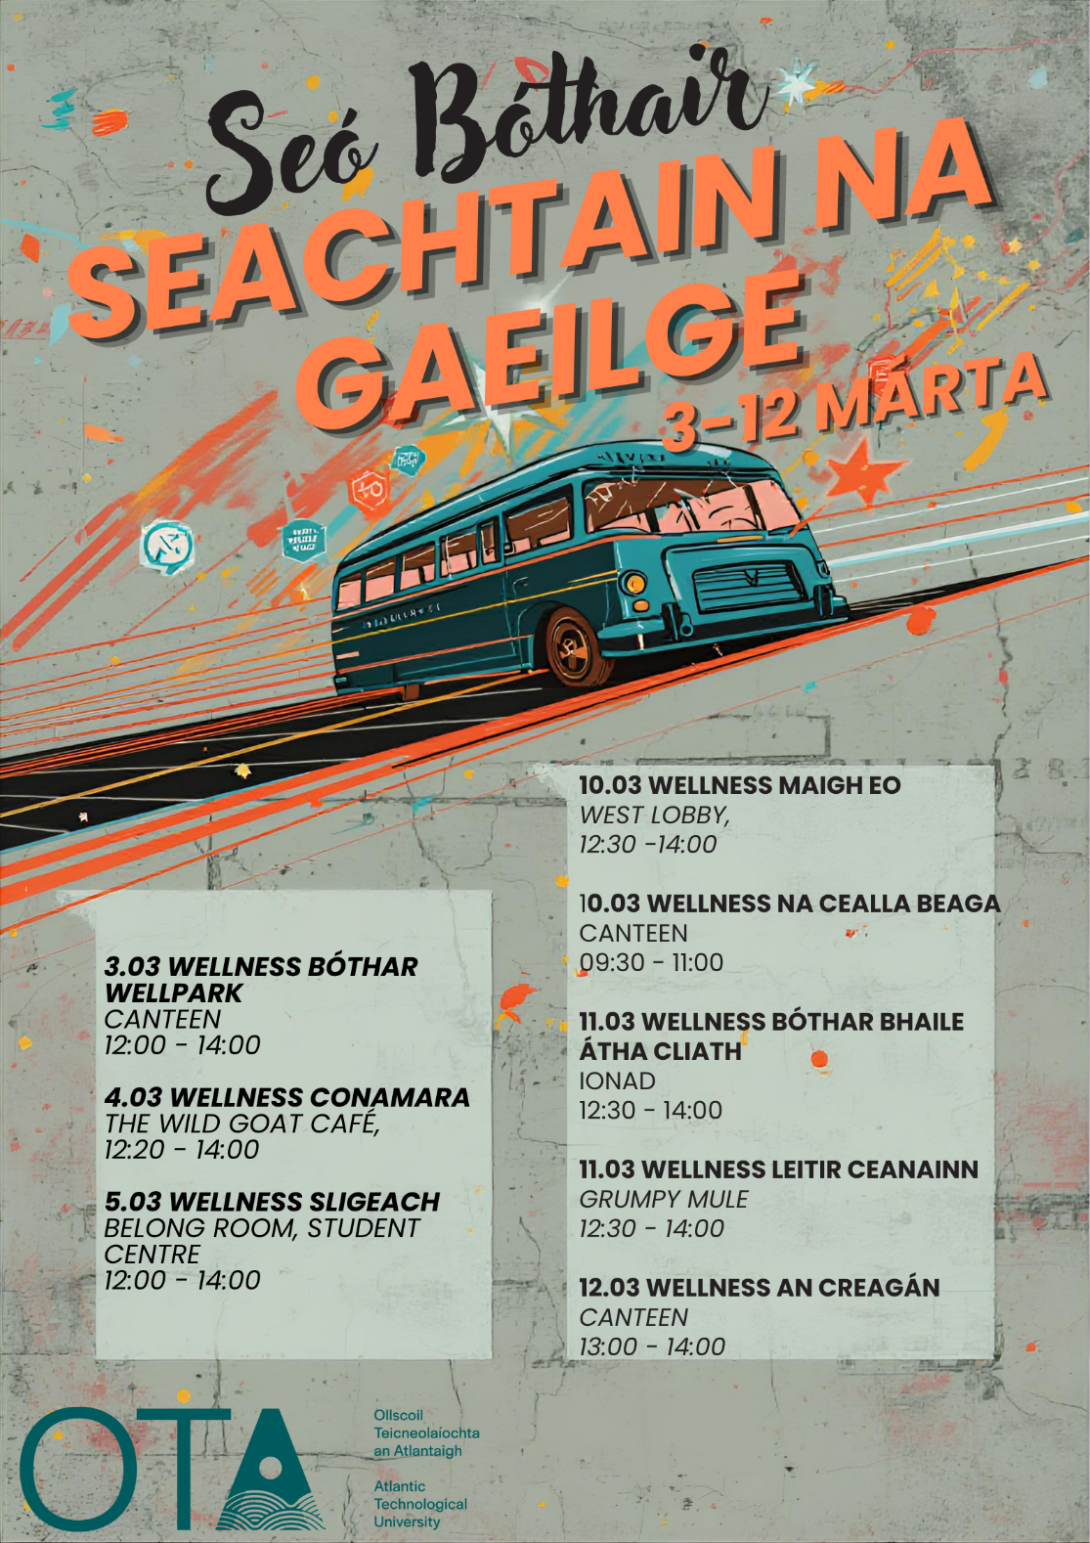

- Evaluation
How was the project evaluated?
Please check the box(es) that apply regarding the type of evaluation and data collection method
Type of Evaluation
Formative Evaluation: ☒  Conducted during development or early implementation to make improvements to the program design. | Process Evaluation: ☒  Assesses how the program is being implemented, including participation rates, quality of delivery, and whether it is reaching its target audience. | Outcome Evaluation: ☐  Focuses on the results—the changes in behaviors, attitudes, or conditions—at the end of a project. | Summative Evaluation: ☐  Assesses the overall effectiveness of a program after its completion to determine if it achieved its intended goals.
Data Collection Method
Survey/Questionnaire ☐  Document Review ☐ (project reports, financial data, attendance logs, etc.)  Direct Observations ☒ | Focus Groups ☐  Interviews ☐  Case Studies ☐  Other____________
High-Level Outcome and Impact
Please include high-level outcomes and impact if not already covered in the summary above.

- Contact Details
Contact Name/s | Sharon Ferguson
Date | 30.03.2026
Email Address | Sharon.Ferguson@atu.ie

