HEA Healthy Campus Case Study Template 2026

NOTES FOR COMPLETION
Context
- Case studies should relate to your institution's progression of the following policies:
  - HEA Healthy Campus Charter and Framework
  - HEA Healthy Campus Self-Evaluation Tool
  - National Student Mental Health and Suicide Prevention Framework
  - The Limerick Framework for Action: Advancing the Health Promoting Campus Agenda
- Case studies can include a wide range of work including those relating to governance and oversight, planning, strategy, policy, research, implementation, as well as others.
- We encourage examples that also showcase the interaction of wellbeing and other areas for example sustainability, belonging, progression, teaching and learning.
Template
- Please be as concise and clear as possible and consider the use of bullet points to summarise information.
- All sections must be completed.
- Case studies should be written in the third person and anonymous when it comes to participants’ names.
- Case studies will be used as part of HEA communications including email, website, and social media.
Submission
- Please submit your case study to healthycampus@hea.ie by COB Friday, April 3rd for display at the 2026 Health and Wellbeing Conference.

HEALTHY CAMPUS CASE STUDY
- Project Title | Open Up Mental Health Campaign
- Institution/ Organisation | Aontas na Mac Léinn in Éirinn (AMLÉ)
- Who leads/ led the project? | Mental Health Programme Manager Sarah Hughes, supported by Vice-President for Welfare Emma Manahan
- Date and timeframe | 2021 - ongoing
- Population Group (tick all that apply) | - Students ☒  - Staff ☐  - Wider community ☐  - Other ☐
- Health Topic (tick all that apply) | - Alcohol ☐  - Substance Misuse ☐  - Healthy Eating / Food ☐  - Mental Health & Wellbeing ☒  - Sexual Health & Wellbeing ☐  - Tobacco/ Vape Free Campus ☐  - Physical Activity / Active Transport ☐  - Wellbeing and the Curriculum ☐  - Health & Sustainability ☐  - Other ☐

- Project Alignment

Use the categories below to highlight the alignment of the project with national policy. Please tick all that apply.

Limerick Framework for Action - 10 Actions  LFfA pg. 12 | Healthy Campus Process  HCCF pg. 4 | Whole Campus Approach  HC Tool pg. 8 | Principles of a Healthy Campus  HC Tool + HCCF | National Student Mental Health and Suicide Prevention Framework NSMHSPF
1.Ethos ☐ | Commit ☐ | Leadership, Strategy & Governance  (Pillar 1) ☐ | Participation ☐ | Lead ☐
2.Act ☐ | Coordinate ☐ | Campus Environment (Facilities & Services) (Pillar 2) ☐ | Partnership ☒ | Collaborate ☒
3.Localise ☐ | Consult ☐ | Campus Culture & Communications (Pillar 3) ☐ | Evidence Based ☒ | Educate ☒
4.Leadership ☐ | Create ☐ | Personal & Professional Development  (Pillar 4) ☐ | Sustainability (Longevity) ☐ | Engage ☒
5.Policies ☐ | Celebrate & continue ☐ | Health Focused Area (Pillar 5) ☒ |  | Identify ☐
6.Culture ☒ |  |  |  | Support ☐
7.Partnership ☒ |  |  |  | Respond ☐
8.Students ☒ |  |  |  | Transition ☒
9.Research ☒ |  |  |  | Improve ☒
10.Celebrate ☐

- Project Rationale | To meet students where they are (primarily on-campus and online) with information, signposting and support as needed
- Aims and Objectives | The aims of the campaign are to reduce stigma, to signpost towards support at local and national level, and to provide psychoeducation. We also provide an avenue of contact for other organisations working in mental health to reach the student population through partnerships. We also gather data on student mental health to ensure our project aligns with student need.
- Project Overview/ Summary | Plan  - A yearly review is conducted and a plan created with the incoming Vice President for Welfare and local welfare officers around the country  - Continual planning with partner organisations such as NOSP, Movember Ireland, local unions, Mental Health Ireland etc.  Implementation  - Campus visits are conducted across the country in conjunction with local students’ unions; often in association with relevant local campaigns such as mental health weeks  - Social media is utilised as a key method of reaching students with mental health messaging on stigma via Instagram.  - A dedicated website hosts resource pages and a regularly updated blog as well as an information hub for local students’ union  - A podcast interviews guests monthly on mental health topics  - An online newsletter is created monthly including updates on the campaign  - Merchandise is curated to incentivise engagement and to encourage help-seeking  - In-person events include student mental health conferences  - Awareness days are marked as part of an ancillary campaign process under the overall umbrella campaign such as suicide prevention day, world mental health day, eating disorders prevention week, and exam destress campaigns  Evaluation  - Review with local student union teams to ascertain effectiveness of campus visits  - Collection of research data on student mental health to ensure project continues to align with student need
- Collaboration | - NOSP  - Local unions nationally  - PCHEI  - Shine  - Mental Health Ireland  - Bodywhys  - Turn2Me  - BelongTo  - Student Sport Ireland
- Resource Requirements | - Website associated costs  - Podcast associated costs  - Merchandise creation & delivery  - Travel  - Accommodation  - Event planning & implementation costs
- What are the next steps for the project? | The project has displayed sustainability over the past 5 years and has changed as needed within that time. Previous campaigns within the organisation were short-term and more intensive, but students noted that mental health is ‘more than just a week-long thing’ so a rolling campaign was developed. The open nature of the project name & messaging means other ancillary campaigns such as Movember etc can be brought under the umbrella of the main campaign as needed throughout the year.
- Key Learning Points | Reaching students is the main focus of this campaign, but post-COVID reaching students in an effective way can be challenging. Utilising multiple approaches has been key to success; combining online and in-person mechanisms.  The campaign has adapted over time through talking to students about what they need, and what they think is good about the campaign. We have worked to build relationships with as many partners as possible – both on and off campus; and in particular with students’ unions as a mechanism to reach students. For us, students’ unions invite us on campus and help advertise our work on social media.  We have learned to be flexible but also creative. A campaign needs to stick out from the crowd in order to get attention from students.
- Images and Links | Please include 1/2 images related to the project, this can include document cover pages, logos, a picture of a team meeting etc.  Mentalhealth.amle.ie  https://www.instagram.com/amle_mentalhealth/  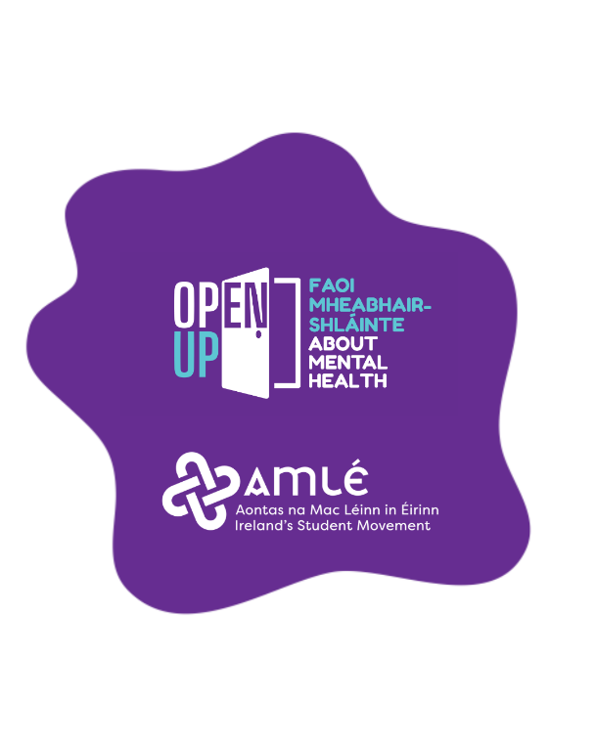

- Evaluation
How was the project evaluated?
Please check the box(es) that apply regarding the type of evaluation and data collection method
Type of Evaluation
Formative Evaluation: ☐  Conducted during development or early implementation to make improvements to the program design. | Process Evaluation: ☒  Assesses how the program is being implemented, including participation rates, quality of delivery, and whether it is reaching its target audience. | Outcome Evaluation: ☐  Focuses on the results—the changes in behaviors, attitudes, or conditions—at the end of a project. | Summative Evaluation: ☐  Assesses the overall effectiveness of a program after its completion to determine if it achieved its intended goals.
Data Collection Method
Survey/Questionnaire ☐  Document Review ☐ (project reports, financial data, attendance logs, etc.)  Direct Observations ☒ | Focus Groups ☐  Interviews ☐  Case Studies ☐  Other informal conversations with students and local student union officers
High-Level Outcome and Impact
Please include high-level outcomes and impact if not already covered in the summary above.

- Contact Details
Contact Name/s | Sarah Hughes
Date | 03/04/2026
Email Address | mentalhealth@amle.ie

