HEA Healthy Campus Case Study Template 2026

NOTES FOR COMPLETION
Context
- Case studies should relate to your institution's progression of the following policies:
  - HEA Healthy Campus Charter and Framework
  - HEA Healthy Campus Self-Evaluation Tool
  - National Student Mental Health and Suicide Prevention Framework
  - The Limerick Framework for Action: Advancing the Health Promoting Campus Agenda
- Case studies can include a wide range of work including those relating to governance and oversight, planning, strategy, policy, research, implementation, as well as others.
- We encourage examples that also showcase the interaction of wellbeing and other areas for example sustainability, belonging, progression, teaching and learning.
Template
- Please be as concise and clear as possible and consider the use of bullet points to summarise information.
- All sections must be completed.
- Case studies should be written in the third person and anonymous when it comes to participants’ names.
- Case studies will be used as part of HEA communications including email, website, and social media.
Submission
- Please submit your case study to healthycampus@hea.ie by COB Friday, April 3rd for display at the 2026 Health and Wellbeing Conference.

HEALTHY CAMPUS CASE STUDY
- Project Title | AMLÉ Gambling, Substance Use and Mental Health Survey 2026
- Institution/ Organisation | Aontas na Mac Léinn in Éirinn (AMLÉ) (in partnership with Ulster University & the Gambling Regulatory Authority of Ireland)
- Who leads/ led the project? | Mental Health Programme Manager Sarah Hughes alongside Dr Elaine Murray from Ulster University
- Date and timeframe | Academic year 2025-2026
- Population Group (tick all that apply) | - Students ☒  - Staff ☐  - Wider community ☐  - Other ☐
- Health Topic (tick all that apply) | - Alcohol ☐  - Substance Misuse ☒  - Healthy Eating / Food ☐  - Mental Health & Wellbeing ☒  - Sexual Health & Wellbeing ☐  - Tobacco/ Vape Free Campus ☐  - Physical Activity / Active Transport ☐  - Wellbeing and the Curriculum ☐  - Health & Sustainability ☐  - Other ☒

- Project Alignment

Use the categories below to highlight the alignment of the project with national policy. Please tick all that apply.

Limerick Framework for Action - 10 Actions  LFfA pg. 12 | Healthy Campus Process  HCCF pg. 4 | Whole Campus Approach  HC Tool pg. 8 | Principles of a Healthy Campus  HC Tool + HCCF | National Student Mental Health and Suicide Prevention Framework NSMHSPF
1.Ethos ☐ | Commit ☐ | Leadership, Strategy & Governance  (Pillar 1) ☒ | Participation ☐ | Lead ☐
2.Act ☐ | Coordinate ☐ | Campus Environment (Facilities & Services) (Pillar 2) ☐ | Partnership ☒ | Collaborate ☒
3.Localise ☐ | Consult ☒ | Campus Culture & Communications (Pillar 3) ☐ | Evidence Based ☒ | Educate ☐
4.Leadership ☐ | Create ☐ | Personal & Professional Development  (Pillar 4) ☐ | Sustainability (Longevity) ☐ | Engage ☐
5.Policies ☐ | Celebrate & continue ☐ | Health Focused Area (Pillar 5) ☒ |  | Identify ☐
6.Culture ☐ |  |  |  | Support ☐
7.Partnership ☒ |  |  |  | Respond ☐
8.Students ☐ |  |  |  | Transition ☐
9.Research ☒ |  |  |  | Improve ☒
10.Celebrate ☒

- Project Rationale | There has been no post-covid large-scale data collected on student mental health or substance use. There has never been any data collected on student gambling in Ireland
- Aims and Objectives | To conduct a large-scale survey on student gambling, substance use and mental health
- Project Overview/ Summary | AMLÉ identified a lack of recent data in some key areas relevant to our work. There has never been data collected on student gambling; and there was no post-COVID data on student mental health or student substance use in Ireland. AMLÉ partnered with the newly formed Gambling Regulatory Authority of Ireland (GRAI) in putting together the gambling section of the survey.  We developed the survey questions in collaboration with the GRAI and one of the researchers who conducted the 2021 Drug Use in Higher Education survey, as well as a review of the 2019 USI Student Mental Health Report.  We collaborated with Dr Elaine Murray at Ulster University for added oversight and ethics approval was obtained from Ulster University.  We rolled out the survey in Autumn 2025 using the AMLÉ mental health podcast, social media posts, inclusion in the AMLÉ mental health newsletter, emails and in-person on-campus recruitment.  Once the data collection was complete, the data was analysed and initial results were collated into three reports. These reports were launched at an event in DCU in February 2026.  Going forward, the data will be used to inform AMLÉ campaigns and lobbying, and AMLÉ will collaborate with relevant parties such as PCHEI, NOSP, GRAI and others to further analyse and make use of the data.
- Collaboration | Dr Elaine Murray, Ulster University  Gambling Regulatory Authority of Ireland  Emma Monahan, AMLÉ Vice President for Welfare
- Resource Requirements | Funding for incentives and social media advertising during recruitment  Survey and data analysis software related costs  Travel & accommodation costs related to recruitment  Costs for launch event
- What are the next steps for the project? | Initial analysis is complete but further, more in-depth analysis will be conducted. All internal work related to these areas will be reviewed and campaigns developed/ altered accordingly. Working with identified partners in the relevant areas will commence once further analysis is complete also.
- Key Learning Points | Students are asked to complete a lot of surveys, and this poses challenges for recruitment. We used a combination of recruitment methods, although from an ethical perspective we were restricted in leaning too much on advertising our incentive due to our gathering of data on gambling. In-person data collection was most successful, as was the use of a push notification from an app used by AMLÉ with students. Students were very interested in what was going to come of this data being gathered and seemed more likely to complete the survey on learning concrete action would be taken with it.
- Images and Links | Please include 1/2 images related to the project, this can include document cover pages, logos, a picture of a team meeting etc.  Please include links to webpages/ documents related to the project.  https://mentalhealth.amle.ie/amle-research/  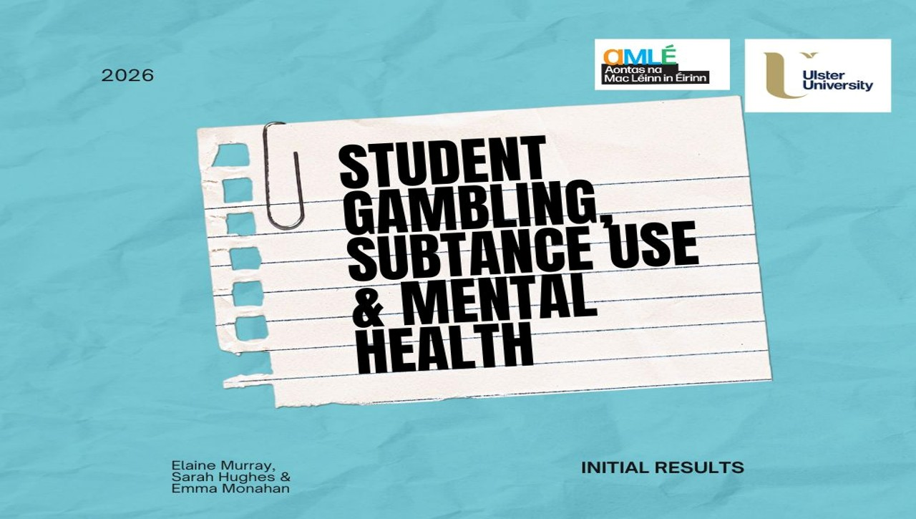

- Evaluation
How was the project evaluated?
Please check the box(es) that apply regarding the type of evaluation and data collection method
Type of Evaluation
Formative Evaluation: ☐  Conducted during development or early implementation to make improvements to the program design. | Process Evaluation: ☐  Assesses how the program is being implemented, including participation rates, quality of delivery, and whether it is reaching its target audience. | Outcome Evaluation: ☐  Focuses on the results—the changes in behaviors, attitudes, or conditions—at the end of a project. | Summative Evaluation: ☐  Assesses the overall effectiveness of a program after its completion to determine if it achieved its intended goals.
Data Collection Method
Survey/Questionnaire ☒  Document Review ☐ (project reports, financial data, attendance logs, etc.)  Direct Observations ☐ | Focus Groups ☐  Interviews ☐  Case Studies ☐  Other____________
High-Level Outcome and Impact
Please include high-level outcomes and impact if not already covered in the summary above.

- Contact Details
Contact Name/s | Sarah Hughes
Date | 03/04/2026
Email Address | mentalhealth@smale.ie

