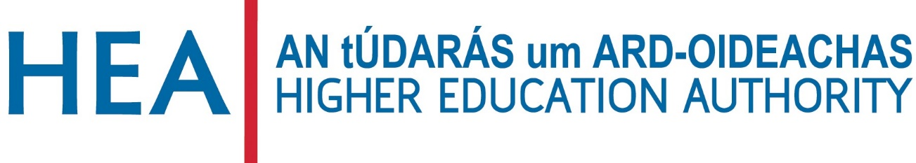

GENDER EQUALITY ENHANCEMENT FUND 2021

APPLICATION FORM

Applications must be submitted to: CEGE@hea.ie

Deadline: 12:00, 24th September 2021. Late applications will not be accepted.

All institutions listed as partners must submit a declaration signed by the Head of their institution (page 5 of the application form).

GUIDE FOR APPLICANTS

- The application form should be named in the following way: HEI name_ Gender Equality Enhancement Fund _Application Form. Please note that HEI refers to the lead applicant in each application.

- A declaration (page 5 of the application form) must be signed by the Heads of institution on behalf of each HEI applicant (lead and partner applicants). Please copy and paste the declaration (page 5) according to the number of HEI applicants and ensure a copy is signed by the Head of each institution partnering in the application.

- Applicants must strictly adhere to word limits. Graphs and tables are not included in the word count. Please include the word count at the start of each section. Submissions that exceed the word count will be penalised.

- Submissions should be emailed to: CEGE@hea.ie

- Deadline: 12:00, 24th September 2021.

SECTION 1: APPLICATION DETAILS

HIGHER EDUCATION INSTITUTION (LEAD APPLICANT):

INSERT HEI NAME HERE

PROPOSAL TITLE:
INSERT PROPOSAL TITLE HERE

SECTION 2: APPLICANT DETAILS

LEAD APPLICANT DETAILS

Higher Education Institution
Name of contact
Position held within institution
Email address
Phone number

SECTION 2 continued

DETAILS OF APPLICATION PARTNERS

Application Partner 1:
Name of contact
Email address

Application Partner 2:
Name of contact
Email address

Please provide details for any other application partners including institution name, named contact and email address

SECTION 3: DECLARATION

In submitting this application for the Gender Equality Enhancement Fund,
INSERT HEI NAME HERE
accepts the conditions outlined in the Gender Equality Enhancement Fund Call for Applications document and any subsequent clarifications from the HEA regarding this initiative and agrees to be bound by them.
INSERT HEI NAME HERE
Furthermore,
accepts this award and commits to providing the necessary support for the programme of activity.

Signature of Head of Institution:

Institutional stamp:

SECTION 4: PROPOSAL SUMMARY

Applications will be assessed according to the assessment criteria set out in the Call for Applications.

Please note that 30 marks have been allocated to the overall quality of the proposal (criterion 5). A minimum threshold of 15 marks applies to this criterion.

  - PROPOSAL TITLE

4.2 KEYWORDS (max 10 words)

4.3 PRIMARY FUNDING AREA
Applicants should indicate the primary area under which funding is sought (see Call for Applications for areas eligible for funding).

Research on or advancing gender equality initiatives in Ireland.

Training programmes specifically addressing gender equality.

Athena SWAN capacity-building activities.

SECTION 4: PROPOSAL SUMMARY

4.4 PROPOSAL OBJECTIVE (max 100 words)
Please state the word count at the start of the section.

SECTION 5: PROPOSAL DETAILS

5.1 PROPOSAL DESCRIPTION (max 1000 words)
This section should describe the proposal and reference alignment of the proposed work with the recommendations of the HEA expert group and / or the recommended actions of the Gender Equality Taskforce where appropriate (criterion 1; max 20 marks, minimum threshold 10 marks). The innovative nature of the work should also be described here (criterion 2; max 10 marks, minimum threshold 5 marks). Please state the word count at the start of the section.

SECTION 5: PROPOSAL DETAILS

5.2 IMPACT AND DELIVERABLES (max 500 words)
This section should clearly describe the outputs, significance and impact of the work. Specific reference should be made to the benefit to stakeholders nationally (criterion 3; max 30 marks, minimum threshold 15 marks). Please state the word count at the start of the section.

SECTION 5: PROPOSAL DETAILS

5.3 PROPOSED BUDGET AND JUSTIFICATION (max 500 words)
This section should provide details of, and justification for, the projected costs. Details of any in-kind funding may be provided here. Specific reference should be made to value for money and impact of the proposed work (criterion 4; max 10 marks, minimum threshold 5 marks). A table of costs may be included at the end of this section. Please state the word count at the start of the section.

