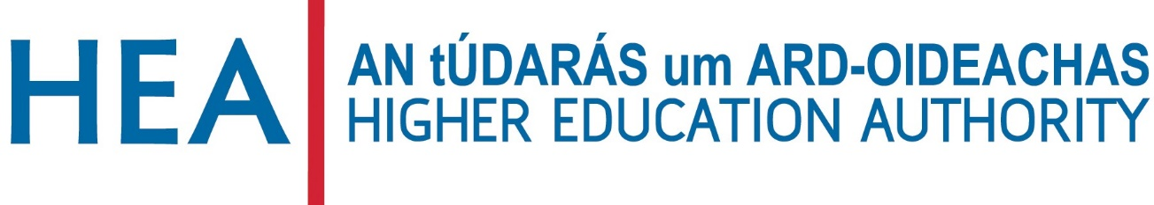

GENDER EQUALITY ENHANCEMENT FUND 2020

APPLICATION FORM

Applications must be submitted to: CEGE@hea.ie
Deadline: 12:00, 11th December 2020. Late applications will not be accepted.
All institutions listed as partners must submit a declaration signed by the Head of their institution

GUIDE FOR APPLICANTS

- The application form should be named in the following way: HEI_ Gender Equality Enhancement Fund _Application Form. Please note that HEI refers to the lead applicant in each application.

- Any graphs / charts should be submitted as an appendix and not inserted into the tables of the application form.

- All appendices must be named according to the section to which they pertain i.e. an appendix relating to content in Section 4.1 should be named: HEI_ Gender Equality Enhancement Fund _Appendix 4.1.

- Applicants must strictly adhere to word limits. Please include the word count at the end of each section. Submissions that exceed the word count may be penalised.

- Submissions should be emailed to: CEGE@hea.ie

- Deadline: 12:00, 11th December 2020.

SECTION 1: APPLICATION DETAILS

HIGHER EDUCATION INSTITUTION (LEAD APPLICANT):

INSERT HEI NAME HERE

PROPOSAL TITLE:
INSERT PROPOSAL TITLE HERE

SECTION 2: APPLICANT DETAILS

LEAD APPLICANT DETAILS

Higher Education Institution
Name of contact
Position held within institution
Email address
Phone number

SECTION 2 continued

DETAILS OF APPLICATION PARTNERS

Application Partner 1:
Name of contact
Email address

Application Partner 2:
Name of contact
Email address

Please provide details for any other application partners including institution name, named contact and email address

SECTION 3: PROPOSAL SUMMARY

Applications will be assessed according to the assessment criteria set out in the Call for Applications.
Proposal title:

Keywords (max 10 words)

Primary funding area
Applicants should indicate the primary area under which funding is sought (see Call for Applications for areas eligible for funding).

Research on or advancing gender equality initiatives in Ireland.

Training programmes specifically addressing gender equality.

Athena SWAN capacity-building activities.

Proposal Objective (max 100 words).
Please include the word count.

SECTION 4: PROPOSAL DETAILS

4.1 PROPOSAL DESCRIPTION (max 1000 words)
This section should describe the proposal and reference alignment of the proposed work with the recommendations of the HEA expert group and / or the recommended actions of the Gender Equality Taskforce where appropriate (criterion 1; max 20 marks, minimum threshold 10 marks). The innovative nature of the work should also be described here (criterion 2; max 10 marks, minimum threshold 5 marks). Please include the word count at the end of this section.

4.2 IMPACT AND DELIVERABLES (max 500 words)
This section should clearly describe the outputs, significance and impact of the work. Specific reference should be made to the benefit to stakeholders nationally (criterion 3; max 30 marks, minimum threshold 15 marks). Please include the word count at the end of this section.

4.3 PROPOSED BUDGET AND JUSTIFICATION (max 500 words)
This section should provide details of, and justification for, the projected costs. Details of any in-kind funding may be provided here. Specific reference should be made to value for money and impact of the proposed work (criterion 4; max 10 marks, minimum threshold 5 marks). If applicants wish to include a table of costs, please submit these as an appendix (pdf format only). Please include a word count at the end of this section.

30 marks have been allocated to the overall quality of the proposal (criterion 5). A minimum threshold of 15 marks applies to this criterion.

