Higher Education Authority

Graduate Outcomes Return User Manual

Ver 1.5

Pre-upload Validation using XSD
Prior to uploading your XML file it is strongly advised to validate the XML against the supplied XSD file. Performing this validation will make the process of uploading much smoother and identify in advance any issues you many have with your XML file.
To do this you will need Notepad++ and the XML tools plugin. You will need the 32bit version of Notepad++ and the installer is available here:
https://notepad-plus-plus.org/downloads/
Please select Notepad++ Installer 32-bit x86 and run the .exe once the download completes.
Select OK for English and then just install with all default options by always clicking NEXT on each window and finally INSTALL. Once it completes click FINISH and then the program will open automatically. Next you will need to install the XML Tools plugin. Go to “Plugins” in the main Notepad++ toolbar and select “Plugins Manager”->”Show Plugins Manager”:
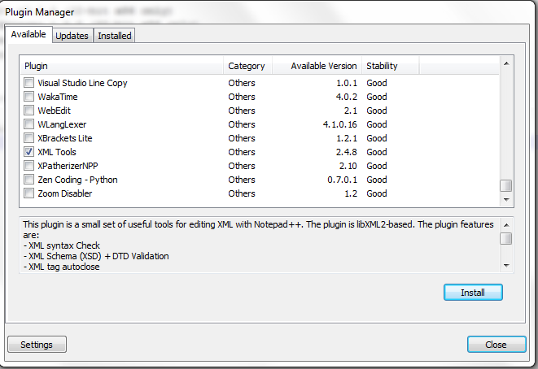

Select XML Tools and click Install. It will then prompt you to update the Plugins Manager:
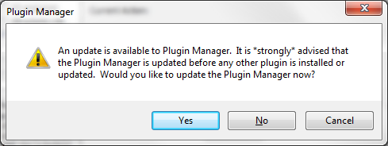
Select Yes and wait until asked to restart Notepad++. Click Yes to continue
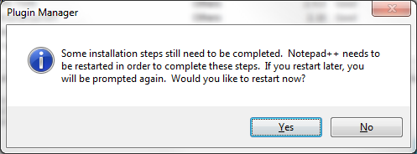

When it has restarted you will be asked to update the Plugins manager again:
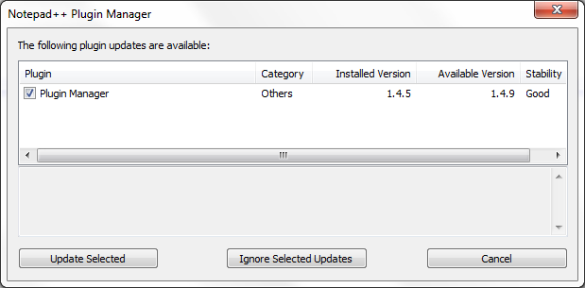

Click “Update Selected” and you will be asked a final time to restart Notepad++. Please click Yes.

Once again go to “Plugins” in the main Notepad++ toolbar and select “Plugins Manager”->”Show Plugins Manager”. Select XML tools and click “Install”
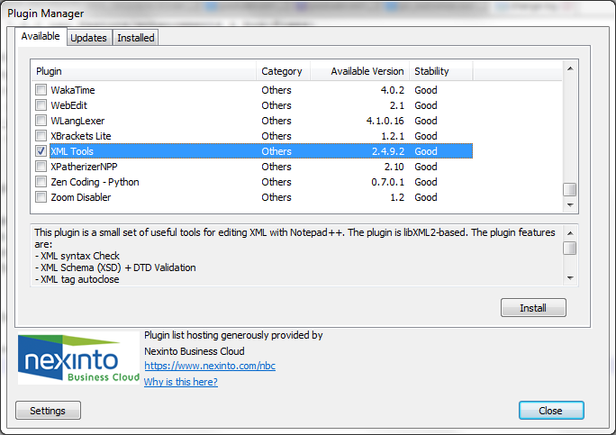
Click Yes to restart Notepad++ again and the installation process is complete.

To Validate:
You will need to reference the XSD file at the top your XML as follows:
<?xml version="1.0"?>
<srs xmlns:xsi="http://www.w3.org/2001/XMLSchema-instance" si:noNamespaceSchemaLocation=" go_outcomes.xsd">
Each record needs to be enclosed within the following tags
<outcomes> </outcomes>
And please ensure the tag names match the tag names in the XSD. For example: <GO_Further_Mode>
And then closed at the end with
</srs>
Both files (.xml and .xsd) will need to be in the same directory.
Once this path is set correctly you can click on “Plugins” -> “XML Tools” -> “Validate Now” and you will receive a message indicating if XML file is correct or if not which fields have issues that need to be resolved. You can also do this with the keyboard shortcut: “Ctl+Alt+Shift+M”
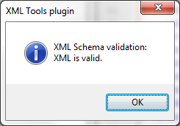

To Validate and Upload:
  - Select the following url https://central.hea.ie:4443/ords/f?p=510

  - Enter username and password as supplied
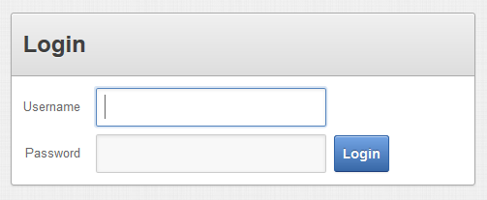

2.1 Select file to be validated and click Validate XML
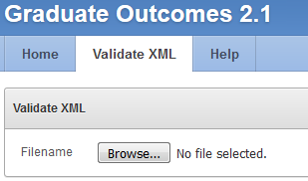
You should receive a message: “XML file has been validated successfully!”
If so click “Next” to proceed to the next screen to load the file into the system.
If not you will need to review and fix the validation errors before being able to continue.

2.2 Click Load XML on the Load XML tab:
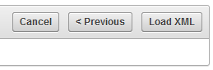
You should now receive a message indicating the load was successful. Otherwise a list of errors that will need to be addressed before the file will be accepted.
2.3 Finally there is a “Discard Previous Upload” tab which allows you to clear down the records loaded for this return should you wish to reload your data. However, be aware that this functionality is not available initially as all records loaded are marked signed-off as a default. If you attempt to clear down your records while they are signed off you will get a error message indicating this is not possible. In this case please contact the HEA in order to avail of this clear-down function.

